ENHANCEMENT OF BIOGAS PRODUCTION FROM CHICKEN DROPPING USING DOPED TITANIUM OXIDE (T₁O₂) AS CATALYST

BY

DAHIRU MOHAMMED
(17410314002)

PRESENTED TO THE DEPARTMENT OF PURE AND APPLIED CHEMISTRY, FACULTY OF SCIENCE, USMANU DANFODIYO UNIVERSITY, SOKOTO
IN PARTIAL FULFILLMENT OF THE REQUIREMENTS FOR THE AWARD OF DOCTOR OF PHILOSOPHY (PhD.) (RENEWABLE ENERGY)

SUPERVISORS:
MAJOR SUPERVISOR: PROF. BAGUDO
CO-SUPERVISOR M.L. MOHAMMED

DECEMBER, 2025

DEDICATION
This research work is dedicated to my late father,late daughter late wife and my children.

CERTIFICATION

This thesis by Dahiru Mohammed (17410314002) has met the Requirement for the Award of Degree of Doctor of Philosophy in Renewable Energy of Usmanu Danfodiyo University, Sokoto and is approved for its contribution to knowledge.

______________________ ____________
(External Examinar) Date
_______________________________ ________________
Proff B.U Bagudo (Major supervisor) Date

_________________________________ _______________
Proff M.L. Mohammad (Co-supervisor 1) Date

____________________________________ _________________
Proff. Chika. Muhammad(Co-supervisor 11) Date

_____________________________________ ________________
Proff. M.L. Mohammad(Head of Department Date

ACKNOWLEDGEMENTS
In the Name of Allah the most Beneficent,the most Merciful. All praise be to Allah (S.W.T) the lord of the universe,which with out his endless blessings,this work would not be possible.May the peace and salutations of Allah be upon his beloved servant and messenger,prophet Muhammad (S.A.W).
I sincerely wish to express my warm gratitude to the good personalities behind the success of this research work.First and fore most, to my supervisory team proff. B.U. Bagudo (Major supervisor), Proff M.L. Mohammad (Co-supervisor 1) and Proff. Chika Muhamad (Co-supervisor 11) for the support,advice, guidance,encouragement and understanding we shared together through out the research period.May almighty Allah bless them and grant them the best of paradise.(Jannatit Fiddaus)
Sepecial appreciation goes Prof A.I. Tsafe, Prof. A.M. Sokoto,Prof. M.N. Almustapha,Proff L.G. Hassan, Prof M.U. Dabai, Prof. M.G. Liman, Dr.J Mohammed, Dr.I. Mudi and entire staff members of Department of Energy and Applied Chemistry as well as Department of Pure and Environmental Chemistry whom their names have not been mentioned for their constructive criticisms,insightful comment and support through out this research.
I am extremely and sincerely thankful to my uncle Alh Mohammad Bawa Tsafe for his moral and financial support right from childhood to date, my beloved motherHajiya Saudatu Mohammad Bawa Tsafe and to all family members.
II equally acknowledged the support of Tertiary Education Trust Fund (TETfund) for their financial support to the successful completion of this study.
Iam also grateful to Zamfara State College of Education Maru for granting me six months Extension in order to complete the programme comfortably and successfully.
I also appreciate and recognized the patient and prayers of my beloved wife Maijidda Mohammad Bawa and our children through out my years of study.
Finally, I acknowledged the help and effort of Mal Umar (Energy Research UDUS), Dr.Gulma (Energy Research UDUS) Mal Naziru Mohammad (Agric Lab UDUS) and Ahamad Mohammad (Ex Student UDUS) for their contribution through out my lab work

TABLE OF CONTENT

Title page i
Dedication ii
Certification iii
Acknowlegement v
Table of content vi
List of Table xi
List of Figures xii
List of Plates xiv
Abbreviation xvi
Abstract xvii
CHAPTER ONE: INTRODUCTION
1.0 Introduction 1
1.1 Methane formation 4
1.2 Biomass 7
1.3 Bio energy 8
1.4 Difination of biogas 9
1.5 Uses of bio gas 10
1.6 Factors affection biogas production 11
1.7 Catalysis 13
1.8 Mechanisms of catalyst enhancement 14
1.9 Doping 15
1.1.0 Research problem 16
1.1.1 Justification of the study 17
1.1.2 Aims and Objectives 18
1.1.3 Scope and Delimitation 18
CHAPTER 2.0 : LITERATURE REVIEW 20
CHAPTER THREE
3.0 Material and methods 26
3.1 Material instrument 26
3.2 Reagents 27
3.3.0 Sample collection and preparation 30
3.3.1 Sample collection 30
3.3.2 Sample preparation 30
3.3.3 Catalyst synthesis 30
3.3.4 Catalyst synthesis 31
3.3.5 Catalyst synthesis 31
3.3.6 Catalyst characterization 31
3.3.7 Catalyst testing 33
3.3.8 Experimental set up for biogas purification and storage 38
3.3.9 Determination of the proximate composition of the undigested slurry 41
3.3.10 Determination of moisture content 41
3.3.11 Determination of total solid 42
3.3.12 Determination of volatile solid 42
3.3.13 Determination of ash content 43
3.3.14 Determination of crude fiber 44
3.3.15 Determination of carbohydrate 44
3.3.16 Determination of percentage crude lipid 45
3.3.17 Determination of crude protein 45
3.3.18 Determination of elemental composition of the sample 45
3.3.19 Determination of percentage Nitrogen 45
3.3.20 Determination of percentage potassium 46
3.3.21 Determination of percentage carbon 47
3.3.22 Determination of carbon to nitrogen ratio 47
3.3.23 Determination of pH 47

CHAPTER FOUR
4.0 Results and discussion 48
4.1 Results 48
4.1.1 Results of the proximate analysis 48
4.1.2 Proximate analysis 48
4.1.3 Moisture content 49
4.1.4 Ash content 50
4.1.5 Total solid 50
4.1.6 Volatile solid 50
4.1.7 Crude fiber,Crude lipid,Crude proteinand Carbohydrate 51
4.1.8 Total carbon 52
4.1.9 Total nitrogen 52
4.1.10 Carbon to nitrogen ratio 52
4.1.11 pH of the slurry before and after digestion 78
4.1.12 Elemental composition 55
4.1.13 Catalyst characterization 56
4.1.14 Volume of biogas produced 65
CHAPTER FIVE
5.0 Conclusion and Recommendation
5.1 Conclusion
5.1.0 Recommendation
References
Appendixes

LIST OF TABLE
Table Title page
1.0 Typical composition of biogas 5
2.0 List of instrument and equipment 26
3.0 List of chemical and reagent 27
4.0 Results of proximate analysis before & after digestion 49
5.0 pH of the undigested and digested slurry 53
6.0 Results of elemental composition of the digested&undigested slurry 55
7.0 Total volume of gas produced in cm³ 58
8.0 65

LIST OF FIGURE
Figure Title Page
1.0 Schematic diagram of anaerobic degradation of biomass 5
2.0 X-Ray Diffraction (Xrd) of TiO₂, CuO/TiO₂,FeO/ TiO₂ and ZnO/TiO₂ catalysts 56
3.0 FourierTransformInfra-RedSpectroscopy(FT-IR)ofTiO₂,CuO/TiO₂,FeO/TiO₂&ZnO/TiO₂ 57
4.0 Brunaer –Emmette-Teller (BET) Analysis 59
5.0 Thermo-gravimetric (TGA) and Differential Thermal Analysis (DTA) 60
6.0 Catalytic biogas production using TiO₂ catalyst: catalyst loading of 0.2g -1.0g. 62
7.0 Catalytic biogas production using CuO/TiO₂ catalyst: catalyst loading of 0.2g -1.0g. 62
8.0 Catalytic biogas production using FeO/TiO₂ catalyst: catalyst loading of 0.2g -1.0g 63
9.0 Catalytic biogas production using ZnO/TiO₂ catalyst: catalyst loading of 0.2g -1.0g 63
10.0 Catalytic bio gas production using TiO₂ Catalyst. Catalyst loading of 5g to 15g 66
11.0 Catalytic bio gas production using CuO/ TiO₂ Catalyst. Catalyst loading of 5g to 15g 66
12.0 Catalytic bio gas production using FeO/TiO₂ Catalyst. Catalyst loading of 5g to 15g 67
13.0 Catalytic bio gas production usingZnO/ TiO₂ Catalyst. Catalyst loading of 5g to 15g 67

.

LIST OF PLATE
Figure Title Page
1.0 Undigested chicken substrate 27
2.0 Digested chicken Substrates 28
3.0 Raw bio methane 29
4.0 Purified Bio Methane 29
5.1 Biogas production using TiO₂, 0.2g, 0.4g, 0.6g,0.8g &1.0g catalyst loading (A, B1-- B₅) 34

6.0 Biogas production using CuO/TiO₂, 0.2g, 0.4g, 0.6g,0.8g &1.0g catalyst loading (C₁₋₋ C₅) 34

7.0 Biogas production using FeO/TiO₂, 0.2g, 0.4g, 0.6g,0.8g &1.0g catalyst loading (D₁₋₋D₅) 35

8.0 Biogas production using ZnO/TiO₂, 0.2g, 0.4g, 0.6g,0.8g &1.0g catalyst loading (E₁₋₋E₅) 35

9.0 Biogas production using control sample A 36

10.0 Biogas production using TiO₂ at 5g, 10g, 15g catalyst loading (B₁-B₃) 36

11.0 Biogas production using CuO/TiO₂ at 5g, 10g, 15g catalyst loading (C₁-C₃) 37

12.0 Biogas production using FeO/TiO₂ at 5g, 10g, 15g catalyst loading (D₁-D₃) 37

13.0 Biogas production using ZnO/TiO₂ at 5g, 10g, 15g catalyst loading (E₁-E₃) 38

14.0 Biogas purification using titanium oxide catalyst (TiO₂) 39

15.0 Biogas purification using copper doped titanium oxide catalyst (CuO/TiO₂) 40
16.0 Biogas purification using iron doped titanium oxide catalyst (FeO/TiO₂) 41

17.0 Biogas purification using zinc doped titanium oxide catalyst (ZnO/TiO₂) 41

18.0 Combustibility test

ABBEREVIATION
AOAC = Association of Official Analytical Chemistry
AD = Anaerobic digestion
EXP = Experiment
BET = Brunauer-Etmet-Teller
BJH = Barret-Joyner-Halenda
TGA = Thermo-Gravimetric-Analysis
XRD = X-ray Diffraction
XRF = X-ray Fluorescence
FT-IR = Fourier transform-Infra-red
CASRAS = Advance Science Research and Analytical Services
C:R = Carbon to Nitrogen Ratio
VFA = Volatile Fatty Acid
SECO = State Energy Conversion Office
IEA = International Energy Agency
IPCC = Intergovernmental Panel on Climate Changes
HTR = Hydrolytic Retention Time
NNFCC = National Non-Food Crop Center
GHS = Green House Gases
- E.C = World Energy Council
CNG = Compress Natural Gas
LPG = Liquefied Natural Gas
CH₄ = Methane
CO₂ = Carbon-dioxide
H₂O = Water
H₂S = Hydrogen Sulphide
H₂ = Hydrogen
W = Weight
BMFV = Bio-Methane Fuel Vehicle
PMV = Power Motor Vehicle

ABSTRACTS

The 10% CuO/TiO₂,FeO/TiO2 and ZnO2/TiO2 catalyst were prepared using wet impregnation method, thereafter XRD,FT-IR,XRF,BET and TGA analysis were carried out to characterize the synthesized catalysts. Proximate analysis of the digested and undigested chicken dropping was investigated for moisture, ash, total solid , volatile solid, crude fiber, crude lipid, crude protein, carbohydrate, total carbon and total nitrogen. Slurries were prepared by thoroughly mixing 2500 g of the sample with 12,500 cm³ of water. Moisture contents were 5.5 % and 13.5 % before and after digestion. The ash content of the substrate before digestion was 38.5 % but decreased to 27.0 % after digestion. There is a difference in the ash contents of the substrates. Total solid before and after digestion were 59.60 % and 49.30 % after respectively. There was difference of the total solid contents before and after digestion. The volatile solid before and after digestion were 61.50 % and 47.90 % respectively. The crude fiber, crude lipid, crude protein and carbohydrate values before digestion were 6.5 %, 1.0 %, 39.9 % and 37. % respectively while after digestion the values reduced to 2.5 %, 0.4 %, 18.4 % and 14 % respectively. Further more result of the total carbon before and after digestion were 24.70 % and 29.80 % respectively while nitrogen content before and after digestion were determined as 1.43 % and 1.08 % respectively. The biogas yield based on catalyst activity are in the order ZnO/TiO₂> FeO/ TiO₂> CuO/TiO₂> TiO₂

CHAPTER ONE

1.0 INTRODUCTION
The global energy demand is growing rapidly and about 88% of this demand is met at present time by fossil fuels. These scenarios have shown that energy demand will increase during this century by a factor of two or three (IEA, 2006). Additionally, concentrations of green house gases (GHGs) in the atmosphere are rising rapidly with fossil fuels derived carbon dioxide (CO₂)emission being the most important contributor. Therefore to minimize related global warming and eliminate climate change impacts, green house gases emission must be reduced (IPCC, 2000). Another important global challenges is the security of energy supply, where most of the known conventional oil and gas reserves are concentrated in politically unstable regions (IPCC, 2000).Biogas is a versatile renewable energy sources, which can be used as replacement of fossil fuels in power and heat productions. Additionally it can be used also as gaseous vehicles fuels. Methane-rich biogas (bio methane) can replace also natural gas as a feed stock for producing chemicals (IPCC, 2000). The productions of biogas through anaerobic digestions offers significant advantages over other forms of bio-energy productions. It has been evaluated as one of the most energy efficient and environmentally beneficial technology for bio-energy production (Fehrenbach etal.,2008) It can drastically reduce green house gasses emission compared to fossil fuel by utilizing the locally available resources. The digestate is an improved fertilizer in which can substitute minerals fertilizer (Fehrenbach et al,2008)
In today’s energy demanding life styles, the need for exploring and exploiting new sources of energy which are renewable sustainable as well as eco-friendly is inevitable (Bal and Dhagat2001). The over dependence on fossil fuels as primary energy sources has led to global climate change, environmental pollution and degradation; thus leading to human health problems. It was predicted by the year 2040, the world will have 9-10 billion people and must be provided with energy and materials Alvarez (2000). The majority of people in developing countries do not easily and steadily have access to advanced forms of energy such as electricity, therefore they entirely depends on solid form of fuels like fire wood to meet their basic energy needs such as cooking and lightening.
According to Alvarez (2000) cooking accounts for about 90% of all household energy consumptions in developing countries. At the same time, over 60% of the total wood in developing countries is used as wood fuels in form of either charcoal, especially in the urban areas or as fire wood mostly in the rural areas. This has resulted in depleting forest at a faster rate than they can be replaced (Fulford, 1998).
The use of doped titanium oxide as a catalyst will provide a means of enhancing biogas production from chicken dropping since chicken dropping contains lignocellusosic materials which are very difficult to break dawn during anaerobic digestion with out application of appropriate catalyst. Composition of the chicken droppings include: faeces, urine, and litters which are mainly made of nitrate. Nitrate pollution is undesirable because of it potential roles in entrophication and nitrosamines formation (Ajuyah, 1996). Methane is the main components of bio-gas accounting for about (50-70%), other components include: CO₂ with (30-40%) and traces of hydrogen sulphide(H₂S) and water vapour (Odeyemi, 2000). The presence of CO₂and H₂S in biogas is undesirable hence need to be removed for optimum performance. Consequently, CO₂ can be removed by passing the gas into calcium hydroxide, potassium hydroxide, barium hydroxide or water while the H₂S can be removed by passing the gas into copper sulphate, iron sulphate, lead nitrate, iron chloride or water (Lawaletal.,2000).The gasses methane, hydrogen and carbon dioxide produced can be combusted or oxidize with oxygen (Ryckeboschet al.,2011 and Garba et al.,1998). This energy released allows biogas to be used as fuel in any country for heating purposes, such as cooking. It can also be used in anaerobic digesters where it is typically used in the gas engine to convert the energy in the gas in to electricity and heat (Bio methane fueled vehicle, 2009) .Biogas can be compressed much like natural gas and used to power motor vehicles. In the UK for example biogas is estimated to have the potential to replace around 17% of vehicles fuel(State Energy Conservation Office, (Texas 2009).It can also be clean and upgraded to natural gas standards when it become bio methane(Himanen et al.,2011).Anaerobic digestion can be affected by micro organisms including acetic acid forming bacteria (acetogenes)and methane forming bacteria (methanogens).These organisms promote a number of chemical processes in converting the biomass to biogas(NNFCC,2012). There are four (4) key biological and chemical stages in anaerobic digestion that include: Hydrolysis, acidogenesis, acetogenesis and methanogenesis.For the bacteria in anaerobic digesters to access the energy potential of the material,these chine must be broken down into their smaller constituent parts. These constituent parts are readily available to other bacteria.
The process of breaking these chains and dissolving the smaller molecules in to solution is called hydrolysis. Therefore, hydrolysis of these high- molecular-weight polymeric component is the necessary step in anaerobic digestion (Sleat et al.,2006). Through hydrolysis ,complex organic molecules are broken down in to simple sugars, amino acids and fatty acids.Acetate and hydrogen produced in the first stage can be used directly by methanogenes.Other molecules, such as volatile fatty acids (VFAs) with a chain length greater than that of acetate must first be catabolized into compound that can be directly used by methanogens (Boon et al.,2006).The biological processes of acidogenesis result in further breakdown of the remaining components by acedogenic (fermentative) bacteria. Here, volatile VFAs are created along with ammonia, carbondioxide and hydrogen sulphide, as well as other by products(Hanreichet al.,2011) .The third stage of anaerobic digestion is acetogenesis, here simple molecules created through the acetogenesis phase are further digested by acetogens to produce largely acetic acids as well as CO₂ and hydrogen (Ferry, 1997) The final stage of anaerobic digestion is the biological process of methanogenesis. Here methanogens use the intermediate product of the preceding stages and convert them in to methane, CO₂ and water. These component make up the majority of the biogas emitted from the system (Martin.,2007)

1.1 Methane Formation
The methane producing bacteria decompose further the compound with a low molecular weight. For example, in order to form methane and CO₂, the methane producing bacteria utilizes hydrogen,CO₂and acetic acid. Equations 1-3 outlined the various products, by-products and intermediate products that are formed in digestion process of an anaerobic production of methane (Cossmann et al.,2007)
CH₃COOH CH₄ +CO₂ ....................................................................................(1)
Acetic acid Methane + Carbon dioxide
2CH₂CH₂OH + H₂ + CO₂ CH₄ + 2CH₃COOH …………………………….(2)
Ethanol + Hydrogen + Carbon dioxide Methane Acetic acid
CO₂ + 4H₂ CH₄ + 2H₂O ………………………………………….(3)
Carbon dioxide + Hydrogen Methane + Water

.
Feedstock’s (e.g. poultry waste) + water

CO₂ +4H₂ CH₄₊ 2H2O
CH₄, CO₂, N₂, H₂, H₂S
Methane-forming Phase
VFA, NH₃, CO₂, H₂, etc.
Acid-forming Phase
Simple Soluble Molecules
Hydrolysis Phase

Figure 1.0 Schematic Diagram of Anaerobic Degradation of Biomass (Jewitt et al,2009)
- Hydrolysis
This process involves the decomposition of complex organic polymeric materials such as carbohydrate ,protein and lipid. These complex organic compounds are hydrolyzed I to smaller soluble water compounds such as sugars, amino acids and log chai fatty acids y enzymes produced by the fermenter bacteria that is micro organisms (Eastman and Fergoson,1981).At the end of hydrolysis stage, simple organic compounds are produced which the undergo adsorption and degradation by different facultative anaerobic bacteria in the acidogenic step, there by producing short-chain volatile fatty acids(VFA).This phase involves hydrolyzing polysaccharides in to monosaccharaides, fat in to fatty acids and protein in to amino acids (lyilade,2009) Hydrolysis is the first step in a in anaerobic digestion process(AD) .It is a relatively slow step that can limit the rate of overall digestion process, especially when solid waste substrates are used. (Ostrem,2004 )
- Acidiogenesis
In this stage of the anaerobic digestion process, which is the fermentation stage, soluble compounds form in the hydrolysis stage are further broken by the variety of obligate and facultative fermentative microorganisms to produce weak acids (mostly organic acids) such as acetic acids, propionic acid, butyric acid (VFAs), lactic acid, alcohol hydrogen and carbon dioxide _{(CO2) through} acidogenicbacteria ₍Kalyuzhyi et al.,2000).Thusthe process of acitogenesis transforms the organic acid that is produced the second stage in to acetic acid, carbon dioxide and hydrogen(Frang et al.,2010).The important acid in this stage is the acetic acid (_{CH3COOH}), and it is the most significant organic acid used as a substrates by CH₄₋ forming microorganisms (Ostrem, 2004)
(c) Acetogenesis
During acetogenesis stage, alcohol (ethanol),VFAs with more than two carbon atoms are converted by acetate –forming bacteria into acetate with hydrogen and carbon ( iv) oxide being the main products (Geradi, 2003). This conversion is a vital process because hydrogen and carbon (iv) oxide are constantly reduced to acetate by homoacetogenic microorganisms (Chandra et al., 2012), thereby reducing the hydrogen accumulation that may affect the functioning of acetogenic bacteria (Weiland, 2010). The waste product of acetogenesis is hydrogen gas formed in the acetogenic stage of the anaerobic digestion process (AD) hence this stage is also known as dehydrogenation stage.

(d ) Methanogesis
Methanogenesis constitute the fourth and final stage of anaerobic digestion process. In this stage, bacteria convert ethanoic acid (CH₃COOH), carbon (iv) oxide (CO₂) and hydrogen gas (H₂) into methane (CH₄) and carbon (iv) oxide( CO₂) ,the bacteria responsible for this conversion are called methanogen and are strictly anaerobic that are highly vulnerable to small amount of oxygen (Verma, 2002). The methanogens played a vital role in anaerobic digestion process because they grow slowly and are extremely sensitive to change in environment. They can absorb and digest the simplest of substrates. These end products are the primary substrates for the methanogenic bacteria to produce biogas which generally consist of 50-75% methane (CH₄), 50-25 (CO₂) and trace amount of Nitrogen (N₂), Hydrogen (H₂) and Hydrogen sulphide (H₂S). Methanogenesis indicates the extent of biological activities in an anaerobic system and the state of the digestion. The more methane is produced, the more the system is stable and well performing.

1.2 Biomass: Biomass is a renewable organic materials that comes from plant and animals.It contains stored chemical energy from the sun. Plant produce biomass through photosynthesis,biomass can be burned directly for heat or converted to renewable liquid and gaseous fuels through various processes.It is used for energy production in the form of electricity or heat or in various industrial processes as raw material for a range of product (Ur-Rehman,2015). It could be grown as energy crop( e.g.switch grass),wood or fores residues, waste from food crop (bagasse,wheatstraw), horticulture (yard waste),food processing (coen cobs), animals fafming (manure rich in nitrogen and phosphorus),or human waste from sewage plants (US-EIA, 2020).Biomass resourcess such as chicken waste,agricultual waste,cow dung,camel dung and other organic waste have been one of the energy sourcess for mankind since the dawn of civilization. Biomass waste can be used as an energy sourcess for various applications such as, cooking, heating, electricity generation and gaseous fuel for vehicular application (Pipatmanomai et alo.,2009).In his study, Syed, (2006) noted that the renewable energy sourcess of interest is biomass which is any material that comes from renewable biological origins such as plant and animals and could be converted in to fuels using different methods such as, biological processes, thermo-chemical conversion process and chemical process that convert the carbohydrate in to sugars and sugars in to alcohol (liquid bioenergy fuel).Another way to use biomass is to create gas (biogas) from organic materials such as animals manure or sewage (Li et al.,2009). More over there is a vast scope to convert these energy sourcess in to biogas (Ozor et al., 2014).Thus, biomass is one of the renewable sources of bio energy capable of significant contribution to the future energy supply (W.E.C.,2004).

1.3 Bio energy: is one of many diverse resources available to help meet our demand for energy. It is a foem of renewable energy that is drived from recently living organic materials known as biomass, which can be used to produce transportation fuels heat and electricity (US EERE,2020).Example include burning wood to create heat using biodiesel and ethanol to fuel vehicles and using methane gas and wood to generate electricity. Thus bioenergy generated from diverss sources provide local energy need, reduce dependency on fossil fuels and help to mitigate green house gas effect. It has potential for liver aging sustainable livelihood development as well as tackling local and global land air and water pollution. In this study the bioenergy of interest is biogas which production is a clean low carbon technology for efficient management and conversion of fermentable organic waste in to clean cheap fuel. There fore biogas produce from biomass take on a special role among renewable energies, it is suitable for the simultaneous production nof heat and electricity as a fuel for cooking and as a natural gas subtitute.In addition, it is flexible in use and relatively easy to store (W.E.C., 2017).

1.4 Definition of Biogas :when organic matter such as food, plant, debris, animal manure, sewage sludge, biodegradable portion of municipal waste, etc. undergo decomposition in the absent of free oxygen, it normally generate a gas which consist of 55-65% methane,30-35% carbon dioxide ( CO₂) with some hydrogen, nitrogen and some other trace of gases (Vinayak and katti,2014). If ignited this gas burns cleanly without producing any harmful smoke or foul smell, similar to compressed natural gas (CNG). hence biogas has good calorific value .The term biogas is an imprecise term because the gas which is produced by anaerobic decomposition (CO₂) is also biogas in the sense that it is also a results of bio degradation just as the other biogas is, but the word biogas has come to be used exclusively to denote combustible ( CH₄-CO₂) mixture (beside traces of other gases) that is generated by anaerobic decomposition of organic matter. The main constituent of biogas are CH₄ and CO₂ gas.

Table 1.0 : Typical composition of biogas
Matter Chemical formula Percentage
Methane CH₄ 50-75
Carbon dioxide CO₂ 25-50%
Nitrogen N₂ 0-10%
Hydrogen H₂ 0-1%
Hydrogen sulfide H₂S Trace
Water vapour H₂O Trace
Oxygen O₂ 0-2%
Source :( Vinayak and Katti,2014)

1.5 Uses of Biogas : The combustible component of biogas are CH₄ and H₂, other gases are of no use, toxic or harmful and have no energy contribution in biogas, also among these two gases only CH₄ is present in a significant amount and hence is considered in most application involving biogas. The biogas burns very well when the CH₄ content is more than 50% (Nallamothu et al., 2013) and here fore biogas can be used as a substitute for kerosine, charcoal and fire wood for cooking and lighting. This saves time and money and above all it conserves the natural resources from cutting tree to get fire wood, Thus the biogas produced in the digester is usually transported to desired outlet like kitchen by pipe line on the pressure developed in the biogas digester dome itself. But this is not sufficient to transport gas to farther distance from the from the generation side. Thus uses of bigas is hindered. More over due to it limited use, biogas until now it is not largely produced. A large scale biogas production is often rendered valueless due to lack of it effective and efficient use. Due to lack of portability of biogas there has been limited effort to commercialized the use of biogas produced. Hence it becomes necessary to research on biogas storage to enhancing it portability and commercialization.
Utilization of biogas as an efficient energy sources depend strongly on it methane (CH₄) Concentration, biogas can be used directly right from point of production but impurities in it poses danger to the vital part of the mechanical device that might serve as stove or generator. Purifying and compressing biogas prior to its use prevent the part from corrosive effect of hydrogen sulphide (H₂S) and water vapor. Getting rid of these impurities can be done by compressing the gas in to the cylinders or bottles which can be carried out from one stage to another.
Impurities remove from biogas are carbon iv oxide (CO₂), hydrogen sulphide (H₂S) and water vapour. Biogas purification increase the concentration of methane (CH₄) in biogas which aid to have fuel of high calorific value .This can be achieved by decreasing the concentration of carbon iv oxide (CO₂) which in turn eliminating the effect of green house gas effect as described by Virendra et al,. (2006) .

1.6 Factors Affecting the Rate of Biogas Production :: Many factors affects biogas production and these factors includes; nature of substrates, temperature, surface area, carbon to nitrogen ratio (C:N) ratio, pH, loading rate, dilution, hydrolytic retention time (HTR), food to microorganisms ratio (F:M), concentration of the slurry, stirring mixture rate and feeding of bacteria (starter), (Oyeleke et al., 2003).
(a) Nature of substrates
Materials of plant origin vary widely in composition. In general, the concentration of water soluble substrates such as sugars, amino acids, protein and minerals decrease with the age of plant (Nicholas et al., 1980). This is because substances that are non- water soluble such as lignin, cellulose and hemi cellulose increase in content with the age of the plant (Nicholas et al,. 1980). This means that vegetable matter from young plants produce more biogas compared to those from old plants (Bagudo et al., 2011). For the waste products from animals, it feeding rates and living condition, the age and storage of waste products before use are all factors that can affect the quantity and quality of the gas Produced. Generally, finely grounded waste products produce more biogas than lumps of waste materials due to large surface area of contacts with the bacteria (Bagudo et al., 2011)
(b) Dilution
Water is added to the raw materials i.e. (substrates) to generate slurry which is neither too thick nor too thin, generally in the range of 10-25% of solid (Dioha et al.,2014)
(c) pH
Optimum biogas production is achieved when the pH value of the input mixture is from 6-7 (Zuru et al.,1998).
(d) Carbon to Nitrogen ratio(C:N)
The optimum carbon to nitrogen ratio for anaerobic digestion is 25:1 to 30:1is (Biswas and Kartha,1997,Maishanu and Huseni,1991 husseni,1991, Dioha et al.,2014). High carbon to nitrogen ratio (C:N) allows carbon content. Low carbon to nitrogen ratio can lead to liberation of nitrogen and rise in pH which will kill bacteria (Biswas and Kartha,1997)
(e) Loading Rate
Loading rate is very important especially in continuous mode operation digester, at least two third the volume of digester, over loading can easily lead to system failure. It might cause rise in volatile fatty acids concentration, leading to sharp drop in pH.
(f) Hydrolytic Retention Time (HTR)
This is the time which an organic materials (substrates) which is aerobically degraded, spends in a digester from the instant of its addition in to the digester to the end of digestion process Yeole and Ranade,( 1972) reported that high retention time for 14 days was optimum for biogas
production from cow dung and chicken dropping while Gadre et al., (1990) reported 15days HRT for the same substrates. They further observed that shorter HRT than 15 days resulted I accumulation of volatile fatty acid (VFA), whereas at HRT longer than 15 days, the digester components were not fully utilized.

(g) Temperature
Anaerobic break dawn of waste occurs at temperature lying between 0ºC and 69ºC but the action of the digesting bacteria will decrease sharply below 16ºC .However, there are there are three types of temperature ranges, namely, thermophilic (45ºC -60ºC ), mesophilic (25ºC-40ºC), and psychrophilic (10ºC -25ºC).Production of gas is most rapid between 29ºC and 41ºC or between 49ºC and 60ºC.This is due to the fact that two different types of bacteria multiply best in these ranges ,but the high temperature bacteria are much more sensitive to ambient influence. However, temperature between 30ºC and 35ºC have proven most efficien for stable and continuous production of biogas as reported by Elhalwagi (1986).

1.7 Catalysis
Biogas production from chicken dropping offers a promising solution for managing poultry waste while generating renewable energy through the use of anaerobic digestion there by converting organic waste in to biogas a mixture of methane (CH₄) and carbon dioxide ( CO₂) (Oyewole, 2010). How ever the efficiency of biogas can be improve through catalytic enhancement (Kothari et al.,2014). Catalysis involves the addition of an appropriate catalyst at a specified or recommended concentration (catalyst loading) to increase reaction rate with out being consumes or alters (Roduner, 2014).In addition catalysis can be considered or described as an acceleration or retardation of the rate of chemical reaction brought about by addition of catalyst to the reaction medium, the catalyst present in a small amount is not consumed in the reaction (Galadima,2018).Catalysis today is almost associated with the rate acceleration and is very important in biogas production from chicken dropping because rate acceleration means that a chemical compound can be made more cheaply and cleanly (Galadima,2018). In general terms catalysis is key tools commonly used to produce biogas from chicken dropping which is clean, friendly and free from environmental pollution. In biogas production catalyst can enhance the activity of micro organisms improve the hydrolysis rate and improve the methane (CH₄) content of biogas (Ahamed,2016).
Different types of catalyst are used in biogas production from chicken dropping ,these includes: Natural catalyst such as bio char, zeolite and clay minerals (Mohan et. al.,2014).Biological catalyst such as enzymes, like lipase, amylase, and micro organisms (Sangeetha,et al.,2011) and chemical catalyst such as metal oxide e.g. Iron oxide (FeO), Zinc oxide (ZnO),copper oxide (CuO) and acids e.g. HCl and (Védrine, 2019)

1.8 Mechanisms of catalyst enhancement
Catalyst enhancement includes surface area, electron transfer and pH buffering enhancement. Surface area enhancement provide large surface area (pore volume) for micro organisms to attach and grow hence increasing the rate of reaction (Özkar,2009). Electron transfer enhancement, catalyst facilitate electron transfer between microorganisms there by enhancing oxidation reaction more prominently and appropriately while in pH buffering, catalyst played an important roles by maintaining a stable . pH. The ability of a solution to resist change of pH, when acid or base are added in biogas production because micro organisms involves in anaerobic digestion are sensitive to pH change (Chen et al.,2020)
In general. Catalysis played an important roles toward enhancing biogas production from chicken dropping there by increasing biogas yield, improving biogas quantity and reducing energy input (Garben, 2002).

1.9 Doping
Catalyst doping is a technic commonly used to enhance catalyst performance in biogas production from chicken dropping, it involves introducing an impurities in to a catalyst structure in order to modify it electronic and chemical properties. Iron oxide (FeO), Copper oxide(CuO) and Zinc oxide ( ZnO) are added to titanium oxide i.e. FeO/TiO₂, CuO/TiO₂ and ZnO/TiO₂ to serves as doped catalyst hence improving the performance of titanium oxide (TiO₂). Doping enhanced the catalytic activity of titanium oxide by introducing new energy level and increasing the surface area of reaction, doped catalyst is very stable and resistance to deactivation, it is also proven to enhance biogas production from chicken dropping (Zhuet al., 2022).The use of doped catalyst has becomes necessary because it played a prominent roles toward producing cleanly, friendly and free pollution biogas from chicken dropping.
This study prepared and characterized three catalyst used for biogas production from chicken dropping, the prepared catalyst was tested using the chicken dropping as substrates, the objectives of the work was to prepared and characterized three catalysts used in biogas generation.

1.1.0 RESEARCH PROBLEM
Raw materials for biogas production cover a wide range of feed stocks including animal wastes,house hold wastes,crops residues,sewage sludge food waste,chicken waste and waste water (Suneerat et al., 2009). Manure component (Carbohydrate, Protein and lipid) which are ultimately transformed in to methane (CH₄) and carbon (iv)oxide (CO₂) are the main composition which determine which organic substrate is suitable for biogas production (M,asse et al.,2011). These waste when not properly managed or disposed contribute to unhygienic environmental condition that breed pathogenic microorganisms.Apart from the health implication,waste make an environment unpleasant and unattractive.How ever,these waste i.e chicken dropping can be managed properly by conversion in to useful and more environmentally -friendly energy form called biogas.Chicken dropping was going waste in Nigeria especially in nor-than part of the country where chicken farming is gaining a serious attention.Unfortunately,improper waste management is one of the major problems confronting every developing nation like ours Nigeria.This is because increase in industrial,commercial,agricultural and environmental activities had resulted in generation of large antiquities of wastes (Adeniran et al., 2014). Chicken are non-ruminant animal that people relied on for eggs and meat,chicken are valuable to us as they provide sources of income and their waste are nutrient to plants.The air pollution emitted from chicken manure include Methane, nirtous oxide,ammonia, hydrogen sulphide,volatile organic compound and particulate matter which can cause serious environmental concern and health problems.
How ever as pointed out earlier (Table 1.0), the biogas produced also contain some harmful gases such as CO₂,H₂S and H₂O(g). Relatively large volume of CO₂ reduce the heating value of the biogas, while H₂S and water vapour corrode vital mechanical component within engine generator set and vehicle engines if they are not removed properly to generate power.Additionally purified biogas provide reduction in green house gases (GHG) emission as well as several other environmental benefit when use as fuel.Biogas emit less nitrogen oxide ,hydrocarbon and carbon monoxide than gasoline or diesel, and engines fueledby purified biogas are quiter than diesel engines (Bauner et al., 2009).
One of the most problem associated with this research is the present of lignocelluloses materials that are resistance to microbial hydrolysis which reduce the bioconversion efficiency of organic matter into biogas. Lignocelluloses materials generally resist attack by microorganisms and enzymes (Surendraet al.,2018). Therefore conversion of lignocelluloses materials is not always near hundred percent(100%), because several analysis shows the presents of large percentage of the lignocelluloses materials in the spent slurry (Surendraet al.,2018). The use of catalyst i.e. doped titanium oxide will increase the conversion rate of lignocelluloses materials there by increasing the optimum yield of biogas from chicken dropping.

1.1.1 JUSTIFICATION OF THE STUDY
To meet energy demand and solves the problems of climate change and environmental pollutions, alternative low emission energy technologies have to be developed urgently, such as biogas production via anaerobic digestion. Energy is a basic needs for productivity and economic development of any nation. The energy crises in Nigeria have been on the increase over the years as peoples have very limited sources of energy. This research intends to contribute to solving this energy crises through detail investigations of the possibility of renewable energy generations from chicken dropping. Biogas productions via anaerobic digestions could contribute to solving the above listed problems. The production of biogas through anaerobic digestion offers significant advantages over other forms of bio energy productions. It has been evaluated as one of the most energy efficient and environmentally beneficial technology for bio-energy productions (Fehrenbach .et al, 2008), it can drastically reduce green house gases (GHGs) emission compared to fossil fuels by utilizing a locally available resources. Therefore application of biogas technology successfully can meet the current energy demands and solve the problems of climate change as well as the environmental pollutions.

1.1.2 AIM AND OBJECTIVES
Aim: The aim of this research work is to produce biogas from chicken dropping using metal doped titanium oxide catalysts. The aim of this study will be achieved through the following specific objectives;
- To synthesized Cu/TiO₂, Fe/TiO_{2,} and Zn/ TiO₂ catalysts.
- To characterize the synthesized catalysts using BET, XRD spectroscopy, FT-IR spectroscopy, XRF, TGA and DTA analyses.
- To test the catalyst on the production of biogas from chicken doping.
- To study the effect of different catalyst loading on the biogas yield.
- To determine the physiochemical properties of the raw and its digested feedstock.
V To determine the chemical composition of the produce gas.
Vi To study the effect of different adsorbents on the purification of biogas.

1.1.3 SCOPE AND DELIMITATION
The scope of this work is limited to productions of biogas from chicken dropping using doped titanium oxide (TiO₂) catalyst. The work is exclusively restricted to chicken dropping as sources of biogas and doped titanium oxide as the only catalyst. The work will neither work with biomass from other source nor use any catalyst other than doped titanium oxide. Furthermore, proximate analysis was conducted on the substrate to determine key parameters influencing biogas production from this substrate. Efficient method of purification and storage of the resulting biogas were also investigated.How ever, post scrubbing test on the purified biogas was limited to qualitative test for CO₂,H₂S and H₂O. This research work was carried out at Sokoto Energy Research Center, Usmanu Danfodiyo University, Sokoto, Nigeria.

CHAPTER TWO

2.0 LITERATURE REVIEW
The use of fuel whose sources are renewable is gaining serious attention globally. Previous researchers have made scholarly impacts on biogas production via anaerobic oxidation. Biogas originates from bacteria during the process of biodegradation of organic materials under anaerobic conditions. The natural productions of biogas is an important biochemical carbon cycle. Methanogens (methane producing bacteria) are the last chain of microorganisms that degrade organic materials and returns the decomposed products to the environment. It is in this step of the bio-geothermal carbon cycles that biogas, a sources of renewable energy is generated (Salminen and Rintala,2003).
It has been known from several centuries that combustible gas is generated when organic waste is allowed to rot in huge piles. For example in the seventeenth century, Van Helmond recorded that decaying organic materials produced flammable gases, in 1976, Volta reported the directs connections between how much organic material was used and how much gas the material produced.
Combustible gas methane was established by the work conducted independently by John Dalton and Humphrey Davy during 1804-1808, the formation of methane during decomposition of organic matter was through a microbiological process (Salminen and Rintala,2003)
Production of biogas from biodegradable materials mostly waste of plant and animals origin through anaerobic fermentation is one of the ways of generating an alternative energy source which is cheap, clean and environmentally friendly. For obvious reason most of the studies involving animal dropping have been carried out, waste from domestic animals such as sheep, cow, chickens ,goats and donkeys.(Meshau and Husai,( 1991) .Zuru et al,. (1998),Bagudo et al, (2011,Dioha et,(2014).Tambuwal,(2005),Baki,(2004). These animals (cow, goats ,donkeys ,sheep’s and horses,etc) as domestic livestock’s produce significant amount of methane as an element of their normal digestive process. Thus ruminant from animals have been a subject of interest by scientist and industrialist searching for a way to produce biome thane using microorganisms from solid biomass (A lvarez and Lida,2009; Ashekuzzamap and Poulsen,2011). Waste management is one of the society’s most significant issues, particularly in developing nations. Due to their detrimental environmental effect, waste management and development has risen to the top of the priority list in several countries. They play a significant role in the shared duties and effort to lower pollution and green house gas emission, the primary causes of global climate change.(Nkoi,et al.,2018).There fore it is imperative to look for sustainable sources of energy that are renewable and beneficial to the environment. Biogas provide such sustainable renewable energy , by substituting renewable energy sources like biogas for fossil fuels, the carbon cycle is closed and it lowers the atmospheric concentration of carbon dioxide and the quantity of pollutant in the atmosphere (Feroskhan,et al.,2022).Waste materials such as chicken dropping, cotton, agricultural and municipal trash and industrial and animals waste are often used as feedstock for biogas production. In addition, biomass such as chicken dropping, cattle dung and crop waste from agriculture has the potential to be converted in to biogas by regulated anaerobic degradation (Kabeyi,et al.,2022).Biogas can be used directly to produced heat and electricity as a by-product of microbial metabolisms or process to produce biome thane and value-added compounds for use in energy and industrials processes (Kabeyi,et al.,2022).The gas has excellent potential for utilization as a renewable resource and it use can help reduce green house gas emission, (Kabeyi,et al.,2022). According to Uddin &wRight (2022), the anaerobic digestion process occurs in a closed tank or vessel known as a biogas digester.Also it can be defined as any structure that helps and facilited organic materials to break dawn and produce gas. The size and form of a bio- digester might vary based on the users need and materials availability (Abubakar,2022). Omelianski 1990, isolated microbes responsible for the release of hydrogen, acetic acid, and butyric acid during methane fermentations of cellulose. He also reported that methane perhaps formed due to microorganism mediated reactions between hydrogen and carbon dioxide. Later, in 1995 Omelianski also reported the fermentation of complex materials through oxidation reductions to form hydrogen, carbon dioxide and acetic acid. Omelianski demonstrated that hydrogen then reacts with carbon dioxide to form methane. He also assumed that acetic acid through decarboxylation formed methane. This assumption remain highly controversial for decades but is now known to be essentially correct. Shortly after the second world war there was substantial growth in the biogas industry, particularly in Germany, France and Britain. Technology gradually found it ways into agriculture with energy production as the main purpose. At the end of 1950s developments nearly stopped, however, due to the cheapness of fossil fuels oil and gas. The interest of the biogas was not reawakened until the mid 1970s following the oil crisis in 1973. The Danish state initiated a research and development programme with the aim of testing and constructing different types of biogas plant using animal manure as the main sources of biomass. In addition, around 20 communal biogas plant of various size have been constructed to treat manure, slurry in particular, from a number of livestock farms (Mc-Carty and Ritman,2011). These biogas plants also take in large amount of organic waste from the food industry and slaughter houses, whereby the energy from the waste is extracted and the nutrients recycle to the agricultural sector (Mc-Carty and Ritman,2011)).
A number of developing countries use biogas extensively in India and China alone, there are more than one million small, simple plant, each treating waste (sewage, animal manure, crop residues etc.) from a single household. The plant are dug into the ground and are unheated. The biogas is used in the house keeping for cooking and the digested biomass is used as a fertilizer (Peter et al., 2009). Biogas production from chicken dropping offers a promising solution for managing poultry waste while generating renewable energy through the use of anaerobic digestion there by converting organic waste in to biogas a mixture of methane (CH₄) and carbon dioxide ( CO₂) (Oyewole, 2010). How ever the efficiency of biogas can be improve through catalytic enhancement (Kothari et al.,2014). In addition biogas production via anaerobic digestion becomes more prominent widely implemented especially when it involves the use of catalyst through the process known as catalysis. It is widely accepted and believed that biogas production can be enhanced by using appropriate catalyst through the process or technique known as catalysis. Catalysis there fore played an important roles toward enhancing biogas production from chicken dropping there by increasing biogas yield, improving biogas quantity and reducing energy input (Garben, 2002). Catalysis involves the addition of an appropriate catalyst at a specified or recommended concentration (catalyst loading) to increase reaction rate with out being consumes or alters (Roduner, 2014).In addition catalysis can be considered or described as an acceleration or retardation of the rate of chemical reaction brought about by addition of catalyst to the reaction medium, the catalyst present in a small amount is not consumed in the reaction (Galadima,2018).Catalysis today is almost associated with the rate acceleration and is very important in biogas production from chicken dropping because rate acceleration means that a chemical compound can be made more cheaply and cleanly (Galadima,2018). In general terms catalysis is key tools commonly used to produce biogas from chicken dropping which is clean, friendly and free from environmental pollution. In biogas production catalyst can enhance the activity of micro organisms improve the hydrolysis rate and improve the methane (CH₄) content of biogas (Ahamed,2016).
Different types of catalyst are used in biogas production from chicken dropping ,these includes: Natural catalyst such as bio char, zeolite and clay minerals (Mohan et. al.,2014).Biological catalyst such as enzymes, like lipase, amylase, and micro organisms (Sangeetha,et al.,2011) and chemical catalyst such as metal oxide e.g. Iron oxide (FeO), Zinc oxide (ZnO),copper oxide (CuO) and acids e.g. HCl and (Védrine, 2019). The efficiency of a catalyst can be improved by introducing more impurities to the existing catalyst through the process called doping. Doping system provide a simple mechanism of improving catalyst activity there by enhancing biogas production (yield) at a very faster rate. Catalyst doping is a technic commonly used to enhance catalyst performance in biogas production from chicken dropping, it involves introducing an impurities in to a catalyst structure in order to modify it electronic and chemical properties. Iron oxide (FeO), Copper oxide(CuO) and Zinc oxide ( ZnO) are added to titanium oxide i.e. FeO/TiO₂, CuO/TiO₂ and ZnO/TiO₂ to serves as doped catalyst hence improving the performance of titanium oxide (TiO₂). Doping enhanced the catalytic activity of titanium oxide by introducing new energy level and increasing the surface area of reaction, doped catalyst is very stable and resistance to deactivation, it is also proven to enhance biogas production from chicken dropping (Zhuet al., 2022).The use of doped catalyst has becomes necessary because it played a prominent roles toward producing cleanly, friendly and free pollution biogas from chicken dropping. Catalytic enhancement follows surface area, electron transfer and pH buffering enhancement. Surface area enhancement provide large surface area (pore volume) for micro organisms to attach and grow hence increasing the rate of reaction (Özkar,2009). Electron transfer enhancement, catalyst facilitate electron transfer between microorganisms there by enhancing oxidation reaction more prominently and appropriately while in pH buffering, catalyst played an important roles by maintaining a stable . pH. The ability of a solution to resist change of pH, when acid or base are added in biogas production because micro organisms involves in anaerobic digestion are sensitive to pH change (Chen et al.,2020).In today’s energy demanding system it becomes necessary to provide or source many alternative ways of improving or enhancing biogas yield from chicken substrate, biogas upgrading and bottling technologies becomes apparently used toward improving and enhancing biogas yield from chicken substrates. Biogas upgrading and bottling system convert raw biogas ( from organic waste ) in to purified biome thane greater than or equal to 95% CH₄ for storing in high pressure cylinders. This process enable renewable energy distribution for cooking transportation or grid injection, lowering dependency on fossil fuels and lowering emission of carbon (iv) oxide.(Black et al.,2021).The performance of biogas digester, particularly when integrated with effective upgrading system, is a critical area of research in the pursuit of sustainable energy solution (Obaideen,et al.,2022). Biogas digester convert organic waste in to biogas through anaerobic digestion, a process that not only cut dawn on waste but also produced renewable energy in the form of methane CH₄ (Chynoweth, et al.,2001).The enhanced biogas must be compressed and bottled for the convenience of distribution, storage and commercialization, (Werkneh,et al.,2022).

CHAPTER THREE

3.0 MATERIALS AND METHODS:
Information on the instruments, chemicals and methods used in this research are presented in the following subsections.

3.1 Materials (Instruments)
The materials (instruments) used in this research work are listed in Table 1. The instruments were used in accordance to manufacturers’ operation guidance.

Table 2: List of Instruments
Instrument Model Manufacturer
Analytical balance AW320 Shimadzu, Japan
Oven DHG-90 Thermostat
Furnace AAF 1100 Carbolite Gero
Araldite gum Hunts man Singal chemical corporation
25 liter digester ---------- ----------------------
2liter digester ----------- ----------------------
Digital pH meter DvX 101 Electronic India
Hose pipe PVC flexible pipe Jiansanmiao
Morta and pestle Locally sourced Locally sourced
Kjeldhal apparatus ------------------ Heraeus-Vitmana W.G
Rubber bowl D plastic M.C plastic, Nigeria
Sellotape D plastic M.C plastic, Nigeria
Measuring cylinder
Urine bags
X-ray diffraction(XRD) analyzer Miniflexx600-C Rigaku
Thermo-gravimetric(TGA) analyzer TG 800 Perkin Elmer
BET analyzer version 1103 Quanta Chrome
Fourie Transform-Infra-Red spectroscopy Cary 360 Agilent
X-Ray Fluorescence (XRF) X-supreme 800 Rigaku

3.2 Reagents
The reagents used in this research work are listed in Table 2. All the chemicals were of analytical grade and were used as purchased without prior purification.

Table 3
Reagent Chemical Formula Purity (%) Manufacturer

Titania TiO₂ 99 Sigma Aldrich
Iron nitrate Fe(NO₃)₃ · 9H₂O 98 Alpha chemicals
Copper nitrate Cu(NO₃)₂ · 3H₂O 98 Sigma Aldrich
Zinc nitrate Zn(NO₃)₂ · 6H₂O 98 Sigma Aldrich
Sodium hydroxide NaOH 98 BDH
Tetra oxosulphate (vi) acid H₂SO₄ 98 May and Baker
Boric acid H₃BO₃ 99.5 May and Baker
Distilled water ------ ------ ---------------
Silica gel ------ AR E. Merck Germany
Hydrochloric acid HCl 36 BDH
Ammonium acetate CH₃COONH₄ --- Fisher Scientific

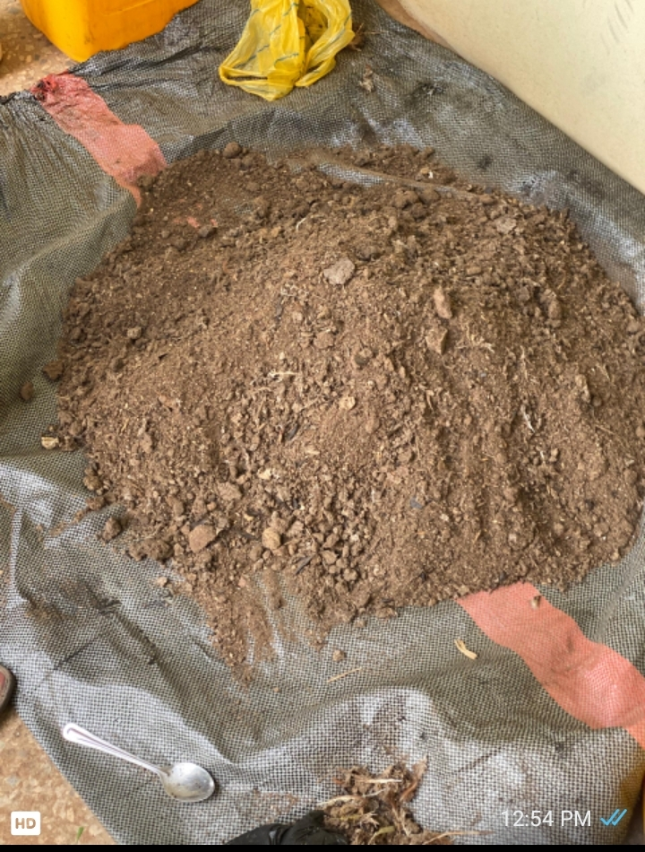

Plate 1 :Undigested Substrates
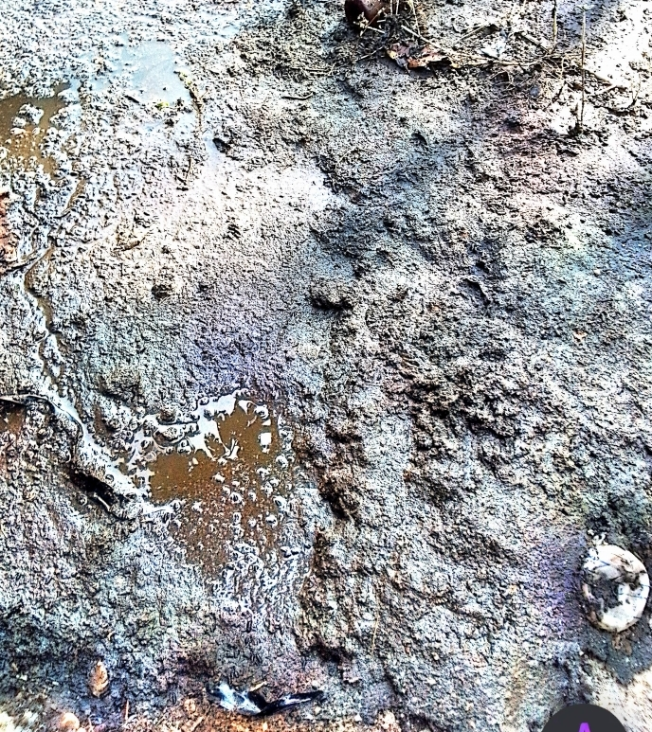

Plate 2: Digested substrates

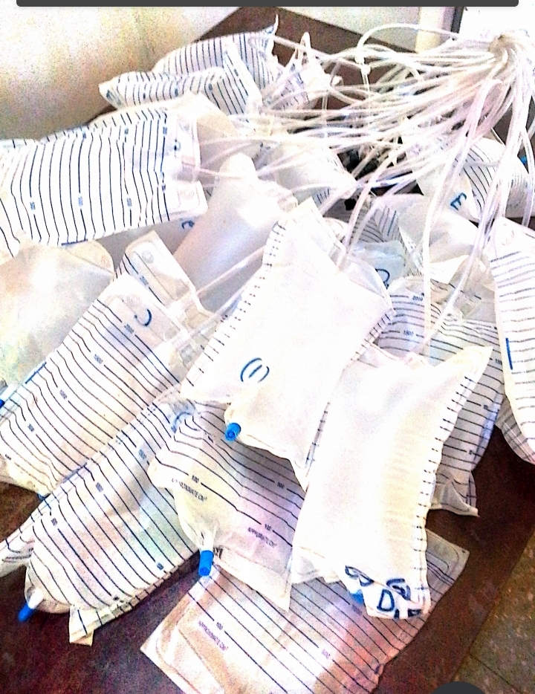
Plate 3 : Raw Bio Methane
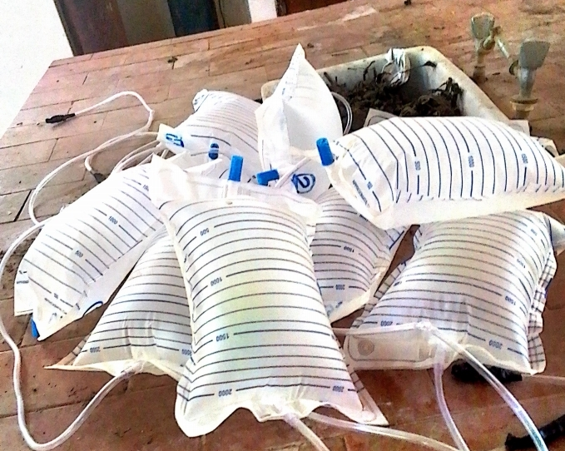

Plate 4: Purified Bio Methane

3.3.0 SAMPLE COLLECTION AND PREPARATION

3.3.1 Sample Collection
The chicken dropping was collected from Mushmin farm Gidangiye, Tsafe local Government, Zamfara State, Nigeria while high grade, titanium oxide (TiO₂), Copper nitrate (Cu(NO₃)₂.3H₂O), Iron nitrate (Fe(NO₃)₃.9H₂O), and Zinc nitrate (Zn(NO₃)₂.6H₂O) were purchased from chemical vendor in sokoto.

3.3.2 Sample Preparation
The sample collected was properly dried on a drying bed and further grounded to powdered (Ofoefule et al.,2005).The slurry was prepared by measuring 2500g of chicking dropping into 12500ml of water, mixed and fill in to 25liters anaerobic digesters with occasional agitation as described by Bajah and Garba (1992).

3.3.3 Catalysts synthesis( Cu/TiO₂)
The 10% Cu/TiO₂ catalyst was prepared using wet impregnation method by dissolving 4.28g of copper (ii) nitrate trihydrate in 50 mL of deionize water to form an aqueous solution, and 20g of Titania powder was gradually added to the aqueous solution while stirring at 200 r.p.m. The mixture was then stirred at 400 r. p.m. and 70 ^{O}C using a hot plate magnetic stirrer to evaporate all the water, leaving behind a wet solid catalyst that was dried overnight at 80ºC in the oven. The resulting Cu/TiO₂ catalyst was calcined at 500ºC for 5 hours (Gurbaniet al., 2009; Mudi et al., 2023).

3.3.4 : Catalyst synthesis(10%Fe/TiO₂)
The 10%Fe/TiO₂ catalyst was prepared using wet impregnation method by dissolving 4.28g of copper (ii) nitrate trihydrate in 50 mL of deionize water to form an aqueous solution, and 20g of Titania powder was gradually added to the aqueous solution while stirring at 200 r.p.m. The mixture was then stirred at 400 r. p.m. and 70 ^{O}C using a hot plate magnetic stirrer to evaporate all the water, leaving behind a wet solid catalyst that was dried overnight at 80ºC in the oven. The resulting Cu/TiO₂ catalyst was calcined at 500ºC for 5 hours (Gurbaniet al., 2009; Mudi et al., 2023).

3.3.5 : Catalyst synthesis(10%Zn/TiO₂)
The 10%Zn/TiO₂ catalyst was prepared using wet impregnation method by dissolving g of copper (ii) nitrate trihydrate in 50 mL of deionize water to form an aqueous solution, and 20g of Titania powder was gradually added to the aqueous solution while stirring at 200 r.p.m. The mixture was then stirred at 400 r. p.m. and 70 ^{O}C using a hot plate magnetic stirrer to evaporate all the water, leaving behind a wet solid catalyst that was dried overnight at 80ºC in the oven. The resulting Cu/TiO₂ catalyst was calcined at 500ºC for 5 hours (Gurbaniet al., 2009; Mudi et al., 2023).

3.3.6 : Catalyst Characterization
a) XRF Analysis: The catalytic performance was determing by measuring the catalyst chemical composition using X-supreme 8000 fluorescence machine at department of chemistry, multi user science laboratory, Ahmadu Bello University Zaria.

b) Fourier transform-infra-red (FT-IR) analysis
The FT-IR analyses was carried out using at the Center for Advanced Science Research and Analytical Services (CASRAS), Usmanu Danfodiyo University, Sokoto using an agilent Cary 630 FT-IR spectrometer with a base system of a high infrared radiation emission. The base is used in conjunction with 5-bounce diamond ATR sampling accessories of internal reflection element (IRE) crystal. The analysis was carried out in the transmittance mode and the signal collected within the range of 4000 – 650 cm⁻¹ wave number. The sample scan was 32 while the background scan was also 32 and the resolution was set at 4. The generation of sample spectra was achieved through microla software.
c) X-ray diffraction (XRD)
The powdered X-ray Diffraction (PXRD) analysis was carried out using the Rigaku MiniFlex 6G equipped with the Rigaku SmartLab Software Situated at Central Advance Science Laboratory Complex (CASLAC), Usmanu Danfodiyo University, Sokoto. The measurement was carried out with Cu-Kα radiation (40Kv, 15mA) using a Sc-70 detector recorded over 3 – 90º 2 range at a speed of 10.00º/min. The basal spacing (d001) values were also determined from XRD patterns.
d) Thermo-gravimetric analysis (TGA)
TGA was used to examine the thermal stability of the rice husk and egg shell catalysts. A PerkinElmer TGA 800 equipment was used to carry out thermo-gravimetric analyses of the samples. About 17.5 mg of the catalyst was placed on the zeroed sample pan, nitrogen flow switched on and the sample loaded onto the furnace.
Thermo-gravimetric analysis was performed on the catalysts under nitrogen atmosphere (purity 99.9%) and the temperature ramped from 25°C to 800°C at a rate of 10°C per minute. During TGA analyses, sample weight changes over the temperature range are continuously recorded as the gaseous products are removed.
e) Surface area and pore volume determination
The surface area, pore width and pore volume analyses of the prepared catalysts were determined using N₂ adsorption isotherms at 77.35K using Quantachrome Instrument (Version 11.03) The samples were degassed for 3 hours at 250ºC in a vacuum. The surface area was was determined using multiple point Brunauer-Emmet-Teller (BET) method. The pore volume and pore size were estimated using Barrett-Joyner-Halenda (BJH) method (Brame and Griggs et al., 2016)
3.3.7 : Experimental set up for biogas production
The experimental set-up consisted of two unit, namely, the digester slurry where the biogas is generated and the biogas collection unit where the biogas is collected,measured and stored using the principle of water displacement in a urine bag.
- Digester Description
A 2-litre and 25 litre plastic Jerry can was used as digesters for preliminary biogas production as well as the main biogas production respectively (plate 5 and 9). A hole was bored on the lid and one end of the PVC hose pipe (20 mm internal diameter and 20 meters length ) was inserted through the hole and glue with araldite adhesive and ensure air tight fitting so that no air was allowed to either seeps in or out of the digesters as described by Babatola (2008). The fee end of PVC hose pipe serves as the gas out let from the digesters (plate 5 and 9)
- Description of biogas collection unit.
The biogas collection unit consisted plastic Jerry can (digesters) hose pipe and urine bag. The urine bag is connected to the hose pipe through the digester where the biogas is collected and stored. (plate 5 and 9).
3.3.7 :Catalyst testing for biogas production
Preliminary production of biogas was conducted using 100 g of the substrate in to 500 dm³ of water, mixed and fill into an anaerobic digester with occasional agitation to obtain the slurry as describe by Bajah and Garba (1992). The doped and undoped titanium oxide (TiO₂) catalysts were mixed into different samples at different concentrations. Two liters digesters and urine bags were used for gas production and collection respectively.

The plates 5-8 illustrate the biogas production set-up using 100g substrates (catalyst testing).
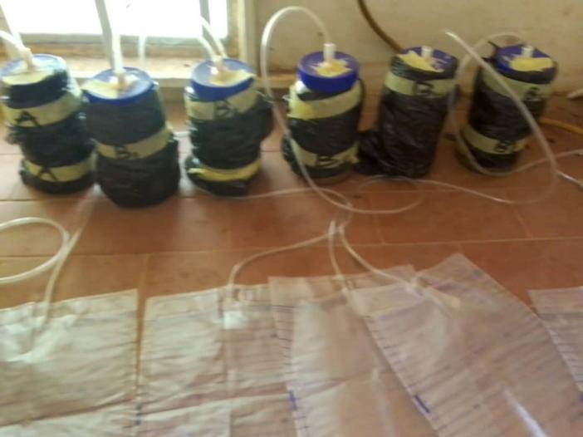

Plate 5: Biogas production using TiO₂ at control, 0.2g, 0.4g, 0.6g, 0.8g

and 1.0g catalyst loading (A, B1 to B5).

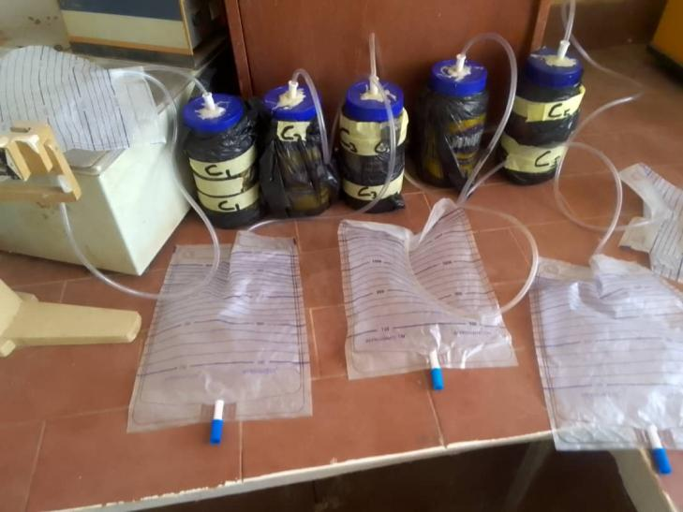

Plate 6: Biogas production using CuO/TiO₂ at 0.2g, 0.4g, 0.6g, 0.8g and 1.0g catalyst loading (C1 to C5)
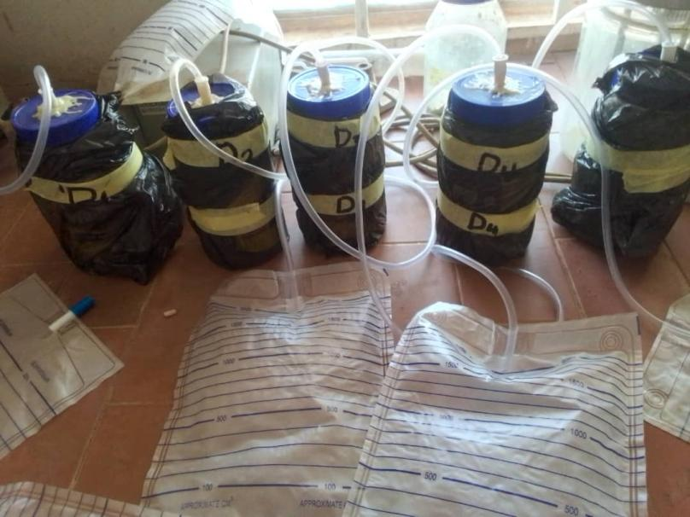

Plate 7: Biogas production using FeO/TiO₂ at 0.2g, 0.4g, 0.6g, 0.8g and 1.0g catalyst loading (D1 to D5)

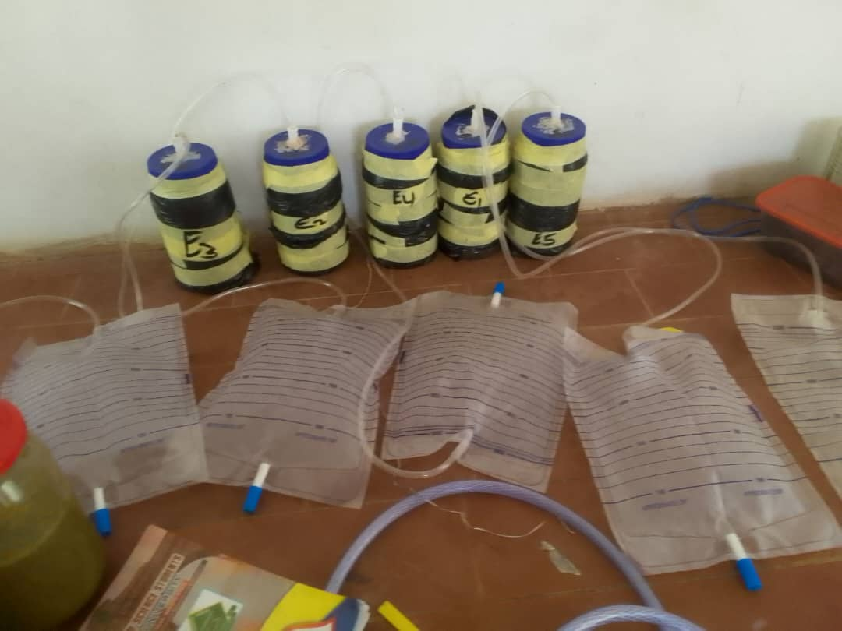

Plate 8: Biogas production using ZnO/TiO₂ at 0.2g, 0.4g, 0.6g, 0.8g

and 1.0g catalyst loading (E1 to E5).

.

.The plate 9- 13 illustrate the biogas production set up using 2500g chicken substrates
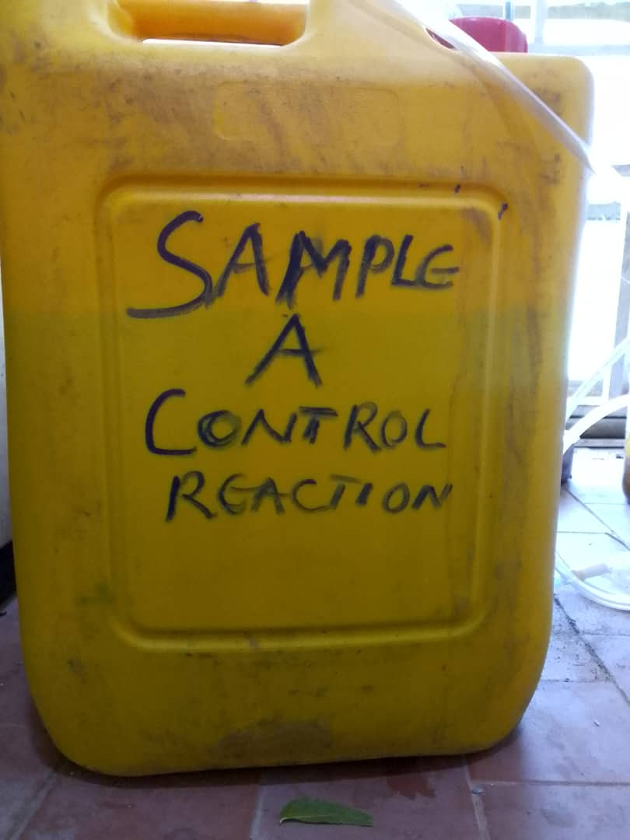

Plate 9: biogas production using control sample A
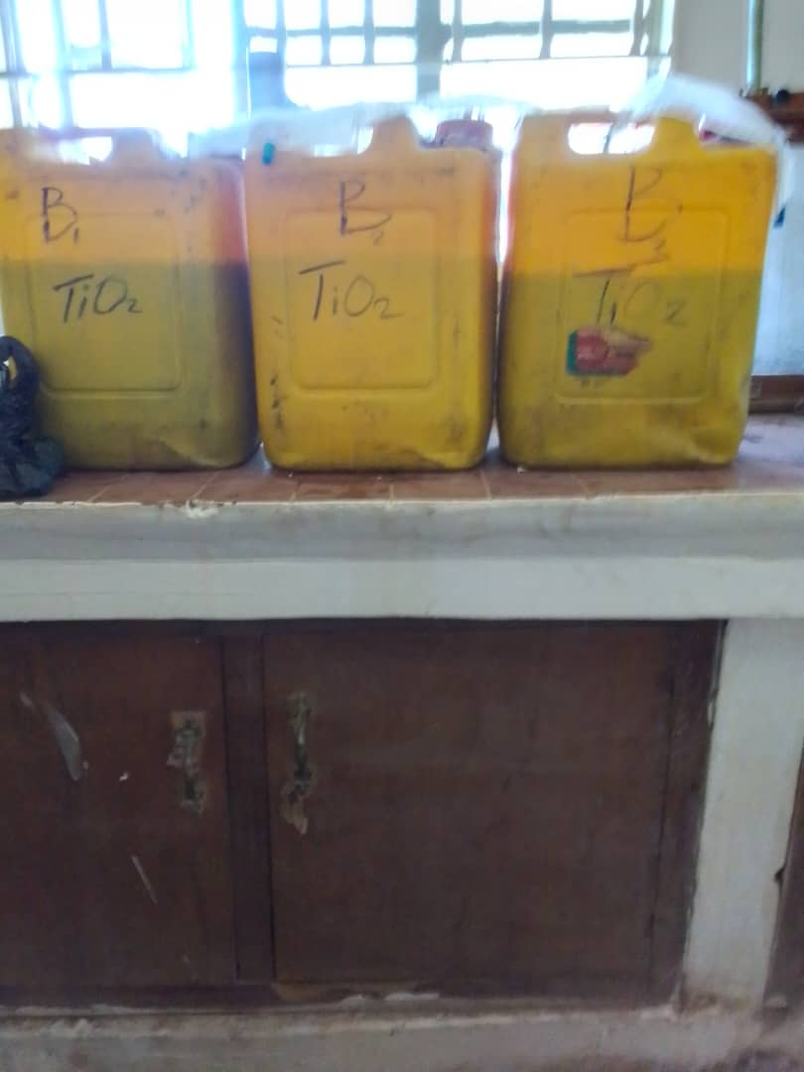

Plate 10: Biogas production using un-doped TiO₂ at, 5g, 10g, 15g catalyst loading (B₁-B₃)
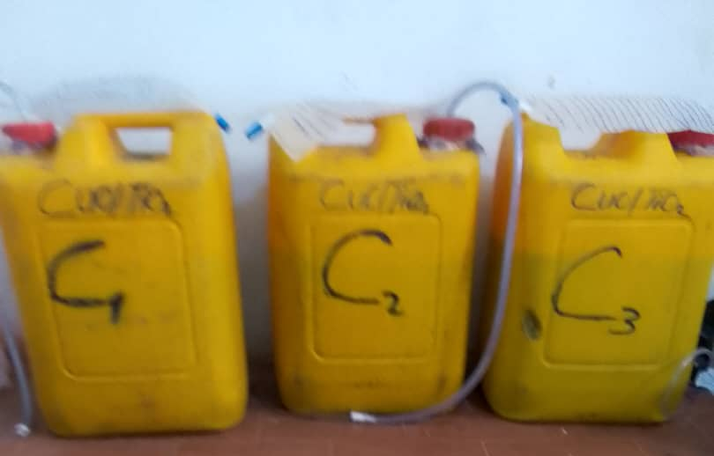

Plate 11: Biogas production using Cuo/Tio₂ at 5g, 10g, 15g catalyst loading (C₁-C₃)
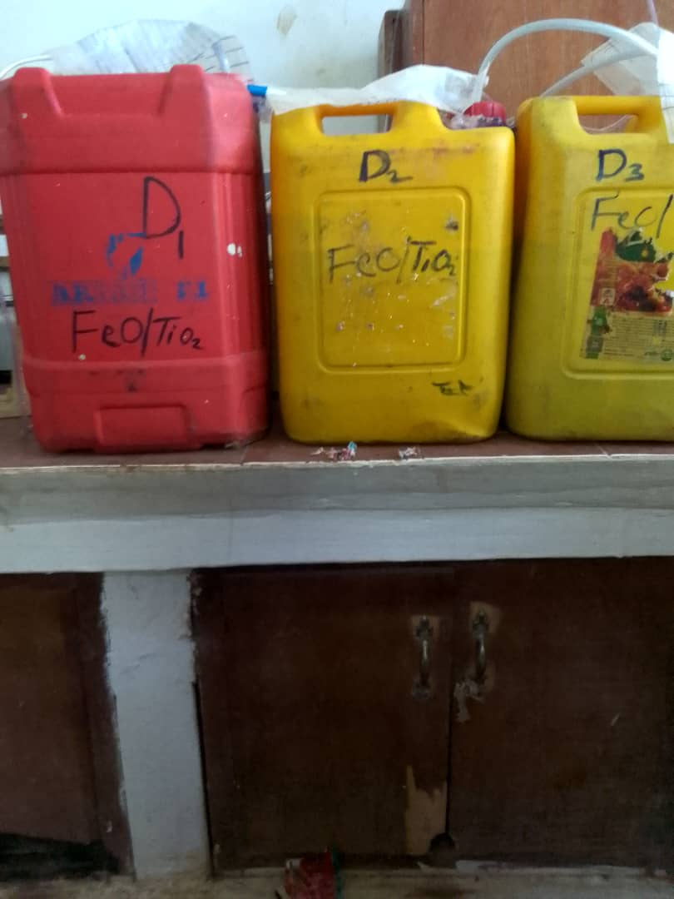

Plate 12: Biogas production using FeO/Tio₂ at 5g, 10g, 15g catalyst loading (D₁-D₃)
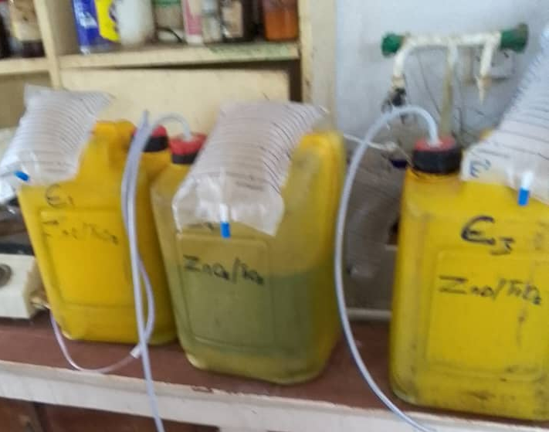

Plate 13: Biogas production using ZnO/Tio₂ at 5g, 10g, 15g catalyst loading (E₁-E₃)

3.3.8 Experimental Set-Up for biogas purification and storage
In this set-up,the biogas slurry digesters was connected through scrubbers for the removal of moisture,hydrogen sulphide and carbon (iv) oxide and the purified bio-methane is collected and stored in urine bags.The slurry-was prepared by thoroughly mixing 2500g chicken dropping substrates)with 12500ml of water to form the slurry in 25L anaerobic digester and the substrate to water ratio is 1:5.The digester was closed with PVC hose pipe-fitted lid as the biogas outlet.The lid was screw with polythene bag to ensure that ,there is no gas leakage from the lid.The free end of the PVC hose pipe of the digester slurry was connected was connected to a 2Lcylindrical container containing 83g of silica gel for absorption of moisture (moisture scrubber).The out let PVC pipe from the moisture scrubber was then connected to a 2L plastic container containing 83g of iron filling for absorption of hydrogen sulphide(hydrogen sulphide sulphide scrubber) .The outlet PVC hose pipe from the hydrogen sulphide scrubber was also connected to a 2Lcylindrical plastic container containing 83g of calcium oxide for absorption of carbon iv oxide (carbon dioxide scrubber).Similarly the out let PVC hose pipe from carbon(iv) oxide scrubber was connected to a 2000cm³urine bag.Therefore as the biogas was generated it was passed through the moisture scrubber where moisture was removed ,the moisture free gas was passed through the hydrogen sulphide scrubber where the hydrogen sulphide was removed.Finally the water and hydrogen sulphide free gas was passed through the carbon (iv) oxide scrubber where the CO₂ was removed leaving only pure bio-methane to collect and stored in urine bag. Plates 14-17 outlined the biogas purification set-up using different catalyst
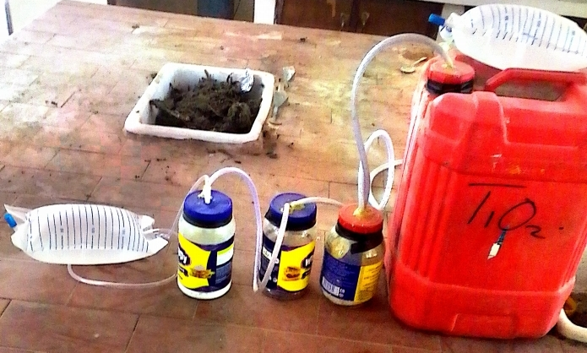

Plate 14: Biogas purification Titanium oxide catalyst (TiO₂)
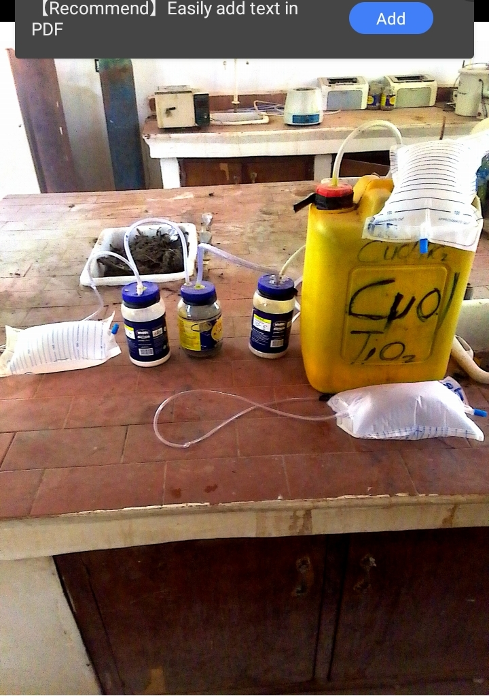

Plate 15: CuO/(TiO₂)
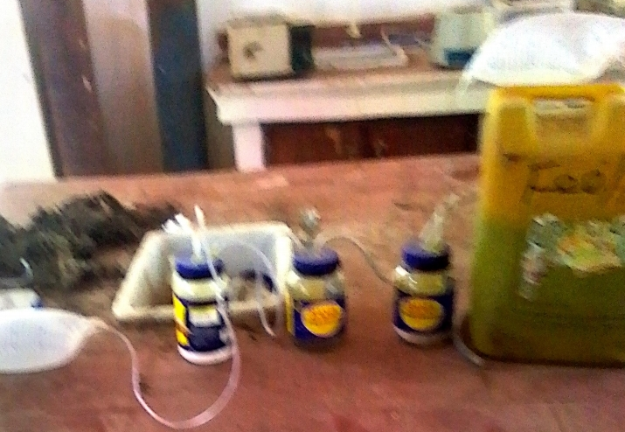

Plate 16: FeO/TiO₂ catalyst.
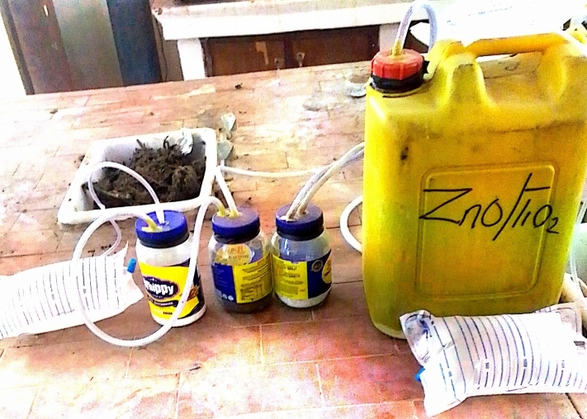

Plate 17 : Zinc oxide doped titanium oxide ( ZnO/TiO₂)

3.3.9. Combustibility Test : Combustibility test was conducted in sokoto energy research center using the bur sen burner as combustibility tester as shown in plate 27 below.The bur sen burner was connected to PVC hose pipe and the hose pipe was in turn connected to the urine bag where the gas flow to the bur sen burner for combustion.The combustibility of purified bio methane and raw biogas was tested.The bio methane gas was compressed manually using hand to allow easy flow from the urine bag to the tester (bunsen burner ).In the raw biogas from the sample containing titanium oxide (TiO₂), copper-oxide doped titanium oxide ( CuO/TiO₂), iron oxide doped titanium oxide (FeO/TiO₂) and zinc oxide doped titanium oxide (ZnO/TiO₂), 1800 cm³ each of the gases was subjected to combustibility test by igniting the biogas in the bun sen burner (tester) ,blue flame similar to that of liquefied natural gas (LNG) was observed for 1 minute 30second except the sample containing zinc oxide dopoed titanium oxide ( ZnO/TiO₂ ) which burnt for 1minute 13 second.Similarly 1800 cm³ each of purified bio methane was ignited in the tester and found to be highly combustible,burning with blue colouration for about 1minute similar to that of liquifed natural gas (LNG) was observed except the sample containing iron oxide doped titanium oxide (FeO/TiO₂) and zinc oxide doped titanium oxide ( ZnO/TiO₂) which burnt for 56 second and 58second respectively.

3.3.9 : Determination of proximate composition of the samples
The assessments of the potential of biogas production of the substrates was conducted using the following parameters before and after digestion of each substrates: moisture contents, total solids, volatile solid contents, ash content, carbohydrate, crude fiber, crude lipid, crude protein and elemental composition (nitrogen, phosphorus, carbon, potassium) carbon to nitrogen contents as recommended by AOAC (2016).

3.3.10 : Determination of the moisture content
The moisture contents was determined using oven drying machine, as follows: 2 g of the sample was weighed and subsequently heated at a temperature of 105 ºC to allow for the release of moisture. Following this, the sample was cooled in a desiccator before reweighing. Moisture content was calculated by the difference in wet and dry weight.

3.3.11: Determination of the total solid
Total solid simply refers to as organic and inorganic matter present in the feed stock, it represents the solid after drying. The liquid present in the sample was evaporated and 2 g was measured from the residue obtained and placed in a dried crucible at 105 ºC in a drying oven for one hour follow by taking it out and cool in a desiccator at room temperature, the total solid content was calculated using equation 1.
Total solid (%) = $\frac{M2−M3}{M2−M1}$ ×100 ------------------------------------------1
Where:
M₁ =mass of empty oven – dried crucible
M₂ = mass of crucible + sample
M₃ = mass of crucible + residue

3.3.12 Determination of volatile solid.
The volatile solid content of the sample was determined by measuring 2 g of the residue obtained from the determination of the total solid and placed in a silica crucible and ignite in a muffle furnace at 550 ºC for 30min follows by taking the crucible out of the muffle furnace ,partially cool in air and kept in desiccator for few minute and then weigh. The volatile solid was calculated using equation 2
Volatile solid ( %) == $\frac{M2−M3}{M2−M1}$ ×100 ------------------------------------------ 2
Where:
M₁ =mass of empty oven – dried crucible
M₂ = mass of crucible + sample
M₃ = mass of crucible + residue

3.3.13 Determination of the ash content.
The ash content of the sample was determined by drying a porcelain crucible in an oven for 10 min at 105 ºC, cool in a desiccator and dry weight M_{1,} 2 g of the sample was measured in the porcelain crucible and reweighs M_{2,} the crucible containing the sample was incinerated in the furnace for 3 hrs at a temperature of 550 ºC to ensure accurate and proper ashing. The crucible was removed and allow to cool in a desiccator and weigh M₃. The ash content in percentage was calculated using the equation 3
Ash Content 100 (%) =$\frac{M3−M1}{M2−M1}$ × 100 --------------------------------------------- 3
Where:
M₁ =mass of empty oven – dried crucible
M₂ = mass of crucible + sample
M₃ = mass of crucible + residue

3.3.14 Determination of crude fiber
2.0 g of the sample was placed in a conical flask (0.25 cm³) and weighed (M₀). H₂SO₄ (.002dm^{3,} 1.25% v/v) was added to the sample and boiled gently for 30 minutes .The mixture was filtered through muslin cloth over 9cm buchner and then rinsed with hot distilled water. The materials was scraped back in to the flask with a spatula and boiling NaOH (0.02 dm^{3,} 1.25 % v/v) was added and allowed to boils gently for one minute, the material was again filtered through muslin cloth. T\he sample was allowed to drain, dried and then scrapped in to a crucible and dried over night at 150 ºC in the oven, it was then cooled in a desiccator and weighed ( M₁). The sample was ash in a furnace at 500 ºC for 90 minute, dried in a desiccator and weighed ( M₂). The crude fiber was calculated using the equation 4
Crude fiber (%) =M₁₋M₂/X 100 ---------------------------------------------- 4
Where
M₁ = mas of empty oven – dried crucible
M₂= mas of crucible + sample

3.3.15 Determination of carbohydrate content
The carbohydrate content of the samples was determined by considering the difference obtained after summation the value of percent moisture content (%MC), percent ash content (%AC),percent lipid content (%LC), percent protein content (%PC) and percent crude fiber content from 100 % total dry matter
% Carbohydrate- (%MC+%AC+%LC+PC+%CFC) --------------------------------------------- 5

3.3.16 Determination of crude lipid
The crude lipid content of the sample was calculated using Soxhlet extraction method as recommended by AOAC (2016). 5g of the sample was transferred in to 0.5 dm³ round bottom flask containing a few gram of anti-bumping granules and weighed (W₁) all together. The fat content of the sample was extracted in 0.1 dm³ of di-ethyl ether at 40 ^{O}C to 60 ºC for 6 hrs attached in the flask to the Soxhlet extractor at reflux, the filtrate-was concentrated, diethyl ether recovered and the oil in the round bottom flask was dried in an oven, the oil and round bottom flask weighed as (W₂) .The percentage of crude lipid content was calculated using the equation 6
% Crude lipid = W₂-W₁/W₁ X100------------------------------------------------ 6

3.3.17 Determination of Percentage Crude Protein
The percentage crude protein was estimated using the equation 7
% crude protein = % N x 6.2------------------------------------------------------ 7

3.3.18 Determination of Elemental Composition of the Substrates
Determination of elemental composition will focus strictly on (carbon, nitrogen, phosphorus and potassium) because they seriously affect biogas production and digested slurry as bio fertilizer.

3.3.19 Determination of percentage nitrogen
The elemental nitrogen was determined using the Kjeldahl method as follows: 2 g of the sample was placed in to a 0.3 dm³ Kjeldahl flask and digested with 0.02 dm³ concentrated sulfuric acid (H₂SO₄). Catalyst was used and a clear solution was observed, the digest was allowed to cooled and diluted with 0.25 dm³ distilled water and transferred in to 0.5 dm³ Kjeldahl flask containing anti bumping chip and 0.4 dm³ of 40 % NaOH. The distillate from the solution was transferred in to a collecting liquid (0.25 dm³and 2 % boric acid and a few drop of mixed indicator) by immersing the end of the condenser inside the liquid to trap the gaseous ammonia being liberated. The resulting liquid was then back- titrated against 0.01 M hydrochloric acid until the end point violet color was reached and percentage nitrogen was calculated using the equation 8
N (%) = 14 X M X V₁ X V_{100/} W_{s}xVa -------------------------------------------------------------------------- 8
Where :
M = molarity of the acid (HCl)
V₁= total volume of the diluted digest
V₁₀₀ ₌ is the titre value (cm³) of (HCl) used
W_{s=} weight of sample (g)
V_{a}= is the aliquot volume distilled

3.3.20 Determination of Potassium
The potassium content of the sample was calculated using the standard flame photometer method. 50 cm³ of 0.0I M ammonium acetate was added to 10 g of the sample .The sample was leached with an additional 50 cm³ of 0.01 ammonium acetate and made up to the volume of 100 cm³ .The sample solution and the standard potassium solution were inserted in to the flame photometer and the readings were noted dawn using K-filter. The procedure was repeated three times and the average value are reported.

3.3.21 Determination of Percentage Carbon
The percentage carbon content was calculated using the equation as described by Bagudo et al,. (2008).
C ( %) = 0.5 x organic matter ------------------------------------------------------- 9

3.3.22 Determination of Carbon to Nitrogen Ratio
The carbon to nitrogen ratio ( C:N) was evaluated by calculating the ratio of organic carbon content to that of nitrogen content (Bagudo et al., 2008)

3.3.23 Determination of pH and temperature
The pH of each slurry was determined by using pH meter while the temperature of each of the slurries from thirteen (13) anaerobic digesters was measured using thermometer.

CHAPTER FOUR

4.0 RESULTS AND DISCUSSION

4.1 Results
The results of the experimental various analysis carried out are presented in five categories, (a) proximate and elemental analysis (b) catalyst characterization © preliminary biogas production(catalyst testing) (d) biogas production (e) purification and storage of bio-methane (f) combustibility test.

4.1.1 Results of the Proximate Analysis

4.1.2 Proximate Analysis: Proximate analysis of the substrates for biogas production involves the determination of key parameters that give indication for potential of the substrates to produce biogas and the resulting slurry after digestion is for agricultural activities as bio-fertilizer.
The results of the proximate analysis is presented in Table 2

Table 4 : Result of the proximate analysis before and after digestion of the substrate (%)
Parameter (%) | Before digestion | After digestion | Difference
Moisture content | 5.5 (%) | 13.5 (%) | 8.0 (%)
Ash contents | 38.5 (%) | 27.0 (%) | 11.50 (%)
Total solid | 59.60 (%) | 49.30 (%) | 10.30 (%)
Volatile solid | 61.50 (%) | 47.90 (%) | 13.60 (%)
Crude fiber | 6.5 (%) | 2.50 (%) | 4.00 (%)
Crude lipid | 1.0 (%) | 0.40 (%) | 0.60 (%)
Crude protein | 39.9 (%) | 19.40 (%) | 21.5 (%)
Carbohydrate | 37.00 (%) | 14.0 (%) | 23 (%)
Total carbon | 27.70 (%) | 29.80 (%) | -2.10 (%)
Total nitrogen | 1.08 (%) | 1.43 (%) | -0.35 (%)
Carbon to Nitrogen Ratio | 25:1 (%) | 30:1

4.1.3 Moisture Content
Moisture content value is favorable in biogas production as recommended by Bagudo et al., (2008), high moisture will result in early digestion. The results in table (1) obtained in this work revealed that the moisture content before and after digestion were 5.5(%) and 13.5 (%) respectively. Analysis of this research work show that the moisture content of the substrates increased by 8%, that is to say the anaerobic digestion process has increased the moisture retention capacity of the substrates. Since the moisture contribute to early start of digestion of substrates, it is expected that the biogas production process will start very early. This is actually the case since all digesters started production from the first week after the set up.

4.1.4 Ash content
The ash content of the substrate before and after anaerobic digestion were 38.5 (%) and 27 (%) respectively.(Table 1) This means that there was a decreased in ash content by 11.5% . Ash can be defined as a non volatile inorganic matter of a substance which remain after subjecting it to a high decomposition temperature. Ash content played an important role in biogas production process because it show the presence of some elemental composition like N,P and K which point to the fertilizer potential of the substrates. Gizegorzet al., (2015) had said that high ash content of between 50-55% reduce the biogas production potential as only organic matter can be converted to biogas. But the result obtained in this research work were not up to 50-55 % meaning that biogas production will be favored since the value of ash fall within the range 27- 39 %

4.1.5 Total solid: The result presented in Table (3) showed that the total solid before and after anaerobic digestion were 59.60 (%) and 49.30 (%) respectively, this shows that there was difference between the total solid of the digesters before and after digestion. meaning that some of the solid have been converted to biogas. This result is in line with the work of Adeniran et al., (2014). who reported a decreased in the value of total solid after anaerobic digestion.

4.1.6 Volatile solid: volatile solid is left out after a total removal of moisture and ash content.There fore volatile solid are basically the organic matter contained in the substrate which are the main sources of biogas production because the micro-organisms act on them to produce biogas. The value of volatile solid before and after anaerobic digestion as presented in table (1) in table were 61.5 (%) and 47.9 (%)respectively, this show a decreased of 13.6%. There was a difference in the value of volatile solid of the substrate before and after anaerobic digestion. The reduction in this value may be as a result of volatile solid that are being converted in to biogas production. This is in accordance with finding of Bagodo et al.,(2008) .In-fact this provide a convincing evidence why chicken dropping produced high quality bio-methane at a faster rate when compared with other substrates. I used 100g chicken dropping when I was carrying out preliminary production, another lady (under graduate) equally used 100g cow dung, the production set up was conducted the same day but gas production was observed five days ahead.

4.1.7 Crude Fiber, Crude Lipid, Crude Protein and Carbohydrate
In anaerobic digestion process Carbohydrate are converted to sugars, lipid are broken dawn to long chain fatty acids and protein are split in to amino acids (Guumisiriza, et al ., 2017). These soluble molecules are converted by acetogens to acetic acids and other longer volatile fatty acids, alcohol, carbon dioxide and hydrogen on acitogenesis. Therefore the acids produced includes : Acetic acid (CH₃COOH), propanoic acid (CH₃CH₂COOH), butyric acid (CH₃CH₂CH₂COOH) and ethanol (C₂H₅OH).
The Crude fiber, Crude lipid, Crude protein and Carbohydrate content of the substrates before digestion and the corresponding value for the substrate after digestion are presented in table (1). The values of the substrates before digestion are 6.5%, 1.0%, 39.9% and 37.% respectively after digestion the value reduced to 2.5%, 0.4%, 18.4% and 14% respectively. This show that 4%,0.6%,21.5% and 14% ( Crude fiber, Crude lipid, Crude protein and carbohydrate) had been used up for biogas production.
The crude lipid content of the substrate is very low being being 1.0 (%) before digestion after digestion the crude lipid content reduced to 0.4 (%), this shows a 60% conversion of crude lipid content of the substrates to biogas.
The crude protein content of the substrate also reduced from 39.9% before digestion to 21.5% after digestion this show a conversion rate 18.4%,however the carbohydrate content decreases from 38% to 14% before and after digestion, this show that the carbohydrates content of the substrates have been converted to sugars and later to biogas.

4.1.8 Total Carbon: The results presented in table (1) revealed that, total carbon value of the substrates before and after digestion were 24.70 (%) and 29.80 (%) respectively before and after digestion. Organic matter content of the substrates affect biogas production, low organic matter contents would result in low biogas yield and high organic matter content would result in more yield of biogas, this is obviously true because microbes acquire carbon for their food and utilize nitrogen for the enrichment of their tissues as described by Tambuwal, (2005) and Bagudo et al., (2008). The results obtained in this research work show that there is an increased in the carbon content of the substrates after digestion, meaning that high yield of biogas production would be achieved.

4.1.9 Total Nitrogen: The result presented in table (1) showed the total nitrogen value before and after digestion as 1.08 (%)and 1.43 (%) respectively. There was no much difference between the nitrogen content of the substrates before and after digestion. The result obtained in this work is in line with the work of Yavini et al., 2014) who stated that the main problem with anaerobic digestion of chicken residues is that most of the residues are lignocellulosic biomass with low nitrogen content.

4.1.10 Carbon to Nitrogen (C/N )Ratio : The optimal carbon to nitrogen (C/N ) ratio for anaerobic degradation depend solely on the substrate used, but a value between 20-30 has been recommended (Kwietniewska and Tys, 2014). when a substrate have low carbon to nitrogen (C/N ) ratio, it is expected to contained relatively high ammonium concentration, inhibiting microbial growth and the anaerobic digestion ( Borja et al., 1996 ). In addition, anaerobic reactors treating waste water rich in nitrogen tend to have high pH value ( Borja et al., 1996 ). At high pH value free ammonia dominates and this form is more inhibitory than the ammonium ion (NH₄).( Rajagopal et al., 2013). There fore the carbon to nitrogen (C/N) ratio and pH play an important role in anaerobic digestion process for optimum biogas production .The pH influences the chemical equilibria of ammonia ( NH₃), hydrogen sulphide (H₂S) and volatile fatty acids (VFA) , which could inhibit the activity of microorganisms. The ideal pH range for anaerobic digestion has been reported to be 6.8 -7.4 (Khalid et al., 2011) .Other reports have shown that the benefit of improving methane yield from anaerobic digestion of chicken dropping substrates based on optimized feeding composition and carbon to nitrogen ratio ( C/N) of 25:1 and 30 :1 had similar highest cumulative biogas production about three fold high than that from materials with a carbon to nitrogen (C/N) ratio of 15:1 (Wang et al., 2012).

The results in table (1) revealed that the carbon to nitrogen (C/N) ratio before and after digestion were 24.65:1.08 and 29.80 :1.43 respectively. This result shows that both the digested and undigested substrates are within the optimum carbon to nitrogen ratio,(Wang et al.,2012). How ever,it can be seen clearly that there is a significance increased in carbon to nitrogen content after anaerobic digestion, this implies that there is an increases in biogas yield and this results is in line with work of Rabah et al., (2010) who noted that carbon to nitrogen ratio in anaerobic digestion increases the biogas production.

Table 5: pH of the Undigested and Digested Substrates
Table 2 revealed the pH value of all the slurries before and after the anaerobic digestion in all the digesters. The difference of the pH was calculated between undigested and digested slurries as follows : A(0.3)B₁(0.8) B₂(0.9) B₃(0.5) C₁ (1.0) C₂(0.5) C₃ (0.4) D₁ (0.4) D₂ (0.9) D₃(1.4) E₁ (-0.3) E₂ (0.3)E₃(0.9).
Substrates | Undigested | Digested Difference
A₁ | 6.6 | 6.3 0.3
B₁ | 6.7 | 5.9 0.8
B₂ | 6.8 | 6.0 0.9
B₃ | 6.9 | 6.4 0.5
C₁ | 6.8 | 5,8 1.0
C₂ | 6.9 | 6.4 0.5
C₃ | 6.8 | 6.4 0.4
D₁ | 6.7 | 5.8 0.9
D₂ | 6.8 | 6.1 0.3
D₃ | 6.9 | 5.5 1.4
E₁ | 6.7 | 7.0 -0.3
E₂ | 6.8 | 6.5 0.3
E₃ | 6.7 | 5.8 0.9

The pH difference are all shifted to the positive direction that is acidic medium except for substrates (E2) which shifted to the negative direction with value of (-0.3) which is slightly less acidic. The pH range for the undigested slurries is 6.6 - 6.9 while that of the digested slurries is 5.5-7.0 and the largest pH change from undigested to digested is 1.4 that is 5.5 to 6.9 . This clearly shows that the pH remain within the optimum range of 6-7. The pH value of the digested slurries is slightly lower than that of undigested ones. The decreased in the pH value of the digested slurries as compared to undigested may be attributed to the formation of the sulphide (s₂) in the slurries due to breaking dawn of the biodegradable Sulphur containing organic and in organic compound and also it might be as a result of formation of organic acids by acetogens during digestion process (Bagodo et al., 2011) .The neutral pH between 6 and 7 has been found favourable for optimum bio gas production (Zuru et al., 1998).

4.1.11 Elemental Composition:The results of the elemental compositions are presented in Table 3.

Table 6 : Result of the elemental composition of the digested and undigested slurry

Element (%) | Symbol | Undigested | Digested
Potassium contents (%) | K | 74.32 (%) | 16.00 (%)
Phosphorus contents (%) | P | 4.94 (%) | 3.74 (%)
Nitrogen contents (%) | N | 1.43 (%) | 1.O8 (%)
N.P.K . ratio |  | 1:5:74 | 1:4:16

It can be seen from Table (3) the concentration of the elemental composition reduced in a positive direction.Potassium (K) reduced from 74.32 to 16.00%, phosphorus (P) from 4.94 to 3.74 % and nitrogen (N) from 1.43 to 1.08 %. The addition of water to the substrates to form the slurry can seriously reduced the elemental concentration.additionally these nutrient may be converted to biogas during anaerobic digestion and some of the nutrient could be lost as gas, such as nitrogen as ammonia.The result obtained is in accordance with the work of Hafsat, et al., (2025) who had reported the decrease in the values of elemental composition (K,N,P,Mg and Ca) after anaerobic co-digestion of the birds and broilers substrates.

4.1.12 Catalyst Characterization
Catalyst characterization is an important tool used in catalyst development. It provides information about the catalyst surface properties needed to improve the catalyst performance. This chapter provide information on the catalyst characterization methods carried out on the synthesized catalysts.
X-Ray Diffraction (XRD)
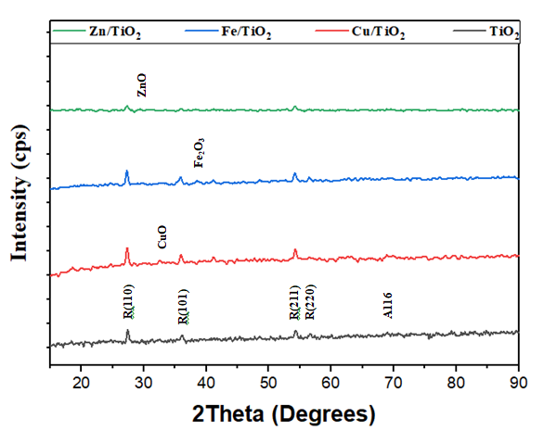

Figure 2 : X-Ray Diffraction (Xrd) of TiO₂, CuO/TiO₂,FeO/ TiO₂ and ZnO/TiO₂ catalysts
The titania (TiO₂) support and supported metal catalysts were analyzed using X-ray Diffraction (xrd) spectroscopy to study their phase composition and crystallinity (Figure 1). Analysis of TiO₂ support reveals the presence of a prominent rutile phases of (110), (101), and (211) with almost no anaphase phase (Abbasi, 2019).
Additional peaks were revealed at 31.8º for ZnO , at 40º for Fe₂O₃) and 35.5º for CuO and these confirm the successful incorporation of Zinc oxide (ZnO), Iron oxide (FeO), and Copper oxide (CuO) metals onto TiO₂ support to form the ZnO/TiO₂, FeO/TiO₂, and CuO/TiO₂ catalysts respectively (Ma, 2015) The observed narrowing of the peaks suggests high dispersion of nanoparticles of the active metals on the TiO₂ support surface (Ma, 2015).
Fourier Transformation Infra-red Spectrcopy (FT-IR)
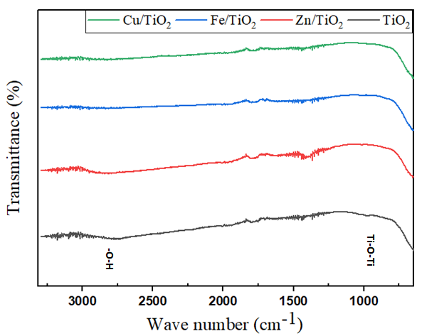

Figure 3: Fourier Transform Infra-Red Spectroscopy (FT-IR) of TiO₂, CuO/TiO₂,FeO/TiO₂ and ZnO/TiO₂catalyst.

The FT-IR analyses (Figure 2) revealed the presence of matching groups such as O-H stretching vibration for hydroxyl group of adsorbed water molecules between 3200 cm⁻¹ -3600 cm⁻¹, Ti-O-Ti vibration for TiO₂ support between 400 cm⁻¹ – 800 cm⁻¹ (El-Maazawi, 2000). However, a slight variation in peak position and intensity for surface hydroxyl group in the metal impregnated catalysts indicate the successful incorporation of Copper oxide (CuO), Iron oxide (FeO), and zinc oxide (ZnO) onto the TiO₂ support to form the CuO/TiO₂, FeO/TiO₂, and ZnO/TiO₂ catalysts respectively (El-Maazawi, 2000).

Table 5: Surface area, pore volume and Metal loading of TiO₂, CuO/TiO₂, FeO/TiO₂ and ZnO/TiO₂ catalysts
Catalyst Surface area (m²/g) Pore volume (cm³) Metal loading (%)
TiO₂ 237.726 0.1168 -
Cu/TiO₂ 182.457 0.165 10.08
Fe/TiO₂ 199.263 0.181 9.98
Zn/TiO₂ 159.133 0.140 10.13

Brunaer –Emmette-Teller (BET) Analysis
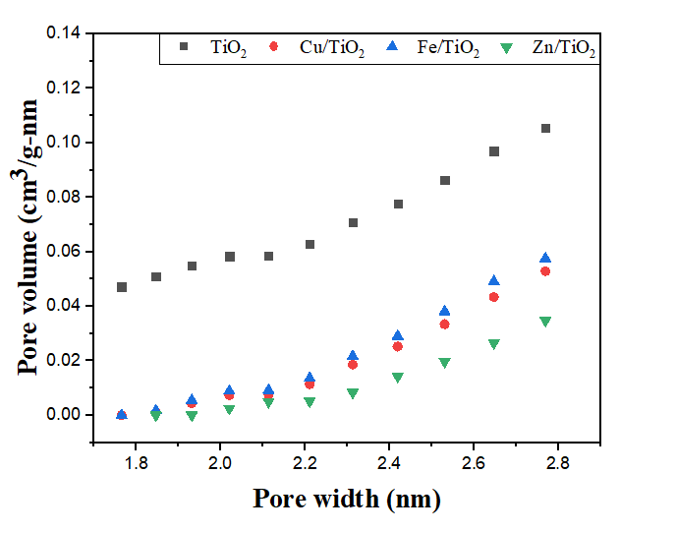

Figure 4: Pore size distribution of TiO₂, CuO/TiO₂, FeO/TiO₂ and ZnO/TiO₂ catalysts
The BET (Brunaer-Emmette-Teller) analysis was used to evaluate the surface area and pore size (width) and pore volume of the synthesized catalysts (Table 1; Figure 3). FeO/TiO₂ have the highest surface area of 199.27 m²/g, followed by CuO/TiO₂ (182.43 m²/g), while ZnO/TiO₂ have the lowest with 159.13 m²/g. Relatively lower surface area in the catalysts compared to the support resulted from the incorporation of the active metals onto the pores of the support (Table )
Figure 3 shows the pore size (width) distribution of all the three catalysts found within the range of 1.8 nm – 2.8nm confirming the presence of both microspores (>2nm) and mesopores ( 2nm – 50nm). Generally, higher surface area leads to availability of metal active sites necessary for a chemical reaction to occur. A higher surface area provides better opportunity for the reactant molecules to interact with one another, thereby increasing the rate of chemical reaction (Bernard, 2021)
Different catalyst pore sizes can facilitate different stages in biogas production. Smaller pores can favour thermogenesis while medium pores favour the growth of acidogenic micro-organisms (Mondal, 2019). The xrf results reveal the actual active metal loading of the catalysts to be 10.08%, 9.98% and 10.13% for Cu/TiO₂, Fe/TiO₂, and Zn/TiO₂ catalysts respectively.
Thermo-gravimetric (TGA) and Diffrential Thermal Analysis (TDA)
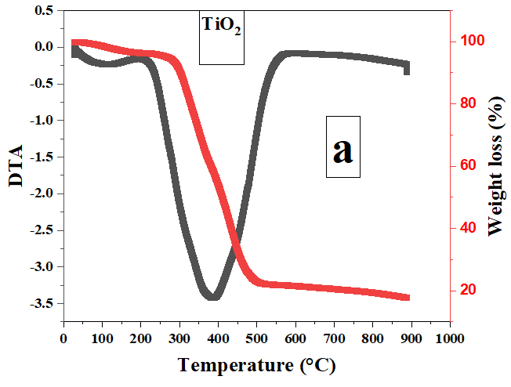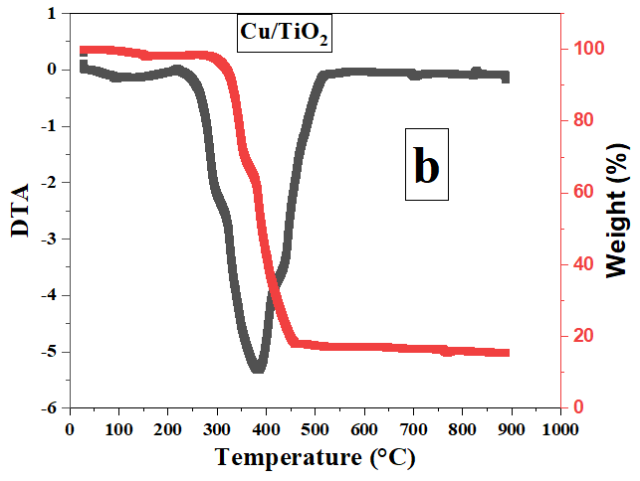
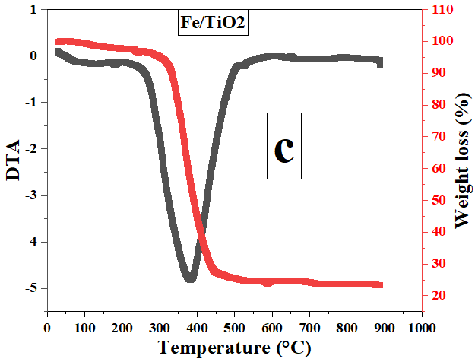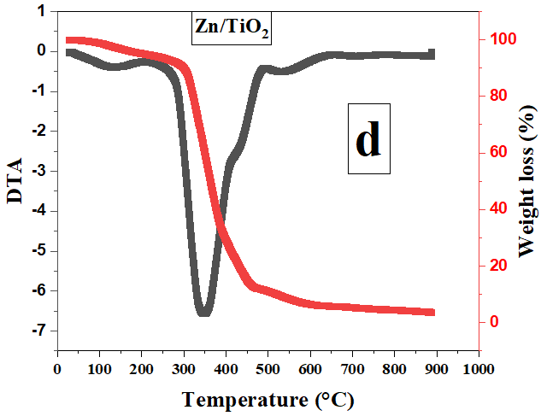

Figure 5 : Thermo-gravimetric (TGA) and Differential Thermal Analysis (DTA) of a) TiO₂ b) CuO/TiO₂ c) FeO/TiO₂ and d) ZnO/TiO_{2.}
Thermo-gravimetric analysis (TGA) was used to study the thermal behavior and stability of the catalysts as a function of temperature while DTA measured the difference between temperature of the sample and reference for the same amount of heat input.
The TGA result for the prepared catalysts showed 3 responses to temperature as shown in Figure 4. A small initial weight loss was visible in all the samples which may be attributed to loss of physisorbed water and the corresponding weak DTA signal is for dehydration. The TGA of the TiO₂ support (a), CuO/TiO₂ (b), FeO/TiO₂ (c), and ZnO/TiO₂ (d) showed significant weight loss of 69-80% between 300 ºC to 500 ºC (Nankya, 2016).
The DTA signal of TiO₂ showed a moderate exothermic minimum close to the main mass loss step which is consistent with residual burnt off and partial restructuring of the TiO₂ support (Figure 4).The DTA of CuO/TiO₂ catalyst showed a deeper exothermic minimum than the TiO₂ support which is in line with the decomposition of copper precursor into CuO on the TiO₂ support. FeO/TiO₂ showed a comparable DTA signal to CuO/TiO₂ while ZnO/TiO₂ showed the deepest DTA signal which is consistent with decomposition of the Zn precursor and the formation of ZnO species on the TiO₂ support (Nankya, 2016). All samples showed very minimal weight loss above 500 ºC which indicate higher thermal stability of the metal doped catalysts after removal of metal precursor and possible surface groups.

The effect of catalyst loading on preliminary biogas production is presented in figure 6-9
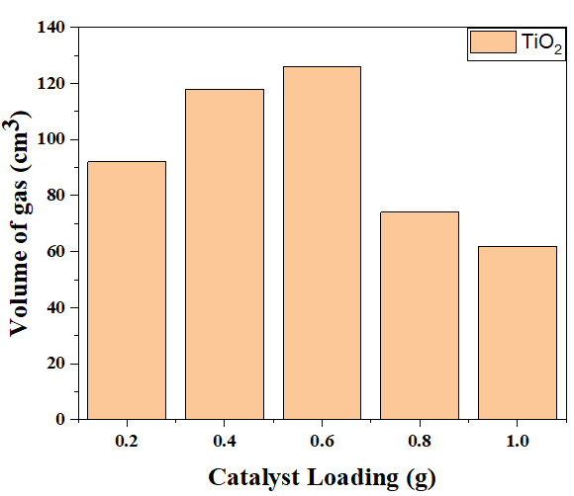

Figure 6: Catalytic biogas production from chicken dropping over TiO₂ catalyst: catalyst loading of 0.2g -1.0g.
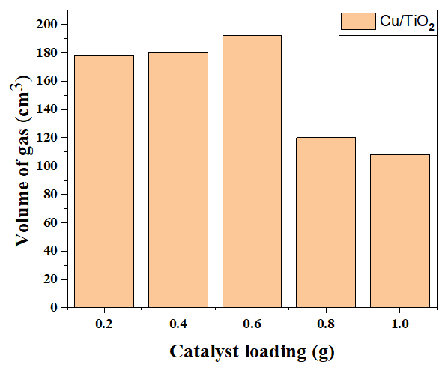

Figure 7 : Catalytic biogas production from chicken dropping over CuO/TiO₂ catalyst: catalyst loading of 0.2g -1.0g.
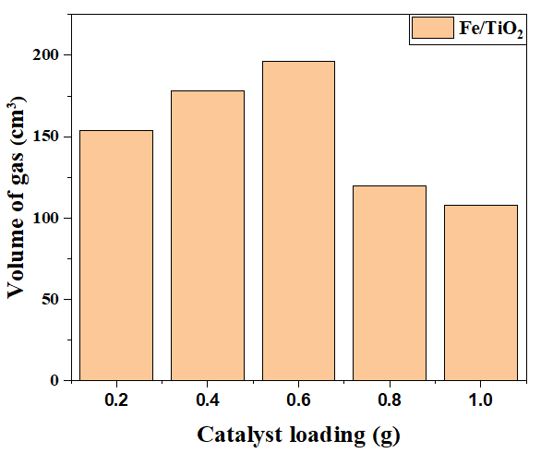

Figure 8: Catalytic biogas production from chicken dropping over FeO/TiO₂ catalyst: catalyst loading of 0.2g -1.0g.
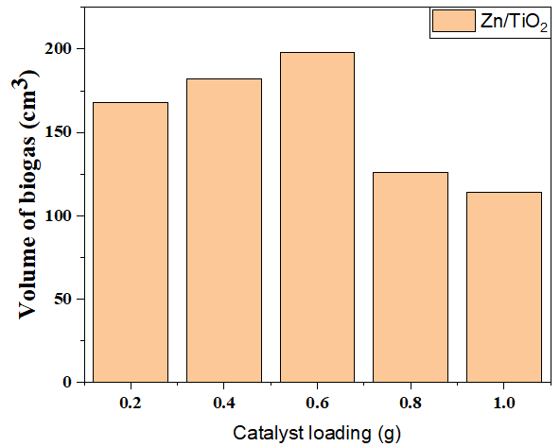

Figure 9: Catalytic biogas production using FeO/TiO₂ catalyst: catalyst loading of 0.2g -1.0g.

Figure 6-9 showed similar trend in the anaerobic digestion of chicken dropping to biogas with an exponential increase in the biogas yield over the synthesized catalysts (TiO₂, CuO/TiO₂, FeO/TiO₂, and ZnO/TiO₂) as the catalyst loading increases from 0.2 g- 0.6 g and a corresponding decrease in biogas yield observed at catalyst loading >0.6 g and the highest volume of biogas produced over TiO₂ catalyst was 1260 cm³ and this could be due to the enhanced degradation of complex organic matter in the chicken droppings into smaller intermediate molecules which accelerate methane production. Doping the TiO₂ with active metals oxide (CuO, FeO, and ZnO) improve its catalytic performance in the production of biogas.
The CuO, FeO and ZnO doped TiO₂ catalysts (CuO/TiO₂, FeO/TiO₂, and ZnO/TiO₂) enhance the catalyst performance with an increase in biogas yield by providing more active sites on the TiO₂ surface, thereby promoting the catalytic conversion of the chicken dropping into a high quality biogas. The observed increase in the rate of biogas production over the synthesized catalysts is in the order of ZnO/TiO₂> FeO/TiO₂> CuO/TiO₂> TiO₂.
The sudden decrease in the biogas production observed at catalyst loading > 0.6g resulted from the high concentration of transition metals present in the catalyst (Cu, Fe, Zn, and Ti) which tend to inhibit the growth of methanogenic bacteria which are essential for biogas production. Therefore a catalyst loading of ≥0.6 is therefore recommended for the catalytic conversion of biogas for 100 g of chicken dropping over transition metals based catalyst.

4.1.13 Results of the volume of biogas produced in cm³ from samples A,B,C,D and E are presented in Table ().Sample A refers to as control sample, B contains undoped titanium oxide while sample C, D and E contains copper oxide doped titanium oxide (CuO/TiO₂), iron oxide doped titanium oxide (FeO/TiO₂) and Zinc oxide doped titanium oxide(ZnO/TiO₂) .

Table (7): Total volume of gas in cm³ produced from samples A,B,C,D and E
Sample | Volume of gas in cm³
A | 4210.00cm³
Sample | Volume of gas in cm³
B₁ | 9610.00
B₂ | 11093.00
B₃ | 9734.00
Sample | Volume of gas in cm³
C₁ | 10884.00
C₂ | 11132.00
C₃ | 11106.00
Sample | Volume of gas in cm³
D₁ | 14352.00
D₂ | 13920.00
D₃ | 14520.00
Sample | Volume of gas in cm³
E₁ | 14308.00
E₂ | 14400.00
E₃ | 15100.00

The effect of catalyst loading on biogas production is presented in Figure 10-13

Fig 10: Catalytic bio gas production using TiO₂ Catalyst. Catalyst loading of 5g to 15g

Fig 11: Catalytic bio gas production from chicken dropping using CuO/TiO₂ Catalyst. Catalyst loading of 5g-15g

Fig 12: Catalytic bio gas production from chicken dropping using FeO/TiO₂ Catalyst. Catalyst loading f 5g-15g

Fig 13: Catalytic bio gas production from chicken dropping using ZnO/TiO₂ Catalyst. Catalyst loading of 5g-15

Figure 10-13 showed similar trend in the anaerobic catalytic digestion of chicken dropping to biogas with an exponential increase in the biogas yield over the synthesized catalysts TiO₂,CuO/TiO_{2,}FeO/TiO₂ and ZnO/TiO₂) as the catalyst loading increases from 05g-15g. The highest volume of biogas produced over TiO₂ catalyst was 11093cm3 and this could be due to enhanced degradation of complex organic matter in the chicken dropping in to smaller intermediate molecules which accelerate methane production.
Doping the titanium oxide with active metal oxide (CuO, FeOand ZnO) improve its catalytic performance in the production of biogas. The CuO, FeO and ZnO doped titanium oxide catalyst (CuO/TiO₂, FeO/TiO₂ and ZnO/TiO₂) enhance the catalytic performance with an increase in biogas yield by providing more active site on t he titanium oxide (TiO₂) surface, there by promoting the catalytic conversion of the chicken dropping in to high quality biogas. The observed increase in the rate of biogas production over the synthesized catalyst is in the order. ZnO/TiO₂ >FeO/TiO₂>CuO/TiO₂
The catalyst loading 5g, 10g and 15g is as a result of the preliminary biogas production conducted using 100 g chicken substrate at catalyst loading 0.2 g -1.0 g where a sudden decrease in biogas production was observed at catalyst loading >0.6 which resulted from high concentration of transition metal present in the catalyst ( Cu, Fe,Zn and Ti) which tend to inhibit the growth of methanogenic bacteria which are essential for biogas production.

REFERENCES
Abbasi, S. (2019). Photocatalytic activity study of coated anatase-rutile titania nanoparticles with nanocrystalline tin dioxide based on the statistical analysis. Environmental monitoring and assessment, 191(4), 206.
Aubabakar, A.M . Biodigester and Feedstock Type: Characteristic, Selection and Global Biogas Production. J. Eng.Res. 2022,1,170-187.
Adeniran, A. K., Ahaneku, I.E., Itodu, I.N & Rojy, H.A. (2014). Relative effectiveness of biogas production using poultry waste & cow dung. Agric Eng Int: CIGR Journal. 16(1):126-132
Ahamed, J. U., Raiyan, M. F., Hossain, M. S., Rahman, M. M., & Salam, B. (2016).Production of biogas from anaerobic digestion of poultry droppings and domestic waste using catalytic effect of silica gel. International journal of automotive and mechanical engineering, 13(2), 3503-3517.
Ajuya, A.O., (1996).The potent of Integrated Biosystems in small specific island countries, School of Agriculture and Institute for Research Extension, University of the south pacific, Western Samoa, UNESCO publication pp 5-9.
Alvarez, J., (2000).Anaerobic digestion of organic solid waste: An over view of research achievement and perspective. Bioresource Technology,74(1),3-16.
AOAC,(2016) Official Methods of Analysis, Association of Analytical Chemists 4th edition, Alinton Vigenia vol (2)2:20-29
Babalola,J.O (2008). Comparative study of biogas yield pattern in some animals and house hold waste. African Research Review, 2 (4):54-68.
Bagudo, B.U., Garba B., Dangoggo S.M. &Hassan L.G. (2008). Comparative Study of Biogas Production from Locally Sourced Substrate Materials. Nigeria Journal of Basic & Applied Science, 116(2): 262-266 .
Bagudo, B.U., Garba B., Dangoggo S.M. &Hassan L.G. (2011). The Qualitative Evaluation of Biogas Samples Generated from Selected Organic Wastes. Scholars research library, 3 (5): 549-555.
Bajah, S. H. &Garba, A. (1992).Chemistry.A new certificateapproach.Longman Publisher, Lagos Nigeria.
Bauner,D.,Laestadius, S., & Lida, N. (2009). Evolving Technological System For Diesel Engine Emission Control:Balancing GHG and Local Emission.Clean Technol Environ Policy.
Bernard, P., Stelmachowski, P., Broś, P., Makowski, W., & Kotarba, A. (2021). Demonstration of the influence of specific surface area on reaction rate in heterogeneous catalysis. Journal of chemical education, 98(3), 935-940.
Biomethane fueled vehicles the carbon neutral option (2009).Claverton Energy Conference ,October 24th2009,Bath,UK
Biswas, T.D. &Kartha, A.R.S., (1997). Removal of Carbon Dioxide form Biogas. Proceedings of National Symposium on Biogas Technology and Uses. New Delhi, India, IARI.
Black,M.J., Roy, A.,Tuinomunuji, E.,Kemausuor, F., Oduro, R., Leach, M.,Sadhukhan, J & Murphy, R. Bottle biogas-An opportunity for clean cooking in Ghana and Uganda.Energies 2021,14,3856.
Boone,D. and Mah,R.(2006). Transitional bacteria in anaerobic digestion of biomass,p35
Borja R., Sanchez E., &Weiland P. (1996) Influence of ammonia concentration on thermophilic anaerobic digestion of cattle manure in up flow anaerobic sludge blanket (UASB) reactors. Process Biochem, vol 31,no.5,June 1996. [Online]. Available :http://doi.org/10.1016/0032-9592(95)00092-2
Brame, J. A., & Griggs, C. S. (2016). Surface area analysis using the Brunauer-Emmett-Teller (BET) method: scientific operation procedure series: SOP-C.
Chandra R., Takeuchi, H., & Hasegawa, T. (2012). Methane Production from lignocellulosic agricultural crop waste :A review in context to second generation of biofuel production. Renewable and Sustainable Energy reviews, 16(3), 1462-1476.
Cyhnoweth, D.P., Owens, J.M.,& Legrand. Renewable methane from anaerobic digestion of biomass.Renew.Energy 2001,22, 1-8.
Dioha, I.J., Ikeme C.H., Nafi’u T., Soba N.I., & Yusuf M.B.S (2014). Effect of Carbon to Nitrogen Ratio on Biogas; International Journal of Natural Science, Vol (2): 1,pp 30-39.
Eastman, J. & Ferguson, J. (1981). Solubilization of particulate organic carbon during the acid phase of anaerobic digestion. Journal of Water of Water Pollution Control Federation. Vol (8): 352-36
Elhalwagi, M.M. (!986).Biogas Technology. Transfer and Diffusion. London and New York,pp.295-301.
El-Maazawi, M., Finken, A. N., Nair, A. B., & Grassian, V. H. (2000). Adsorption and photocatalytic oxidation of acetone on TiO2: an in situ transmission FT-IR study. Journal of catalysis, 191(1), 138-146).
Feroskhan, M., Ismail, S., Natarajan, G., Manavalla, S., Khan, T.M.Y., Khada, S.D.A., Ali, M.A (2023). Comprehensive Study of the Effect of Various Operating Parameters on a Biogas-Diesel Dual Engine. Vol 15 pp 1230-1232
Fehrenbach H, GiegrichJ,ReinhardtG,Sayer U, Gretz M, LanjeK,Schmitz J., (2008) Detection and quantification of micro organisms in anaerobic bioreactors. Biodegradation 9:169-177
Ferry, J.G.(1997).Enzymology of fermentation of acetate to methane by methanosarcina thamophila.Biofactors,6:25-35

Frang, C., Angelidaki, I., & Boe, K. (2010). Biogas Production form Food Processing Industrial Wastes by Anaerobic Digestion, Technical University of Denmark, Department of Environmental Engineering. Ph.D Thesis.
Ferry, J.G.(1997).Enzymology of fermentation of acetate to methane by methanosarcina thamophila.Biofactors,6:25-35
First International Conference on Bio-Energy V.20-25 September 1998, Florance Italy.part 111(Edited BY (A.A.M Sayigh)
Fulford, D., (2011). Biogas technology. Success project in Asia and Africa ,being a paper presentation at Kingdom Bioenergy, available at http://WWW.Kingdombio.com/DJF Biogas Reading presentation.Pdf (17/5/2001)
Galadima, A.(2018).Catalysis in Waste and Biomass Valorization in to Fuel :Current State and Research Perspective pp.1-3.
Garba B,.Atiku A.T. and Aliyu M.(1998).Proceeding of the World Renewable Energy Congress V.20-25 September 1998,Florance Italy, part 111,(Edited by A.A.M. Sayigh).
Gerardi, M. (2003). The Microbiology of Anaerobic Digester. Hoboken, New Jersey: Wiley-inter Science, John Wiley and Sons, Inc.
Gizegorz, B., Reda,F., Iwona, C., Jens E., &mette,T. (2015) .Evaluation of Composition and Biogas Production Potential from sea grass (Halodule University) Native Abu Dhabi. The 7th International Conference on Applied Energy ICAE. Science Direct Energy Proceedia pp760-766.
Gumisiriza r, Hawumba JF,Okure M,Hunsel O, (2017). Biomass waste-to-energy volarization technologies: A review case for banana processing in Uganda.Biotechnology for Biofuels.2017; 10:11.
Gurbani, A., Ayastuy, J. L., González-Marcos, M. P., Herrero, J. E., Guil, J. M., & Gutiérrez-Ortiz, M. A. (2009). Comparative study of CuO–CeO2 catalysts prepared by wet impregnation and deposition–precipitation. international journal of hydrogen energy, 34(1), 547-553.
Henreich A,.Schimpf U, Zakrzewski M, Schluter A, Bendorp D, Clocke M., (2011). Monitoring of changes within a microbial, biogas producing community. In proceeding of the First International Conference on Biogas Microbiology: 14-16September 2011; Leipzig .Edited by Kleinsteuber S, Nikolausz M. UFZ press,Liepzig;2011:49.
IEA (2006) World Energy Outlook. International Energy Agency, Paris
IPCC (2000) Special report on emission scenarios, Intergovernmental panel on Climate Change
Jeffery,C.H.,Bsset,J.,Mendhan,J.,Danney,D.(1989). Vogels textbook of quantitative chemical analysis, Longman Group publishers fifth ed.
Khalid A., Arshard M., Anjum M., Mahmood T.,& Dawson L.(2011) .The anaerobic digestion of solid organic waste. Waste management , vol 31,no.8, August 22011.[On line]. Available: http://doi.org/10/1016/j.wasman.2011.03.021
Kalyuzhnyi, S., Veeken, A., & Hamelers, B., (2000). Two-particles Model of Anaerobic Solid State Fermentation. Water Science and Technology. Vol; (4)1 ;pp43-40.
Kabeyi, M.J. & Olanrewaju,O.A. Biogas Production and Application in the Sustainable Energy Transition J.Energy 2022, 2022,8750221.
Kossmann, U. Ponitz, S. Habermehl, A.Krieg, H.Euler. (2007). Biogas digest. Information and Advisory Service on Appropriate Technology (ISAT).1,1-4
Kwietniewska E.,&Tys J,(2014). Process characteristics, inhibition factors and methane yield of anaerobic digestion process, with particular focus on microalgal on biomass fermentation .Renewable and Sustainable Energy Review, vol 34,June 2014 .[On line]. Available: http://doi.org/10/1016/j.rser.2014.03.04.
Lawal, A.K.,Ajuebor F.N. & Ojosu, J.O (2001). Characteristics of piggery wastes feeds stock for determination of designed Parameters to biogas digester plant.Nigerian Journal of Research and Review in Science 2:193-1198
Li,X., L,Q.,Zhang,M.X.,Fu,. G.Z.,Lar., J.S (2009). Anaerobic co-digestion of cattle manure with corn pretreated by sodium hydroxide for efficient biogas production. Energy Fuel 23,4635-4639
Lyilade, Y. (2009). An Investigation into the Mechanical Biological Pretreatment of Garden Waste using Forced Aeration and its Impact on Carbon Emissions Reduction Potential. Durban: MSc Eng, UKZN.
Ma, J., He, H., & Liu, F. (2015). Effect of Fe on the photocatalytic removal of NOx over visible light responsive Fe/TiO₂ catalysts. Applied Catalysis B: Environmental, 179, 21-28.
Maishanu S. M. & Hussani H. B. N. (1991). Studies on factors affecting biogas generation from Pistia stratiote. Paper presented at the 32nd annual conference of Nigeria society for Microbiology, University of Ilorin, April, 7-11, 1991.
Martin, A.D., (2007). Understanding Anaerobic Digestion, presentation to the Environmental Service Association, 16.10.07, esauk.org
Masse, D.I., Talbot., G. & Gilbert., Y. (2011). In farm biogas production: A method to reduce GHG emission and develop more sustaible livestock operation, Animal Feed Sci and Rechn. 16 (6); 436-445.
Mc.Carty,P.L, Ritman, B.E., (2011).Environmental biotechnology principles and application.MC Graw-Hill. International Edition, New York
Mondal, I., Gonuguntla, S., & Pal, U. (2019). Photoinduced fabrication of Cu/TiO2 core–shell heterostructures derived from Cu-MOF for solar hydrogen generation: the size of the Cu nanoparticle matters. The Journal of Physical Chemistry C, 123(43), 26073-26081.
Mudi, I., Hart, A., Ingram, A., & Wood, J. (2023). Catalytic Hydrodeoxygenation of Vanillin, a Bio-Oil Model Compound over Renewable Ni/Biochar Catalyst. Catalysts 2023, 13, 171.

Nallamothu, RB., Teferra A., & Appa Rao, V.B.,(2013) .Biogas Purification, Compression and Bottling. Global Institute for research and Education. Vol 2 (6):34-38.
Nkoi, B.,Labele-Alawa, B.T.,Odobeatu,B. Design and Fabrication of a Modified Portable Biogas Digester for Renewable Cooking-Gas Production.Evr.J.Eng.Technol.Res. 2018,3,21.
NNFCC (2012).National Non-Food Crops Center. Evaluation of Opportunities for Converting Indigenous UK Waste to Fuel and Energy (Report)
Odeyemi, O.(2000).Biogas production. Preceding of the fifth Annual Conference of the Nigerian Society of Microbiology, Ado Ekiti,2nd-6th Dec.,2001,pp.17-24
Obaideen, k., Abdulkerrm, M.A., Wilberforce, T.,Esaid, k., Sayed, E.T.,Maghrabie, H.M., &Olabi, A. Biogas role in achievement of the sustainable development goals:Evaluation challenges and guidelines. J.Taiwan instChem. Eng .2022,131,104207.
Omelianski,R., (1990).Methane production generationfrom anaerobic digesters;Consideringsubtrates.Environmental biotechnology lowa state University, USA
Omelianski,R., (1995). Biological conversion of biomass to methane corn stover studies.Project report, Report No.COO-2917, Dept. NTIS, PC A08/MF A01, USA.
Oyoleke, S.B.,Onigbajo, H.O.& Ibrahim, K.(2003).Degradation of animals wastes(cattle dung) to produce methane (cooking gas).Preceding of the eight annual Conference of Animal Science Association of Nigeria (ASAN).PP.168-169
Oyoleke, S.B.,Onigbajo, H.O.& Ibrahim, K.(2003).Degradation of animals wastes(cattle dung) to produce methane (cooking gas).Preceding of the eight annual Conference of Animal Science Association of Nigeria (ASAN).PP.168-169
Oyewole, O. A. (2010). Biogas production from chicken droppings. ScienWorld Journal, 5(4).
Özkar, S. (2009). Enhancement of catalytic activity by increasing surface area in heterogeneous catalysis. Applied surface science, 256(5), 1272-1277.
Ozor, O.C., Agah, M.B.,Ogbu, K.I., Nnachi, A.U.,Udu-ibiam, O.E.,& Agwu, M. (2014). Biogas Production Using Cow Dung From Abakalaki Abattoir In South-Estern Nigeria . International Journal Of Scientific and Technology Research Volume (3) 10. ISSN 2277-8616.
Pipatmanomai, S., Kaewluan, S. & Vitidsant, T. (2009).Economic Assessment Od Biogas Electricity Generation System With H₂S Remove by Activated Carbon in Small Pig Farm. Applied Energy. 2(86): 669-667.
Pinzari, F., Patrono, P., & Costantino, U. (2006). Methanol reforming reactions over Zn/TiO2 catalysts. Catalysis Communications, 7(9), 696-700.
Rabah, A.B., Baki, A.S., Hassan, L.G., Musa, M., & Ibrahim, A.D. (2010). Production of Biogas using abattoir Waste at different time. Science World Journal. 5 and 4
Robert D,Mulyadi D, Anwar I,.(2015).Photocatalytic detoxification with titanium oxide (TiO₂) supported on glass-fibre by using artificial and natural light Catal.Today.54. 291-6
Roduner, E. (2014). Understanding catalysis. Chemical Society Reviews, 43(24), 8226-8239.
Ryckebosch E., Drouillon M.,Vervaeren H., (2011). Technique of transforming of biogas to biomethane .Biomass and Bioenergy,35(5),p.1633-1645
Safely L.M., Vetter R. L, Smith D, (2007). Operating a full- scale poultry manure anaerobic digester. Biol wastes 19:79-90.
Salminen,E.Rintal,J., (2003).The methane production of poultry slaughtering residue and effect of pretreatment on the methane production of poultry feathers. Vol .24.Published on line
Sangeetha, R., Arulpandi, I., & Geetha, A. (2011). Bacterial lipases as potential industrial biocatalysts: An overview. Research journal of microbiology, 6(1), 1.
Shindarska,Z., Loutskanova,B.., Baykov, B.(2012) Evaluation of new raw materials for production on biogas. J. Balkan Ecol.2: 197-201
Sleat,R and Mah R. (2006). Hydrolytic Bacteria in Anaerobic digestion of biomass,p16
State Energy Conservation Office (Texas).,(2009). Biomass Energy: Manure for Fuel.
Sangeetha, R., Arulpandi, I., & Geetha, A. (2011). Bacterial lipases as potential industrial biocatalysts: An overview. Research journal of microbiology, 6(1), 1.
Suneerat, P., Sommas, k., & Tharapong, V.(2009) .Economic assessment of biogas to electricity generation system with H₂S removal by activated carbon in small pig farm,Scientific Res and Essay, 4 (9):861-886
Surendra,K.C., Ogoshi, R.,Zaleski,H.M.,Hashimoto A.G., and Khanal, S.K.,(2018) high yielding tropicalenergy crop for bioenergy production:effect of plant
Sustainable Development Dimension (1996).A System to Biogas Technology.
Syed, Z.I. (2006).A Case Study to Bottle The Biogas in a Cylinders as Sources of power in Rural Industries Development in Pakistan. World Applied Science Journal 1(2) : 127-130.
Tambuwal, A.D. (2005). Comparative kinetics and Statistic Analysis of Biogas using Camels, Cattles, Sheps, Goates and Horses. A Ph.D. Thesis submitted to Post Graduate School. Usmanu Danfodiyo University Sokoto.
Twinomunuji, E., Kemausuor,F.,Black, M.,Roy, A.,Leach, M.,Sadhukhan R.O., Murphy, R. The Potential of Bottle Biogas for Clean Cooking in Africa[Online] .Available on line:https//www.mecs.org.uk/working-papers (accessed on 5 May,2024).
Uddin, M., & Wright, M.M. Anaerobic digestion fundamentals,challenges and technological advances.Phys. Sci.Rev.2022,8.2819-2837.
United State Energy Information Administration (US-EIA.2020).Biomass explaind,http://www.eia.gov.energyexplaine/biomass/.Accessed28-10-200
United State Office Of Energy Efficiency& Renewable Energy(US-EERE.,2020).Bioenergy Basics, http://www.energy.gov/eere/bioenergy-basics, Accessed 28-10-2020.
Ur-Rehman, S.,Mustaq,Z.,Zahoor,T.,Jamil, A., Murtaza,MA (2015). “Xylitol:a review of biogasproduction,application,health benefit and related safety issues”Critical Review in Food Science and Nutrition.55(11):1514-28
Védrine, J. C. (2019). Metal oxides in heterogeneous oxidation catalysis: State of the art and challenges for a more sustainable world. ChemSusChem, 12(3), 577-588.
Vinayak, R.G., Katti. (2014). Design of Biogas Scrubbing, Compression and Storage System. Journal of Electrical and Electronic Engineering .pp 58-63.
Virendra, K.B., Ram, C.,Parchuri. M.V and Shyam. S .Kapdi (2008). Biogas Purification and Bottling in to Compressed Natural Gas Cylinders Producing Bioenergy from Biomass for Rural Automotive applications. Mechanical Engineering Department. Indian Institute of Technology. New Delhi India.
Wang X., Yang G., Ren G., & Han X. (2012). Optimizing feeding composition and carbon-nitrogen ratios for improve methane yield during anaerobic co-digestion of dairy, chicken manure and wheat straw. ”Bioresources Technology”.Vol.120.September 2012. [Online].Available: http://doi.org/10.1016/j.biortech.2012.06.058
Warkneh, A.A. Biogas impurities:Environmental and health implication,removal technologies and future perspectives. Heliyon2022,8,e10929.
Weiland, P. (2010). Biogas production: Current State and Perspectives. Journal of Applied Microbiology and Biotechnology. 85(4); 849-860.with TiO₂ immobilized on the glass tubes of UV lamps water.Res.36.1776-82.
World Energy Council, (2004). Renewable energy project hand book, London. World Energy Council.
World Energy Council, (2017).World Energy Resources Report . Publish by World Energy Council.
Wu Z, Dong F, Zhao W, Guo S .The enhancement of photodegradation efficiency using Pt-Tio₂ catalyst. Chemosphere 2008; 48,1103-1111.
Yavini, D.T., Taura, H.U., Mohammed, N &Namo, M.J (2014). Comparative Study of Mesophilic Biogas Production Potential of Selected Agro-waste. The International Journal of Engineering and Science (IJES) 3(2) : 1-6.
Yeole, T. Y. & Ranade, D. R., Alternative Feedstocks for Biogas, 1992, 10-16 as cited Dioha et al., (2014).
Zhu, G., Yang, X., Liu, Y., Zeng, Y., Wang, T., & Yu, H. (2022). One-pot synthesis of C-modified and N-doped TiO2 for enhanced visible-light photocatalytic activity. Journal of Alloys and Compounds, 902, 163677.
Zuru A. A., Saidu ,H., Odum, E.A Onurah, O. A., (1998). A comparative study of biogas production from horse, goat and sheep dung. Nigerian Journal of Renewable Energy Vol. 6; (1 and 2).pp.43-47.

