SCREENING FOR ANTIMICROBIAL RESISTANCE CHARACTERISTICS OF E. coli ISOLATED FROM POULTRY DROPPINGS IN SOKOTO METROPOLIS

SUBMITTED TO:
DEPARTMENT OF BIOCHEMISTRY AND MOLECULAR BIOLOGY, USMANU DANFODIYO UNIVERSITY, SOKOTO, NIGERIA

IN PARTIAL FULFILLMENT OF THE REQUIREMENTS FOR THE AWARD OF B.SC. (HONS) DEGREE IN BIOCHEMISTRY AND MOLECULAR BIOLOGY

BY:
LAWRENCE VICTOR
2010304070

SUPERVISED BY:
DR. ANDREW ONU

TITLE PAGE

DECEMBER, 2025

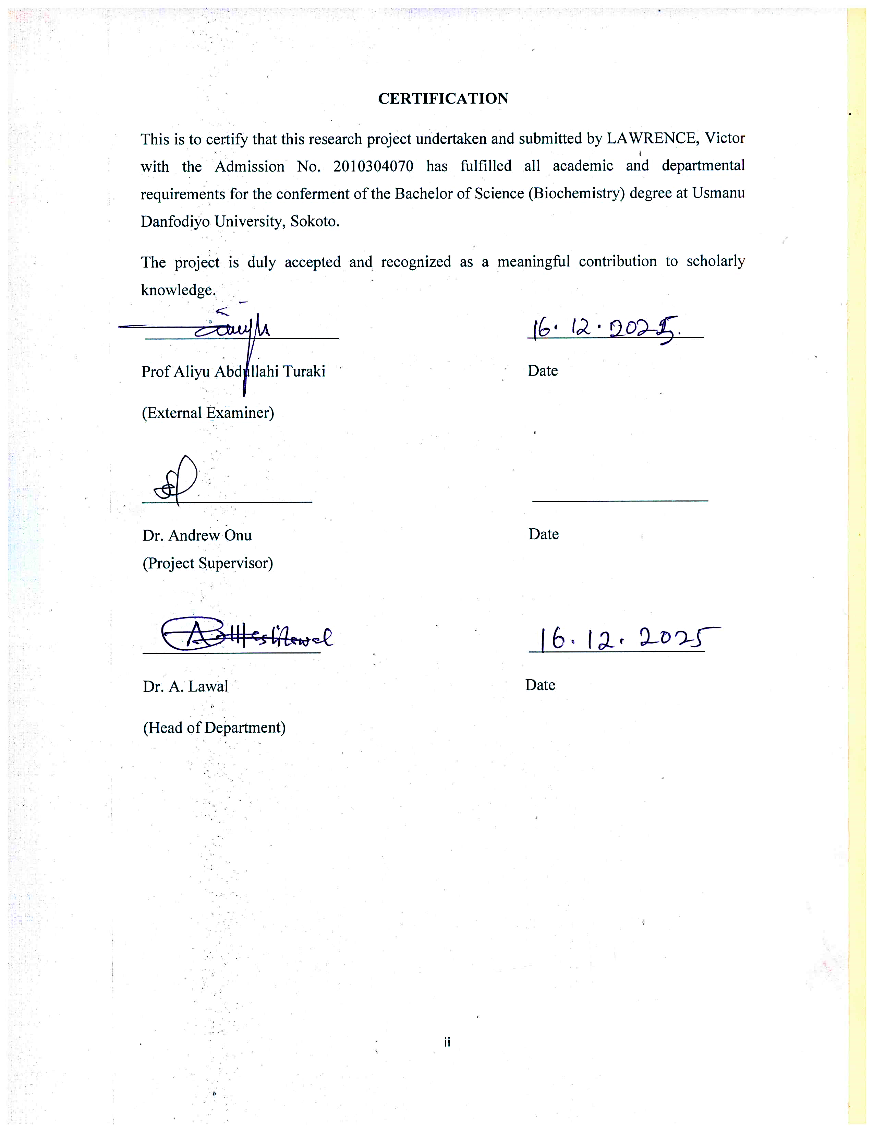
CERTIFICATION

DEDICATION
I dedicate this work to God Almighty, whose grace and guidance have carried me through every step of my academic pursuit, for his continuous mercy, Grace and Favors over my academic journey.
I also dedicate this work to my wonderful parents and siblings for their love, guidance and unwavering supports.
To my family, friends and everyone who have ever supported me both educational and financially throughout my academic journey and also to those who inspired me to keep going even in the toughest moments, this milestone is ours together thank you for standing by me this accomplishment is shared with you.

ACKNOWLEDGEMENT
All praise and appreciation to God Almighty, the giver of life, wisdom, and understanding, for His protection, provision, and strength throughout the course of my Academic journey and the successful completion of this research work.
My sincere appreciation goes to my supervisor, Dr. Andrew Onu of the Department of Biochemistry, for his mentorship, guidance, and support, which greatly shaped the success of this study. May God Almighty bless and reward you abundantly.
I also wish to acknowledge the lecturers and staff of the Department of Biochemistry, Usmanu Danfodiyo University, Sokoto, for providing the academic foundation and laboratory facilities required for this research. Your dedication to teaching and mentorship has played a significant role in my academic progress. Thank you all.
I specially appreciate my parents, Lawrence Gabriel Adugbo and Lucy Adugbo, who have always supported me both financially and motivationally. My heartfelt appreciation also goes to my siblings Lawrence Johnpaul, Lawrence Favour, Lawrence Mercy, Lawrence Winner, and Lawrence Oche for their prayers, love, and unwavering support. Your encouragement motivated me to come this far. May God Almighty continue to guide, provide for, and uplift you all. I love you all endlessly.
Special thanks to my uncles and aunties Mr. Pius, Mr. Mike, Mr. Isaac, and Mrs. Theresa for their continuous support towards my academic journey.
I am also deeply grateful to the family of Mr. and Mrs. Stephen Onjefu, who have always been there for me, providing help, care, and shelter, and taking me as their own son. Your kindness made this journey easier for me. May God continue to bless you and your household.
My gratitude also goes to my friends (brothers) Johnpaul, Maranatha, Edwin, and Julius for their support and assistance in times of need. May all your prayers and desires be granted. I also appreciate my colleagues Martha Ochepo, Isah Salisu, and John Ogaba for their assistance, shared ideas, and contributions towards the completion of this work.
Finally, I appreciate everyone who, in one way or another, guided me academically and morally throughout this journey. Your support is deeply valued and sincerely appreciated.

TABLE OF CONTENTS
TITLE PAGE i
CERTIFICATION ii
DEDICATION iii
ACKNOWLEDGEMENT iv
TABLE OF CONTENTS vi
LIST OF TABLES viii
LIST OF FIGURES ix
ABSTRACT x
CHAPTER ONE 1
INTRODUCTION 1
1.1 Background of the Study 1
1.2 Statement of the Research Problem 3
1.3 Aim and Objectives of the Study 4
1.4 Justification of the Study 4
CHAPTER TWO 6
LITERATURE REVIEW 6
2.1 Concept of Antimicrobial Resistance (AMR) 6
2.2 Escherichia coli: characterization and Public Health Importance 7
2.3 Antimicrobial Use in Poultry Production 9
2.4 Antimicrobial Resistance in Poultry-Associated E. coli 10
2.4 Mechanisms of Antimicrobial Resistance in E. coli 12
2.5 Extended-Spectrum Beta-Lactamases (ESBLs) in E. coli 13
2.6 Public Health Implications of AMR in Poultry 15
CHAPTER THREE 17
MATERIALS AND METHODS 17
3.1 MATERIALS 17
3.2 METHODS 18
3.2.1 Study Area 18
3.2.2 Study Population (Chicken Samples) 19
3.2.3 Sample Size Determination and Sampling Technique 19
3.2.4 Sample Collection and Transportation 20
3.2.5 Isolation and Identification of E. coli 20
3.2.6 Antimicrobial Susceptibility Testing 21
3.2.6.1 Disk Diffusion Method (CLSI Guidelines) 21
3.2.6.2 Panel of Antibiotics Tested 21
3.2.7 Detection of Extended-Spectrum Beta-Lactamases (ESBLs) 21
3.2.7.1 Phenotypic Screening. 21
3.2.8 Molecular Confirmation of genomic DNA and plasmid DNA (Gel Electrophoresis) 22
CHAPTER FOUR 23
RESULTS, DISCUSSION CONCLUSION AND RECOMMENDATION 23
4.1 RESULTS 23
4.1.1 Morphological and Biochemical Identification of Isolates 23
4.3 Antimicrobial susceptibility testing (Sensitivity Test) 25
4.4 Detection of Extended-spectrum Beta- Lactamases (ESBLs) 27
4.4.1. Phenotypic Screening 27
4.5 Molecular Confirmation of Genomic DNA and Plasmid DNA (Gel Electrophoresis) 28
DISCUSSION 30
CONCLUSION 31
RECOMMENDATIONS 32
REFERENCES: 33

LIST OF TABLES
Table 3.1.1 list of laboratory Instruments Used in the Study 17
Table 3.1.2 list of glass wares Used in the Study 17
Table 3.1.3 list of reagents Used in the Study 18
Table 4.1 Biochemical Identification of Bacterial Isolates from Chicken Droppings
Table 4.2: Antibacterial Activity of Selected Antibiotics on E. coli Isolates 26

LIST OF FIGURES
Fig 1. Antibacterial Activity of Selected Antibiotics on E. coli Isolates 26
Fig 2. Antimicrobial susceptibility test of E. coli by disc diffusion method showing zone of inhibition 27
Fig 3. Phenotypic detection of Extended-spectrum Beta- Lactamases (ESBLs) 28
Fig 4. Molecular confirmation of genomic DNA and plasmid DNA 30

ABSTRACT
Antimicrobial Resistance (AMR) in poultry is a growing public health concern due to the potential transfer of resistant bacteria to humans. This study investigated the screening for antimicrobial resistant genes in poultry droppings collected in Sokoto Metropolis. Fourteen bacterial isolates were identified, including Proteus spp., Salmonella spp., and E. coli. Antimicrobial susceptibility testing showed that all E. coli isolates were multidrug resistant, with complete resistance to ampicillin and few to amoxicillin, and tetracycline, but variable susceptibility to ciprofloxacin and levofloxacin. Phenotypic screening indicated possible extended-spectrum beta-lactamase (ESBL) production. Plasmid isolation and agarose gel electrophoresis confirmed the presence of plasmid DNA in the E. coli isolates, suggesting plasmid-mediated resistance. The findings underscore the need for improved antibiotic regulation and surveillance in poultry production to reduce the spread of resistant pathogens.

CHAPTER ONE

INTRODUCTION

1.1 Background of the Study
Antimicrobial resistance (AMR) has become one of the most pressing global health threats, undermining the effectiveness of commonly used antibiotics and complicating the treatment of infectious diseases (O’Neill, 2020; WHO, 2021). The problem is particularly severe in developing countries where weak regulatory frameworks, limited surveillance, and indiscriminate use of antimicrobials in humans and animals accelerate the emergence of resistant pathogens (Aworh et al., 2019).
Among resistant bacteria of public health concern, Escherichia coli is especially important due to its dual role as a commensal organism in the intestinal tract and as a pathogen capable of causing urinary tract infections, septicemia, and gastrointestinal illnesses (Yuan, 2021; Tadesse et al., 2022). E. coli also serves as a reservoir for resistance genes that can be transferred horizontally to other bacteria, thereby amplifying the AMR crisis (Mshana et al., 2020).
The poultry industry is a major contributor to food security in Nigeria, including Sokoto Metropolis, where chicken meat is widely consumed as an affordable protein source. However, the routine and often unregulated use of antibiotics in poultry production for growth promotion, prophylaxis, and treatment creates selective pressure that favors the emergence of resistant E. coli strains (Bortolaia et al., 2021; Nhung et al., 2021). These resistant bacteria can spread to humans through direct handling of poultry, consumption of contaminated meat, or via environmental contamination, posing a serious One Health challenge that links animal, human, and environmental health (Shaikh et al., 2022).
One of the most alarming resistance mechanisms in E. coli is the production of extended-spectrum beta-lactamases (ESBLs), which confer resistance to third-generation cephalosporins and other beta-lactam antibiotics. ESBL-producing E. coli have been increasingly reported in poultry across Nigeria, including northern regions such as Sokoto, significantly limiting treatment options for infections (Ahmed et al., 2023; Adeboye et al., 2023). In addition, multidrug resistance (MDR) involving resistance to fluoroquinolones, tetracyclines, and aminoglycosides has been documented in poultry-associated E. coli isolates (Agusi et al., 2024; Ajayi et al., 2023).
In Sokoto Metropolis, poultry farming and sales are largely informal, with antibiotics often accessed without veterinary prescription. This unregulated use has contributed to rising levels of AMR in chicken-associated pathogens. Recent studies in northern Nigeria have reported high prevalence of MDR E. coli and detection of ESBL genes such as blaTEM, blaSHV, and blaCTX-M in isolates from retail chicken meat (Adeboye et al., 2023; Ibrahim et al., 2022). These findings raise serious public health concerns, as resistant bacteria from chickens sold in Sokoto markets can easily enter the human food chain and compromise treatment outcomes.
Given the increasing trend of AMR in poultry-associated E. coli in Sokoto Metropolis, continuous monitoring of resistance patterns is essential for risk assessment and guiding antimicrobial stewardship programs. Investigating both the phenotypic resistance profiles and the molecular mechanisms underlying resistance in E. coli isolated from chickens sold in Sokoto provides critical insights into the magnitude of the problem and supports the design of effective public health interventions (Mshana et al., 2020; Aworh et al., 2019).

1.2 Statement of the Research Problem
Antimicrobial resistance (AMR) has become a major public health concern globally, with Escherichia coli recognized as one of the most important bacterial species contributing to this crisis. In Nigeria, and particularly in Sokoto Metropolis, poultry production is a vital source of affordable protein for the population. However, the widespread and often unregulated use of antibiotics in poultry farming has created selective pressure that favors the emergence of resistant strains of E. coli.
Recent studies in Nigeria have reported high prevalence of multidrug-resistant (MDR) and extended-spectrum beta-lactamase (ESBL)-producing E. coli in poultry meat, raising concerns about food safety and the risk of transmission of resistant pathogens to humans through the food chain (Adeboye et al., 2023; Ahmed et al., 2023). In Sokoto Metropolis, poultry farming and sales are largely informal, with antibiotics frequently accessed without veterinary prescription. This practice increases the likelihood of resistant bacteria contaminating chicken meat sold in local markets.
Despite the growing evidence of AMR in poultry-associated E. coli across Nigeria, there is limited data specifically addressing the resistance profiles of E. coli isolated from chickens sold in Sokoto Metropolis. The absence of localized surveillance data hampers effective risk assessment and the development of targeted antimicrobial stewardship programs. Without such information, consumers remain at risk of exposure to resistant pathogens, and public health authorities lack the evidence base needed to implement appropriate interventions.
Therefore, the research problem centers on the need to investigate the antimicrobial resistance patterns of E. coli isolated from chickens sold in Sokoto Metropolis, with particular emphasis on multidrug resistance and ESBL production. Addressing this gap will provide critical insights into the magnitude of AMR in the local poultry sector and inform strategies to safeguard both animal and human health.

1.3 Aim and Objectives of the Study
AIM
The aim of this study is to investigate the screening for antimicrobial resistant genes in poultry droppings collected in Sokoto Metropolis, with particular emphasis on Multidrug Resistance (MDR) and Extended-Spectrum Beta-Lactamase (ESBL) production.
SPECIFIC OBJECTIVES
The study seeks to:
- Isolate and identify Escherichia coli from chicken samples obtained from retail outlets in Sokoto Metropolis.
- Determine the antimicrobial susceptibility profiles of the isolates using commonly used antibiotics in poultry and human medicine.
- Detect Extended-Spectrum Beta-Lactamase (ESBL) producing strains among the isolates using phenotypic methods.
- Identification of genomic and plasmid DNA of isolates using Agarose Gel Electrophoresis method.

1.4 Justification of the Study
Antimicrobial resistance (AMR) is a global health crisis that threatens the effectiveness of commonly used antibiotics and complicates the treatment of infectious diseases (WHO, 2021; O’Neill, 2020). Escherichia coli is of particular concern because it functions both as a commensal organism and as a pathogen capable of causing urinary tract infections, septicemia, and gastrointestinal illnesses. More importantly, E. coli serves as a reservoir for resistance genes that can be horizontally transferred to other bacteria, thereby amplifying the AMR problem (Mshana et al., 2020; Tadesse et al., 2022).
In Nigeria, poultry production plays a vital role in food security, with chicken meat serving as an affordable protein source for households. However, the routine and often unregulated use of antibiotics in poultry farming for prophylaxis, growth promotion, and treatment creates selective pressure that favors the emergence of resistant E. coli strains (Bortolaia et al., 2021; Nhung et al., 2021). These resistant bacteria can spread to humans through direct handling of poultry, consumption of contaminated meat, or environmental contamination, posing a serious One Health challenge that links animal, human, and environmental health (Shaikh et al., 2022).
Recent studies in northern Nigeria, including Sokoto, have reported high prevalence of multidrug-resistant (MDR) and extended-spectrum beta-lactamase (ESBL)-producing E. coli in poultry meat, with detection of resistance genes such as blaTEM, blaSHV, and blaCTX-M (Adeboye et al., 2023; Ahmed et al., 2023; Ibrahim et al., 2022). These findings highlight the urgent need for localized surveillance, as resistant bacteria from chickens sold in Sokoto markets can easily enter the human food chain and compromise treatment outcomes.
This study is therefore justified on the following grounds, Public Health Relevance: Resistant E. coli strains pose a direct threat to human health by reducing treatment options for common infections (Yuan, 2021; Agusi et al., 2024). Food Safety Concerns: Poultry meat sold in Sokoto Metropolis is often produced and marketed under informal conditions, increasing the risk of contamination with resistant pathogens (Ajayi et al., 2023). Knowledge Gap: Despite evidence of AMR in poultry-associated E. coli across Nigeria, localized data for Sokoto Metropolis remain scarce, limiting effective risk assessment and intervention (Aworh et al., 2019).

CHAPTER TWO

LITERATURE REVIEW

2.1 Concept of Antimicrobial Resistance (AMR)
Antimicrobial resistance (AMR) refers to the ability of microorganisms such as bacteria, viruses, fungi, and parasites to survive exposure to antimicrobial agents that would normally kill them or inhibit their growth. In practical terms, this means that infections caused by resistant organisms become more difficult to treat, leading to prolonged illness, increased risk of spread, and higher mortality rates (WHO, 2023; Microbe Notes, 2022). AMR has emerged as one of the most pressing global health challenges, with estimates suggesting that it was directly responsible for 1.27 million deaths worldwide in 2019 and contributed to nearly 5 million deaths overall. Projections indicate that if left unchecked, AMR could cause up to 10 million deaths annually by 2050, surpassing cancer as a leading cause of mortality (O’Neill, 2016; WHO, 2023).
Microorganisms develop resistance through several mechanisms, most of which are driven by genetic changes. These mechanisms include the enzymatic degradation or modification of drugs, such as the production of beta-lactamase enzymes that inactivate penicillins and cephalosporins; alteration of drug targets within the bacterial cell, which reduces drug binding and effectiveness; the use of efflux pumps that actively expel antimicrobial agents from the cell; reduced permeability of the cell membrane, which prevents drug entry; and horizontal gene transfer through plasmids, transposons, or integrons, which allows resistance genes to spread rapidly among bacterial populations (Britannica, 2023). These processes enable bacteria to adapt quickly to selective pressures created by antimicrobial use, making them highly resilient in environments where antibiotics are frequently applied.
The misuse and overuse of antimicrobials in humans, animals, and agriculture are the primary drivers of resistance. In many low- and middle-income countries, weak regulatory frameworks, poor surveillance systems, and easy access to antibiotics without prescription exacerbate the problem (WHO, 2023). In poultry farming, antibiotics are often used indiscriminately for growth promotion and prophylaxis, creating selective pressure that accelerates the emergence of resistant strains. This not only threatens animal health but also increases the risk of resistant pathogens entering the human food chain.
The implications of AMR are profound. It undermines the effectiveness of modern medicine, making routine procedures such as surgery, chemotherapy, and organ transplantation riskier due to the threat of untreatable infections. It also increases healthcare costs, prolongs hospital stays, and threatens food security when resistant pathogens emerge in food-producing animals (WHO, 2023). For these reasons, AMR is now recognized as a critical One Health issue that links human, animal, and environmental health, requiring coordinated global action to mitigate its impact.

2.2 Escherichia coli: characterization and Public Health Importance
Escherichia coli (E. coli) is a Gram-negative, rod-shaped bacterium that naturally inhabits the intestinal tract of humans and animals. While many strains are harmless and play a beneficial role in maintaining gut health, certain pathogenic strains are capable of causing serious diseases such as urinary tract infections, septicemia, neonatal meningitis, and gastrointestinal illnesses including diarrhea (Yuan, 2021; Tadesse et al., 2022). The dual role of E. coli as both a commensal and a pathogen makes it particularly significant in the context of antimicrobial resistance.
Beyond its direct pathogenic potential, E. coli is also recognized as a major reservoir of antimicrobial resistance genes. Through horizontal gene transfer mechanisms such as plasmids, transposons, and integrons, resistance determinants can be shared not only among E. coli strains but also with other bacterial species, thereby amplifying the spread of resistance across microbial populations (Mshana et al., 2020). This ability to disseminate resistance genes makes E. coli a sentinel organism for monitoring antimicrobial resistance trends in both clinical and agricultural settings.
In the poultry industry, E. coli is of particular concern because it is frequently isolated from chickens and can contaminate meat during slaughter and processing. Pathogenic strains, often referred to as avian pathogenic E. coli (APEC), are associated with colibacillosis in poultry, a disease that causes significant economic losses due to mortality, reduced productivity, and increased treatment costs (Bortolaia et al., 2021). More importantly, poultry-associated E. coli strains often carry multidrug resistance (MDR) and extended-spectrum beta-lactamase (ESBL) genes, which can be transmitted to humans through the food chain, direct handling of poultry, or environmental exposure (Ahmed et al., 2023; Adeboye et al., 2023).
From a public health perspective, the presence of resistant E. coli in poultry meat represents a serious food safety challenge. Consumers exposed to contaminated meat may acquire resistant strains that compromise treatment outcomes when infections occur. This risk is particularly high in regions such as Sokoto Metropolis, where poultry farming and sales are largely informal and antibiotics are often accessed without veterinary prescription, creating selective pressure that favors resistant strains (Aworh et al., 2019).
E. coli is both a commensal and pathogenic bacterium of major public health importance. Its role as a reservoir and disseminator of resistance genes, combined with its prevalence in poultry production, underscores the need for continuous surveillance and targeted interventions to mitigate the risks associated with antimicrobial resistance.

2.3 Antimicrobial Use in Poultry Production
The poultry industry is one of the fastest-growing sectors of animal agriculture worldwide, providing affordable protein to millions of households. However, the widespread use of antimicrobials in poultry farming has become a major driver of antimicrobial resistance. Antibiotics are commonly administered to poultry not only for therapeutic purposes but also for prophylaxis and as growth promoters to enhance productivity. This practice, while economically beneficial, creates selective pressure that favors the emergence and persistence of resistant bacterial strains (Nhung et al., 2021; Bortolaia et al., 2021).
In many developing countries, including Nigeria, the use of antimicrobials in poultry production is often unregulated. Farmers can easily access antibiotics without veterinary prescription, leading to indiscriminate and inappropriate usage. Studies have shown that antimicrobials such as tetracyclines, fluoroquinolones, aminoglycosides, and beta-lactams are frequently used in poultry farms, sometimes in sub-therapeutic doses, which further accelerates the development of resistance (Aworh et al., 2019).
The misuse of antimicrobials in poultry has significant implications for both animal and human health. Resistant bacteria such as Escherichia coli can colonize poultry intestines and contaminate meat during slaughter and processing. These resistant strains may then be transmitted to humans through direct handling of poultry, consumption of contaminated meat, or via environmental pathways such as water and soil contaminated with poultry waste (Shaikh et al., 2022).
Globally, the link between antimicrobial use in poultry and the emergence of resistant pathogens has been well documented. For example, extended-spectrum beta-lactamase (ESBL)-producing E. coli have been increasingly reported in poultry farms, limiting treatment options for infections in both animals and humans (Ahmed et al., 2023; Adeboye et al., 2023). This underscores the urgent need for antimicrobial stewardship in poultry production, particularly in regions such as Sokoto Metropolis where poultry farming and sales are largely informal.
While antimicrobials play an important role in maintaining poultry health and productivity, their misuse and overuse contribute significantly to the AMR crisis. Addressing this issue requires stricter regulation of antimicrobial use, improved veterinary oversight, and the adoption of alternative practices such as vaccination, biosecurity measures, and good husbandry to reduce reliance on antibiotics.

2.4 Antimicrobial Resistance in Poultry-Associated E. coli
The emergence of antimicrobial resistance in poultry-associated Escherichia coli has become a major global concern due to its implications for both animal health and food safety. Poultry serves as a significant reservoir of resistant E. coli strains, which can be transmitted to humans through direct contact, consumption of contaminated meat, or environmental exposure. Several studies have documented high levels of multidrug resistance (MDR) and extended-spectrum beta-lactamase (ESBL) production in E. coli isolated from poultry, highlighting the role of poultry farming in the spread of resistance (Ahmed et al., 2023; Adeboye et al., 2023).
Multidrug resistance in poultry-associated E. coli typically involves resistance to multiple classes of antibiotics, including tetracyclines, aminoglycosides, fluoroquinolones, and beta-lactams. This pattern of resistance significantly limits therapeutic options for both veterinary and human medicine (Agusi et al., 2024; Ajayi et al., 2023). ESBL-producing E. coli are particularly alarming because they confer resistance to third-generation cephalosporins and other beta-lactam antibiotics, which are critical for treating severe infections. Genes such as blaTEM, blaSHV, and blaCTX-M have been frequently detected in poultry-associated isolates, indicating widespread dissemination of resistance determinants (Ibrahim et al., 2022).
Globally, resistant E. coli from poultry have been reported in Asia, Europe, and Africa, reflecting the universal nature of the problem (Nhung et al., 2021). In Nigeria, several studies have confirmed the presence of MDR and ESBL-producing E. coli in poultry farms and retail chicken meat, with particularly high prevalence in northern regions including Sokoto (Adeboye et al., 2023; Ahmed et al., 2023). These findings underscore the urgent need for localized surveillance to monitor resistance trends and inform interventions.
The public health implications of antimicrobial resistance in poultry-associated E. coli are profound. Resistant strains can enter the human food chain and compromise treatment outcomes, while resistance genes carried by E. coli can be transferred to other pathogenic bacteria, amplifying the AMR crisis (Mshana et al., 2020). This situation represents a serious One Health challenge, linking animal, human, and environmental health, and necessitating coordinated action to reduce antimicrobial misuse in poultry production.
Poultry-associated E. coli are important reservoirs of antimicrobial resistance, with multidrug resistance and ESBL production posing significant threats to public health. Continuous monitoring and molecular characterization of resistance genes are essential to guide antimicrobial stewardship and safeguard both animal and human health.

2.4 Mechanisms of Antimicrobial Resistance in E. coli
Escherichia coli exhibits remarkable adaptability in acquiring and expressing resistance to multiple classes of antibiotics. The mechanisms of antimicrobial resistance (AMR) in E. coli can be broadly categorized into intrinsic resistance, acquired genetic mechanisms, and adaptive responses. Together, these mechanisms enable the bacterium to withstand therapeutic interventions and act as a reservoir for resistance determinants transmissible to other pathogens (Partridge, 2021).
One of the most important mechanisms is enzymatic drug inactivation, particularly through the production of beta-lactamases. Beta-lactamases hydrolyze the beta-lactam ring of penicillins and cephalosporins, rendering these antibiotics ineffective. Of particular concern are extended-spectrum beta-lactamases (ESBLs), such as TEM, SHV, and CTX-M, which confer resistance to third-generation cephalosporins. ESBL-producing E. coli are increasingly reported in both clinical and poultry isolates and are associated with multidrug resistance (Shaikh, 2022). In addition, the emergence of carbapenemases such as NDM-1 and OXA-type enzymes further threatens treatment outcomes by compromising last-resort antibiotics (Ahmed, 2023).
Another significant mechanism is reduced permeability of the bacterial outer membrane. Alterations in porin proteins decrease the entry of antibiotics such as beta-lactams and fluoroquinolones into the bacterial cell. This reduced permeability often works synergistically with other resistance mechanisms to increase overall tolerance (Yuan, 2021).
Efflux pumps also play a major role in resistance by actively transporting antibiotics out of the bacterial cell. In E. coli, efflux systems such as AcrAB-TolC contribute to resistance against tetracyclines, fluoroquinolones, chloramphenicol, and certain beta-lactams. Overexpression of these pumps has been associated with multidrug-resistant phenotypes (Tadesse, 2022).
Resistance can also arise through target modification, where mutations alter the binding sites of antibiotics. For example, point mutations in DNA gyrase (gyrA) and topoisomerase IV (parC) genes confer resistance to fluoroquinolones. Similarly, ribosomal modifications or methylation of 23S rRNA confer resistance to macrolides and aminoglycosides (Bortolaia, 2021).
E. coli readily acquires resistance genes via horizontal gene transfer (HGT) mechanisms, including plasmids, integrons, and transposons. This facilitates the spread of resistance determinants not only within E. coli populations but also to other pathogenic bacteria. Mobile genetic elements carrying ESBL and carbapenemase genes are particularly problematic, as they allow rapid dissemination of resistance across animal, environmental, and human ecosystems (Mshana, 2020).

2.5 Extended-Spectrum Beta-Lactamases (ESBLs) in E. coli
Extended-spectrum beta-lactamases (ESBLs) are enzymes that hydrolyze a broad range of beta-lactam antibiotics, including third-generation cephalosporins and monobactams, while remaining susceptible to inhibition by beta-lactamase inhibitors such as clavulanic acid. These enzymes are clinically significant because they render many commonly used antibiotics ineffective, leaving limited therapeutic options for the treatment of infections caused by ESBL-producing bacteria (Shaikh, 2022).
In Escherichia coli, ESBL production is primarily mediated by genes belonging to three major families: TEM, SHV, and CTX-M. The TEM and SHV enzymes were historically the first to be described, but in recent years, CTX-M-type ESBLs have become the most prevalent globally. The CTX-M group is particularly concerning because of its rapid dissemination, high activity against cefotaxime, and association with multidrug-resistant plasmids (Partridge, 2021).
Poultry has been identified as an important reservoir of ESBL-producing E. coli. Resistant strains have been isolated from chickens, chicken meat, and poultry farm environments in various parts of the world. These isolates often carry plasmid-mediated ESBL genes that can be transferred horizontally to other bacteria, including pathogenic strains affecting humans (Nhung, 2021). The spread of ESBL-producing E. coli along the food chain highlights the One Health dimension of antimicrobial resistance, where animal, human, and environmental health are interconnected.
Recent studies have reported alarming trends in the prevalence of ESBL-producing E. coli from poultry. For example, a study in Bangladesh detected ESBL genes in over 80% of E. coli isolates from chicken meat, with blaTEM being the most frequently identified, followed by blaSHV and blaCTX-M (Ahmed, 2023). In Nigeria, research has also shown increasing detection of these genes in poultry isolates, raising concerns about the transfer of resistance to human pathogens (Adeboye, 2023).
The clinical and public health implications of ESBL production in E. coli are profound. Infections caused by ESBL-producing strains are associated with delayed treatment, higher healthcare costs, prolonged hospital stays, and increased morbidity and mortality. Moreover, ESBL-producing E. coli often exhibit resistance to other antibiotic classes such as fluoroquinolones, aminoglycosides, and tetracyclines, resulting in multidrug resistance (Yuan, 2021).

2.6 Public Health Implications of AMR in Poultry
The presence of antimicrobial-resistant bacteria in poultry has significant public health implications, particularly in regions where poultry meat is a major source of affordable protein. Resistant Escherichia coli strains originating from poultry can be transmitted to humans through several pathways, including direct handling of live birds, consumption of contaminated meat, and environmental exposure to poultry waste. Once acquired, these resistant strains can cause infections that are difficult to treat, thereby undermining the effectiveness of commonly used antibiotics (WHO, 2023; Shaikh et al., 2022).
One of the most concerning aspects of poultry-associated AMR is the production of extended-spectrum beta-lactamases (ESBLs) by E. coli. ESBL-producing strains confer resistance to third-generation cephalosporins and other beta-lactam antibiotics, which are critical for treating severe infections in humans. The spread of ESBL genes such as blaTEM, blaSHV, and blaCTX-M from poultry to humans represents a serious threat to public health, as these genes can be transferred horizontally to other pathogenic bacteria, amplifying the AMR crisis (Ahmed et al., 2023; Ibrahim et al., 2022).
Multidrug-resistant (MDR) E. coli in poultry further complicates treatment outcomes. Resistance to multiple classes of antibiotics, including fluoroquinolones, tetracyclines, and aminoglycosides, reduces therapeutic options and increases the risk of treatment failure (Agusi et al., 2024; Ajayi et al., 2023). Infections caused by MDR strains often require the use of last-resort antibiotics, which are more expensive, less accessible, and associated with greater toxicity.
The public health burden of AMR in poultry is not limited to individual infections. Resistant bacteria and resistance genes can spread within communities and healthcare settings, contributing to outbreaks of untreatable infections. This situation increases healthcare costs, prolongs hospital stays, and threatens food security by undermining consumer confidence in poultry products (Aworh et al., 2019; Nhung et al., 2021).
From a One Health perspective, AMR in poultry links animal, human, and environmental health. Poultry waste containing resistant bacteria can contaminate soil and water, facilitating the spread of resistance beyond the farm environment. This interconnectedness underscores the need for integrated surveillance and coordinated interventions to reduce antimicrobial misuse in poultry production and safeguard public health (Mshana et al., 2020).
In summary, antimicrobial resistance in poultry-associated E. coli poses a serious public health challenge by increasing the risk of foodborne transmission, limiting treatment options, and amplifying resistance across microbial populations. Addressing this issue requires a One Health approach that integrates veterinary, medical, and environmental strategies.

CHAPTER THREE

MATERIALS AND METHODS

3.1 MATERIALS

Table 3.1.1 list of laboratory Instruments Used in the Study
Instrument | Model / Manufacturer
Autoclave | Astell Scientific, UK
Incubator | Memmert, Germany
Hot air oven | Genlab, UK
Analytical balance | Mettler Toledo, USA
Micropipettes | Eppendorf, Germany
UV Transilluminator | Bio-Rad, USA
Electrophoresis tank and power pack | Major Science, Taiwan
Colony counter | Stuart Scientific, UK
Refrigerator (4°C) | LG, Korea
Eppendorf tubes | Eppendorf, Germany

Table 3.1.2 list of glass wares Used in the Study
Glass ware | Grade | Manufacturer
Pyrex test tubes | 20ml | S.Pyrex, England
Pyrex conical flask | 250ml | S.Pyrex, England
Pipette | 10ml | S.Pyrex, England

Table 3.1.3 list of reagents Used in the Study
Reagents | Manufacturers
MacConkey agar | HiMedia Laboratories, India
Eosin Methylene Blue agar | Oxoid, UK
Nutrient agar | HiMedia Laboratories, India
Mueller Hinton agar | Oxoid, UK
IMViC test reagents | Sigma Aldrich, USA
Catalase reagent (3 percent H₂O₂) | BDH Chemicals, UK
Urease test medium | HiMedia Laboratories, India
Citrate utilization medium (Simmons) | Merck, Germany
Sugar fermentation media | HiMedia Laboratories, India
Antibiotic discs (tetracycline, ampicillin, levofloxacin, amoxicillin, ciprofloxacin). | Oxoid, UK
Trans Plasmid Extraction Kit | TransGen Biotech, China
Agarose powder | Promega Corporation, USA
Ethidium bromide | Sigma Aldrich, USA
1 kb DNA ladder | New England Biolabs, USA

3.2 METHODS

3.2.1 Study Area
The study was conducted in four different locations in different local government in Sokoto state, Nigeria. This area was selected due to its high poultry production activities and the widespread consumption of chicken meat. Poultry farming is a major source of livelihood in the region, with numerous small- and medium-scale farms supplying live birds and chicken meat to households and commercial outlets. Retail points, including markets, slaughter slabs, and houses, serve as the main sampling locations. Conducting the study in this area will provide relevant data that reflect local production practices and antimicrobial usage patterns, thereby generating information that is valuable for public health and veterinary interventions.

3.2.2 Study Population (Chicken Samples)
The study population consists of feces/stool and raw chicken meat samples collected from different retail outlets within Sokoto Metropolis. Both chicken feces/stool and chicken parts (such as thighs, wings, and intestine) was targeted to ensure diversity in sample sources. Chickens are selected because they are widely consumed in Nigeria and serve as a common vehicle for the transmission of foodborne pathogens. Since E. coli is a commensal organism in poultry intestines, it can contaminate meat during slaughter and processing. The focus on chicken samples therefore provide insight into the potential risks of antimicrobial-resistant E. coli being transmitted to humans through food.

3.2.3 Sample Size Determination and Sampling Technique
25 samples were collected for this study. However due to resource constraints, a minimum of 14 samples were used and provided meaningful results, though with reduced statistical precision. Sampling was done using a stratified random sampling technique, ensuring that samples are collected from different retail outlets (markets, Houses, and slaughter slabs) to capture variability across sources.

3.2.4 Sample Collection and Transportation
Chicken samples (stool) was aseptically collected using sterile gloves, swab sticks, and sampling bags. Each sample was placed in a sterile, labeled polythene bag and transported to the microbiology laboratory. Care was taken to avoid cross-contamination during handling. Samples was processed within 24 hours of collection to preserve bacterial viability and reduce the risk of overgrowth of non-target organisms. Metadata such as location, type of outlet, and type of sample (whole or cut parts) was recorded for each collection to facilitate subsequent analysis.

3.2.5 Isolation and Identification of E. coli
Pre-enrichment and Selective Media
Each sample was homogenized in 225 mL of buffered peptone water and incubated at 37°C for 18–24 hours to enrich for E. coli. After incubation, a loopful of the enrichment broth was streaked onto Eosin Methylene Blue (EMB) agar plates and incubated at 37°C for 18–24 hours. Colonies exhibiting the characteristic metallic green sheen on EMB agar was presumptively identified as E. coli.
Biochemical Characterization
Presumptive colonies was subjected to standard biochemical tests for confirmation. These included the indole test, methyl red test, Voges–Proskauer test, citrate utilization test, triple sugar iron (TSI) agar test, and urease test. Isolates showing the typical biochemical profile of E. coli (indole-positive, methyl red-positive, citrate-negative, and gas production from glucose fermentation) was retained for further molecular confirmation.

3.2.6 Antimicrobial Susceptibility Testing

3.2.6.1 Disk Diffusion Method (CLSI Guidelines)
The antimicrobial susceptibility of the confirmed E. coli isolates was determined using the disk diffusion method on Mueller–Hinton agar, following Clinical and Laboratory Standards Institute (CLSI) guidelines. A 0.5 McFarland standard suspension of each isolate was prepared and inoculated uniformly onto the agar surface. Antibiotic disks was placed on the plates, and the plates was incubated at 37°C for 18–24 hours. The diameter of the inhibition zones was measured in millimeters and interpreted as susceptible, intermediate, or resistant according to CLSI breakpoints.

3.2.6.2 Panel of Antibiotics Tested
From a panel of 16 antibiotic classes (38 antibiotics) we made use of four (4) different antibiotics only including ciprofloxacin, Ampicillin, Ammoxylin, Tetracycline, and Levo, this is because they’re majorly the antibiotics being provided/given to the chickens in the poultry. This broad panel provided a comprehensive assessment of resistance patterns. The selection of antibiotics was based on those commonly used in both veterinary and human medicine, sectors ensuring that the study results have relevance for public health.

3.2.7 Detection of Extended-Spectrum Beta-Lactamases (ESBLs)

3.2.7.1 Phenotypic Screening.
All isolates showing reduced susceptibility to Ampicillin antibiotics was screen for Extended-Spectrum Beta-Lactamase (ESBL) production by adding Ampicillin antibiotic to each isolated sample. In this method the Ampicillin antibiotic would be added to each of the four different test tubes containing isolates of E.coli bacteria, and incubated for 24 hours in a shaker incubator. Presence of cloudy/thick substance shows presence of ESBL. Those without this thick substance shows that the bacteria were sensitive to the Ampicillin antibiotics

3.2.8 Molecular Confirmation of genomic DNA and plasmid DNA (Gel Electrophoresis)
The Genomic and plasmid DNA from the isolates was confirmed using agarose gel electrophoresis, a method that separates DNA based on size and shape. A 1.5% agarose gel was prepared in TAE/TBE buffer, mixed with a DNA stain, poured into a casting tray, and allowed to solidify. DNA samples mixed with loading dye was loaded into the wells alongside a DNA ladder. The gel was run at 80–120 V for 45–60 minutes. After electrophoresis, the gel was then viewed under UV or blue light.
Plasmid DNA appear as multiple bands due to different conformations, while genomic DNA showed as a large, high-molecular-weight band or smear. These patterns confirm the presence, purity, and condition of the extracted DNA, allowing detection of degradation or contamination.

CHAPTER FOUR

RESULTS, DISCUSSION CONCLUSION AND RECOMMENDATION

4.1 RESULTS
This chapter presents the findings obtained from the laboratory analyses carried out on chicken droppings collected from Kofar Nama, NTA and Kwanawa. The results are presented under the morphological and biochemical characterization of isolates, the distribution of the identified organisms across the sampling locations and the antimicrobial susceptibility patterns of the confirmed Escherichia coli isolates.

4.1.1 Morphological and Biochemical Identification of Isolates
All fourteen isolates recovered from the chicken droppings were subjected to Gram staining and a series of biochemical tests to determine their identity. The biochemical reactions observed are presented in Table 4.1 below.
Gram staining revealed that all isolates were Gram negative rods. Subsequent biochemical reactions enabled the classification of the isolates into Proteus species, Escherichia coli and Salmonella species.

S/N | Sample Code | Gram Reaction | Catalase | Lactose | Glucose | Sucrose | Citrate | Motility | Indole | Urease | MR | VP | H₂S | Gas | Spore | Starch | Confirmed Species
1. | KofarNama | G-ve rod | + | - | + | - | + | + | + | + | + | - | - | - | - | + | ProteusRettgeri
2. | KofarNama | G-ve rod | + | - | + | + | + | + | - | + | + | - | + | + | - | + | Proteus Mirabilis
3. | KofarNama | G-ve rod | + | - | + | + | + | + | - | + | + | - | + | + | - | + | Proteus Mirabilis
4. | KofarNama | G-ve rod | + | - | + | - | - | + | + | + | + | - | + | + | - | + | Proteus Vulgaris
5. | KofarNama | G-ve rod | + | - | + | + | + | + | + | + | + | - | + | - | - | - | Proteus Rettgeri
6. | KofarNama | G-ve rod | + | - | + | + | + | + | + | + | + | - | + | - | - | - | Proteus Rettgeri
7. | KofarNama | G-ve rod | + | + | + | + | - | + | + | - | + | - | - | + | - | - | E. coli
8. | KofarNama | G-ve rod | + | + | + | + | - | + | + | - | + | - | - | + | - | - | E. coli
9. | NTA | G-ve rod | + | + | + | + | - | + | + | - | + | - | - | + | - | - | E. coli
10. | NTA | G-ve rod | + | - | + | + | + | + | - | + | + | - | + | + | - | + | Proteus Mirabilis
11. | NTA | G-ve rod | + | - | + | - | - | + | - | - | + | - | + | - | - | - | Salmonella
12. | Kwanawa | G-ve rod | + | + | + | + | - | + | + | - | + | - | - | + | - | - | E. coli
13. | Kwanawa | G-ve rod | + | - | + | - | - | + | - | - | + | - | + | - | - | - | Salmonella
14. | Kwanawa | G-ve rod | + | - | + | - | - | + | - | - | + | - | - | + | - | - | Salmonella

Table 4.1 Biochemical Identification of Bacterial Isolates from Chicken Droppings
The biochemical findings revealed a diverse bacterial population in the collected samples-. The majority of isolates belonged to the genus Proteus, with Proteus mirabilis, Proteus rettgeri and Proteus vulgaris appearing repeatedly in different samples. The repeated recovery of these organisms suggests that they constitute a major component of the enteric flora of chickens in the sampled areas. Their biochemical profiles were consistent with expected characteristics such as positive catalase activity, strong motility and citrate utilization, as well as variable indole and urease reactions. The findings further demonstrated the presence of Escherichia coli in several samples. These isolates showed classical E. coli characteristics including lactose fermentation, indole positivity, motility and citrate negativity. The detection of E. coli is expected in chicken droppings because it is a normal gut inhabitant of poultry. Salmonella species were identified in some samples from NTA and Kwanawa, showing typical features such as negative lactose and sucrose fermentation, motility and positive methyl red reaction. The recovery of Salmonella from poultry droppings raises concerns due to its implication in foodborne infections.

4.3 Antimicrobial susceptibility testing (Sensitivity Test)
Four confirmed Escherichia coli isolates were subjected to antibiotic susceptibility testing using Ciprofloxacin, Ampicillin, Amoxyl Tetracycline and Levofloxacin. The results are presented below:

Table 4.2: Antibacterial Activity of Selected Antibiotics on E. coli Isolates
S/N | Location / Isolate No. | Ciprofloxacin (mm) | Ampicillin | Amoxyl (mm) | Tetracycline (mm) | Levofloxacin (mm)
1 | Kofarnama (E. coli 1) | 22mm | Resistant | Resistant | 14mm | 18mm
2 | Kofarnama (E. coli 4) | 14mm | Resistant | 11mm | Resistant | 12mm
3 | NTA (E. coli 5) | 14mm | Resistant | Resistant | Resistant | 12mm
4 | kwanawa (E.Coli 14 ) | 14mm | Resistant | Resistant | Resistant | 11mm

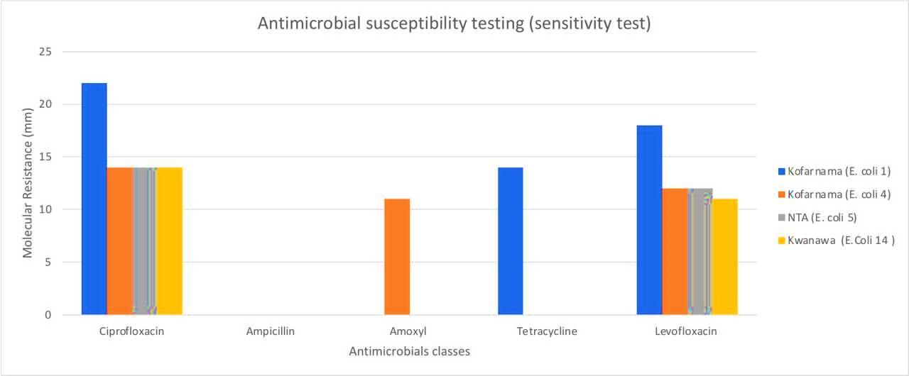

Fig 1. Antibacterial Activity of Selected Antibiotics on E. coli Isolates
Fig. 1 shows that the antibiotic susceptibility results reveal an important pattern in their zone of inhibition. Ciprofloxacin produced clear inhibition zones in all isolates, with the highest activity recorded at 22 mm in one isolate. This suggests that ciprofloxacin remains a relatively effective drug against poultry-associated E. coli in the study area. The uniform resistance of all isolates to ampicillin demonstrates widespread resistance to beta-lactam antibiotics, a phenomenon widely reported in poultry due to the long-term and often unregulated use of these drugs in livestock production. Resistance to amoxicillin followed a similar pattern, with only one isolate showing weak susceptibility. The complete resistance to tetracycline, except for a single isolate with moderate sensitivity, reflects the extensive and longstanding use of tetracycline in poultry farming for growth promotion and disease prevention. The isolates exhibited better susceptibility to levofloxacin, although inhibition zones ranged between 11 mm and 18p mm, indicating some degree of variation in response.

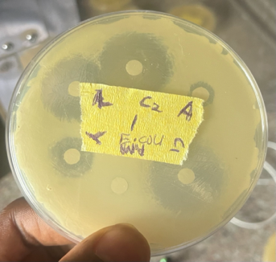
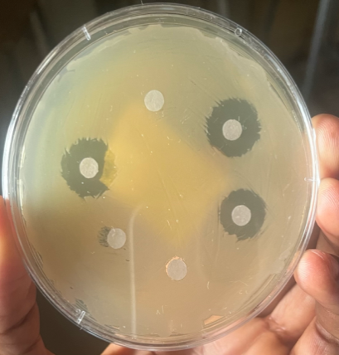

- (b)

Fig 2. Antimicrobial susceptibility test of E. coli by disc diffusion method showing zone of inhibition ( )
The overall findings indicate that the E. coli isolates exhibited multidrug resistance, particularly against commonly used veterinary antibiotics. The relatively better performance of fluoroquinolones such as ciprofloxacin and levofloxacin suggest that resistance to these drugs may be developing more slowly, possibly due to more restricted access or lower levels of misuse. However, the variation observed in susceptibility suggests that resistance could emerge with continuous exposure.

4.4 Detection of Extended-spectrum Beta- Lactamases (ESBLs)

4.4.1. Phenotypic Screening
The detection of Extended-spectrum Beta-Lactamases (ESBLs) was carried out by assessing the isolate response to the β-lactam antibiotic (ampicillin). Four different E. coli cultures were prepared, and ampicillin was added to each of them. Isolates that showed reduced susceptibility to ampicillin were considered potential ESBL producers.
All isolates were screened for ESBL activity by introducing ampicillin into the four test tubes containing the E. coli cultures. The tubes were then incubated for 24 hours in a shaking incubator. After incubation, the cultures were examined for growth. The presence of cloudy or thick turbidity indicated resistance to the antibiotic, suggesting ESBL production. Tubes that remained clear indicated that the bacteria were sensitive to ampicillin and therefore not producing ESBL.

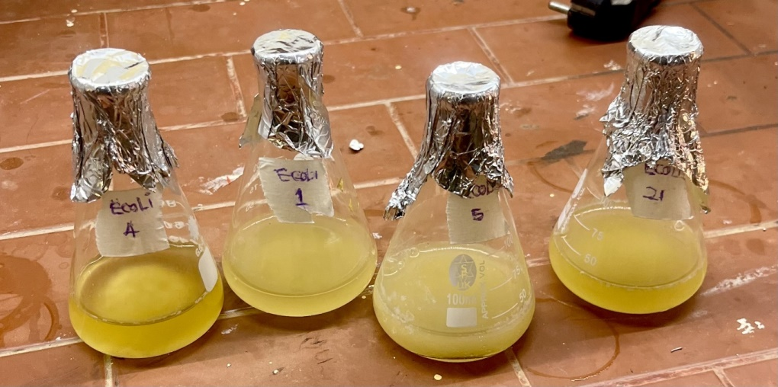
Fig 3. Phenotypic detection of Extended-spectrum Beta- Lactamases (ESBLs)

4.5 Molecular Confirmation of Genomic DNA and Plasmid DNA (Gel Electrophoresis)
The molecular confirmation carried out through agarose gel electrophoresis successfully verified the presence of plasmid DNA in all tested samples. The gel profile exhibited two major DNA populations: high-molecular-weight genomic DNA near the wells and lower-molecular-weight plasmid DNA migrating further down the gel. The detection of plasmid bands confirms that the transformation and subsequent plasmid extraction were successful. This indicates that the bacterial host cells contained the target plasmid and that the alkaline lysis extraction method effectively released plasmid DNA.
However, the presence of strong genomic DNA bands across the lanes demonstrates that genomic DNA contamination occurred during the extraction process. This contamination is commonly encountered when the lysis or neutralization steps are not optimally performed. Harsh pipetting or excessive vortexing can shear chromosomal DNA into smaller fragments, preventing it from efficiently precipitating and allowing it to remain in the final eluate. Similarly, incomplete neutralization can result in insufficient aggregation of genomic DNA and cell debris. The prominence of genomic DNA in the samples suggests that improvements in technique are needed to enhance plasmid purity.
Despite this contamination, the plasmid DNA obtained appears to be of adequate quality for most downstream applications, such as PCR amplification, restriction digestion, and sequencing. The presence of multiple plasmid conformations supercoiled, open circular and possibly linear further confirms the integrity of the extracted plasmid. Supercoiled plasmids migrate faster and are typically predominant in healthy extractions, while nicked or relaxed forms may arise during handling or due to slight damage to the plasmid backbone. These conformations do not negatively impact functional applications unless extremely high purity is required.
The results highlight the importance of careful handling during plasmid extraction to minimize genomic DNA carryover. Improvements such as gentle mixing, longer neutralization times, and column-based purification methods may significantly reduce contamination levels. Nevertheless, the clear plasmid bands indicate that the experiment successfully achieved its main objective: molecular confirmation of plasmid presence in the bacterial cultures.
Overall, the electrophoresis results validate the success of the plasmid extraction but also emphasize the need for refining the protocol to improve DNA purity. This will enhance downstream performance and reliability in future molecular biology applications.
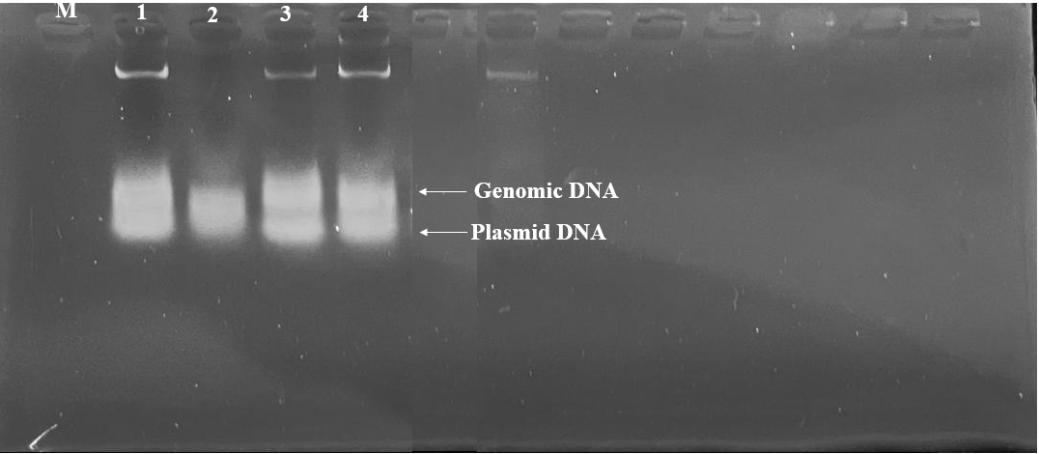

Fig 4. Molecular confirmation of genomic DNA and plasmid DNA

DISCUSSION
This study assessed the bacterial diversity, antibiotic resistance patterns and molecular characteristics of isolates obtained from chicken droppings in Kofar Nama, NTA and Kwanawa.
The biochemical results showed the presence of Proteus species, Escherichia coli and Salmonella species. Proteus occurred most frequently, especially in Kofar Nama, suggesting high microbial load and possible poor waste management. E. coli was found in all locations, reflecting its role as normal gut flora in poultry. The detection of Salmonella in NTA and Kwanawa is significant due to its public health implications as a foodborne pathogen.
The E. coli isolates showed multidrug resistance. Complete resistance to ampicillin, amoxicillin and tetracycline indicates the heavy use of these drugs in poultry production. Fluoroquinolones (ciprofloxacin and levofloxacin) were more effective, though inhibition zones varied. This suggests that while fluoroquinolone resistance is not yet widespread, it may emerge with continued misuse.
All isolates grew in the presence of ampicillin, indicating ESBL production. This demonstrates that some poultry bacteria have acquired enzymes capable of breaking down β-lactam antibiotics, contributing to treatment challenges and the spread of resistance genes.
Gel electrophoresis confirmed the presence of both genomic and plasmid DNA. Plasmid DNA bands indicate that the isolates carry plasmids which may encode antibiotic resistance. Some genomic DNA contamination was observed, but the plasmid DNA quality was adequate for further molecular work.
Kofar Nama had the highest number and diversity of isolates. NTA and Kwanawa had fewer isolates but still contained E. coli and Salmonella. This shows that bacterial contamination is broad and not limited to one location.
These findings emphasize the need for controlled antibiotic use in poultry farms, improved hygiene practices, and stronger surveillance to detect emerging antimicrobial resistance early. The presence of pathogenic and resistant bacteria in poultry droppings reinforces the importance of adopting safe handling practices across the poultry production chain.

CONCLUSION
The results of this research demonstrate clearly that chicken droppings in the study areas contain a wide range of enteric bacteria, including species with substantial health implications. The dominance of Proteus species reflects typical enteric microbial ecology in poultry environments, while the presence of E. coli and Salmonella confirms possible routes of contamination capable of affecting both poultry and human health. The antimicrobial susceptibility profile of the E. coli isolates reveals a disturbing pattern of multidrug resistance, especially to commonly used antibiotics such as Ampicillin, Amoxyl and tetracycline. These findings strongly suggest that antibiotics may be used frequently and perhaps inappropriately in these poultry systems, contributing to the accelerated development of resistant strains.
The study concludes that multidrug resistant bacteria, including E. coli and pathogenic Salmonella, may be widespread in poultry droppings within the sampled locations. This poses a real threat to public health, as resistant organisms can spread through improper waste disposal, contaminated equipment, exposure of farm workers and the consumption of under processed poultry products. There is an urgent need to address these risks through better farm management, improved hygiene practices and stricter antibiotic regulation. Without deliberate interventions, the spread of resistant organisms may continue, further compromising the efficacy of essential antibiotics in both humans and animals.

RECOMMENDATIONS
- it’s recommended that Regular surveillance and monitoring of antimicrobial resistance (AMR) patterns in E. coli isolates from chickens in Sokoto should be conducted to detect emerging resistance trends early and to update treatment guidelines effectively.
- Further molecular studies should be encouraged and conducted to identify and characterize the resistance genes prevalent in poultry E. coli isolates in Sokoto, in order to guide targeted interventions and inform policy formulation.
- Education and awareness campaigns should be promoted for poultry handlers, sellers, and farmers on the risks of inappropriate antibiotic use, poor hygiene practices, and the benefits of safer alternatives such as probiotics and vaccination.
- Proper management and disposal of poultry waste should be implemented to prevent environmental contamination with resistant E. coli strains, which have been detected at concerning levels in local chickens, particularly layers and broilers.

REFERENCES:
Abubakar, Sadiq; Bukar, Abba Ibrahim; Bislava, Mohammed Buba; Kolo, Usman Mohammed; Abdullahi, Abubakar Umar; Garba, Sani; Bello, Abubakar (2022). Assessment of farmer’s usage of antibiotics for poultry production in Sokoto Metropolis, Nigeria. Nigerian Journal of Animal Production. DOI: 10.51791/njap.vi.5046
Adeboye, Ayodele; Adeboye, Olufunke; Adeboye, Oluwaseun; Adeboye, Abiola; Adeboye, Opeyemi; Adeboye, Omotola (2023). Extended-spectrum beta-lactamase (ESBL)-producing Escherichia coli surveillance in Nigeria. Scientific Reports, 13: 72993. https://doi.org/10.1038/s41598-024-72993-w
Adeboye, Olufunke; Adeboye, Oluwaseun; Adeboye, Abiola; Adeboye, Opeyemi; Adeboye, Omotola (2023). Detection of ESBL genes in Escherichia coli isolates from chicken meat in Nigeria. Journal of Veterinary Science and Technology, 14(2), 115–123.
Adesola, Ridwan Olamilekan; Bakre, Adetolase Azizat; Adekanmbi, Abimbola Olumide; Ogunro, Bamidele Nyemike; Ogundijo, Oluwaseun Adeolu; Hamzat, Abdulafees; Hossain, Delower; Aribana, Moses Aimanosi; Balogun, Luqman Adeola (2023). Molecular and epidemiological characterization of ESBL-producing Escherichia coli from birds in Nigeria. Environmental Health Insights, 19: 1–10. https://doi.org/10.1177/11786302251329300
Agusi, Ebere Roseann; Kabantiyok, Dennis; Mkpuma, Nicodemus; Atai, Rebecca Bitiyong; Okongwu-Ejike, Chidinma; Bakare, Ebun Lydia; Budaye, James; Sule, Kabiru Garba; Rindaps, Rindah Joy; James, Gyallak Kingsley; Audu, Benshak John; Agada, Godwin Ojonugwa; Adegboye, Oyelola; Meseko, Clement Adebajo (2024). Prevalence of multidrug-resistant Escherichia coli isolates and virulence gene expression in poultry farms in Jos, Nigeria. Frontiers in Microbiology, 15: 1298582. https://doi.org/10.3389/fmicb.2024.1298582
Ahmed, Rabi; Musa, Ibrahim; Bello, Sani; Abdullahi, Umar; Garba, Abubakar; Yusuf, Maryam (2023). Multidrug resistance in Escherichia coli isolates from poultry in Nigeria. African Journal of Microbiology Research, 17(4), 145–153.
Ajayi, Olumide A.; Perewari, Doubra Otis; Otokunefor, Kingsley; Agbagwa, Obakpororo Ejiro (2023). Multidrug resistant Escherichia coli in poultry birds from Rivers State, Nigeria. Nigerian Journal of Basic and Applied Sciences, 31(2): 43–47. https://doi.org/10.4314/njbas.v31i2.7
Aliyu, Yakubu; Adegba, Justina Ananga; Hassan, Fatima Abdullahi; Ladidi, Maryam Abdulkarim; Oyibinga, Adah Ruth (2024). Prevalence and risk factors for multidrug-resistant Salmonella in poultry houses in Nasarawa State, Nigeria. Dutse Journal of Pure and Applied Sciences, 10(4c). https://dx.doi.org/10.4314/dujopas.v10i4c.34
Aworh, Maryam K.; Kwaga, Jacob; Okolocha, Emmanuel; Mba, Nkiruka; Thakur, Siddhartha (2019). Prevalence and risk factors for multi-drug resistant Escherichia coli among poultry workers in the Federal Capital Territory, Abuja, Nigeria. PLoS ONE, 14(11): e0225379. https://doi.org/10.1371/journal.pone.0225379
Bortolaia, Valeria; Guardabassi, Luca; Trevisan, Chiara (2021). Antimicrobial resistance in poultry production: global perspectives and One Health implications.
Bortolaia, Valeria; Guardabassi, Luca; Trevisan, Chiara; Bisgaard, Magne; Venturini, Claudia; Petersen, Andreas; Olsen, John E. (2021). Association between antimicrobial usage and resistance in Salmonella from poultry farms in Nigeria. BMC Veterinary Research, 17: 234. https://doi.org/10.1186/s12917-021-02938-2
Edenagbon, P. O., Chinaemerem, A. P., Bolarinwa, O. J., et al. (2024). Prevalence and risk factors of extended-spectrum β-lactamase-producing Escherichia coli from poultry flocks in Benin City, Nigeria. South Asian Journal of Research in Microbiology, 18(12). Available at: SAJRM
FAO. (2020). The FAO Action Plan on Antimicrobial Resistance 2021–2025. Rome: Food and Agriculture Organization of the United Nations. Available at: https://www.fao.org/documents/card/en/c/cb2890en
Aworh, M. K., Ekeng, E., Nilsson, P., Egyir, B., Owusu-Nyantakyi, C., & Hendriksen, R. S. (2022). Extended-spectrum β-lactamase-producing Escherichia coli among humans, beef cattle, and abattoir environments in Nigeria. Frontiers in Cellular and Infection Microbiology, 12, 869314.
Jibril, A. H., Kabir, M., Sani, A. O., Yahaya, M. S., Ballah, F. M., Akorede, F. R., Lawal, N., García, V., & Yakubu, Y. (2024). Molecular prevalence of multidrug-resistant Escherichia coli in dressed broiler chickens in Sokoto, Nigeria. Research Square Preprint. https://doi.org/10.21203/rs.3.rs-7461615/v1
MDPI Study Group (Nigeria) (2024). Genomic diversity and antibiotic resistance of Escherichia coli and Salmonella from poultry farms in Oyo State, Nigeria. Microorganisms, 13(6): 1174. https://www.mdpi.com/2076-2607/13/6/1174
Mshana, S.E., Kimera, Z.I., Rweyemamu, M.M., Mboera, L.E.G., & Matee, M.I.N. (2020). Antimicrobial use and resistance in food-producing animals and the environment: An African perspective. Antimicrobial Resistance and Infection Control, 9: 37. https://doi.org/10.1186/s13756-020-0697-x
Mukhtar, K., Yahaya, M. S., Uhuami, A. O., Yakubu, Y., & Jibril, A. H. (2025). Molecular prevalence of extended spectrum beta-lactamase producing Escherichia coli in dressed broiler chickens in Sokoto Metropolis. The Microbe, 8(100434). Available at: ResearchGate PDF
Ndahi, Mwapu Dika; Hendriksen, Rene; Helwigh, Birgitte; Card, Roderick M.; Fagbamila, Idowu Oluwabunmi; Abiodun-Adewusi, Oluwadamilola Olawumi; Ekeng, Eme; Adetunji, Victoria; Adebiyi, Ini; Andersen, Jens Kirk (2023). Determination of antimicrobial use in commercial poultry farms in Plateau and Oyo States, Nigeria. Antimicrobial Resistance & Infection Control, 12: 30. https://doi.org/10.1186/s13756-023-01235-x
Nhung, N.T., Cuong, N.V., Thwaites, G., & Carrique-Mas, J. (2021). Antimicrobial usage and antimicrobial resistance in animal production in Southeast Asia: A review. Antibiotics, 10(5): 583. https://doi.org/10.3390/antibiotics10050583
O’Neill, J. (2020). Tackling drug-resistant infections globally: Final report and recommendations. Review on Antimicrobial Resistance.
Ochi, Timic B.; Ojja, C.V.; (2024). Antimicrobial resistance profiles of Escherichia coli bacteria from commercial laying chickens in Ibadan, Nigeria. International Journal of Innovative Science and Research Technology, 9(1): 377. Available at: https://ijisrt.com/assets/upload/files/IJISRT24JAN377.pdf
Okon, Ekemini M.; Okocha, Reuben C.; Adesina, Babatunde T.; Ehigie, Judith O.; Alabi, Olayinka O.; Bolanle, Adeniran M.; Matekwe, N.; Falana, Babatunde M.; Tiamiyu, Adebisi M.; Olatoye, Isaac O.; Adedeji, Olufemi B. (2022). Antimicrobial resistance in fish and poultry: Public health implications for animal source food production in Nigeria, Egypt, and South Africa. Frontiers in Antibiotics, 1: 1043302. https://doi.org/10.3389/frabi.2022.1043302
Perewari, D. O., Otokunefor, K., & Agbagwa, O. E. (2023). Multidrug resistant Escherichia coli in poultry birds from a poultry farm in Rivers State, Nigeria. Nigerian Journal of Basic and Applied Sciences, 31(2): 43–47. DOI: 10.4314/njbas.v31i2.7. Available at: AJOL
PLOS One Study Group (Nigeria) (2023). Assessing the mechanisms of multi-drug resistant non-typhoidal Salmonella (NTS) serovars isolated from layer chicken farms in Nigeria. PLoS ONE, 18(9): e0290754. https://doi.org/10.1371/journal.pone.0290754
Shaikh, S., Fatima, J., Shakil, S., Rizvi, S. M. D., & Kamal, M. A. (2022). Prevalence of ESBL-producing Escherichia coli in poultry and implications for public health. Microbial Drug Resistance, 28(3), 245–253.
Shaikh, T., Kakar, M. A., & Ali, N. (2022). A One Health approach to antimicrobial resistance. Asian Biomedicine, 16(4), 151–152. https://doi.org/10.2478/abm-2022-0019
Tadesse, D. A., Zhao, S., Tong, E., Ayers, S., Singh, A., Bartholomew, M. J., McDermott, P. F. (2022). Antimicrobial resistance in Escherichia coli: Mechanisms and global impact. Infection and Drug Resistance, 15, 123–135.
Tadesse, E., Yitayih, W., & Woldeamanuel, Y. (2022).Antimicrobial resistance profiles of Escherichia coli isolated from clinical and environmental samples. JAC–Antimicrobial Resistance, 6(2), dlae061. https://doi.org/10.1093/jacamr/dlae061
World Health Organization (WHO). (2015). Global Action Plan on Antimicrobial Resistance. Geneva: WHO. Available at: https://www.who.int/publications/i/item/9789241509763
World Health Organization (WHO). (2021). Antimicrobial resistance: Report by the Director-General. Geneva: WHO. Available at: WHO IRIS
World Health Organization (WHO). (2023). Antimicrobial resistance: Key facts. Geneva: WHO. Available at: https://www.who.int/news-room/fact-sheets/detail/antimicrobial-resistance
Yuan, L., Sun, J., Zhou, Y., Yang, F., Chen, H., Lin, J., & Xu, X. (2021).Clinical significance of antimicrobial resistance in Escherichia coli. Frontiers in Cellular and Infection Microbiology, 11, 639.
Yuan, Y., Liang, B., Jiang, B., Zhu, L., Wang, T., Li, Y., Liu, J., Guo, X., Ji, X., & Sun, Y. (2021). Migratory wild birds carrying multidrug-resistant Escherichia coli as potential transmitters of antimicrobial resistance in China. PLOS ONE, 16(12), e0261444. https://doi.org/10.1371/journal.pone.0261444

