ITLE PAGE

OPTIMIZATION IN THE PRODUCTION OF TEREPHTHALIC ACID FROM WASTE PLASTIC BOTTLES

BY

ABDULLAHI TANKO ABDULLAHI
ADM NO: 2010312061

A RESEARCH PROJECT SUMMITTED TO THE DEPARTMENT OF ENERGY AND APPLIED CHEMISTRY, FACULTY OF CHEMCAL AND LIFE SCIENCES, USMANU DANFODIYO UNIVERSITY SOKOTO.
IN PARTIAL FULFILMENT OF THE REQUIREMENTS FOR THE AWARD OF DEGREE OF BACHELOR OF SCIENCE (BSc.Hons) DEGREE IN ENERGY AND APPLIED CHEMISTRY.

NOVEMBER, 2025
APPROVAL PAGE

This is to certify that the project report titled ‘Optimization in the Production of Terephthalic Acid From Waste Plastic Bottles ’ by Abdullahi Tanko Abdullahi (2010312061) has met the requirements for the award of the Bachelor of Science Degree (B.Sc.Hons)

______________________ _____________________
Prof. A.M sokoto Date
Project Supervisor

______________________ _____________________
External examiner Date

______________________ _____________________
Prof. M. L. Mohammed Date Head of Department

DECLARATION

I hereby declare that this project is based on my original work except for quotation and citation which have been duly acknowledge .I also declare that it has not been previously or concurrently submitted for any other degree at Usmanu Danfodiyo University sokoto.

_________________ _____________________
Abdullahi Tanko Abdullahi Date

Acknowledgement
First and foremost, I give all praise and thanks to Almighty Allah for His infinite mercy, guidance, and strength throughout my academic journey and for the successful completion of this research work. Without His divine help, this achievement would not have been possible.
Secondly, my sincere appreciation goes to my project supervisor, Prof. A. M. Sokoto, for his tireless guidance, patience, and constructive advice throughout the course of this project. His encouragement, valuable suggestions, and continuous support played a vital role in the success of this work.
I am also deeply grateful to the Department of Chemistry, Faculty of Chemical and Life Sciences, Usmanu Danfodiyo University, Sokoto (UDUS), for providing a solid academic foundation, an enabling environment, and the facilities required for the smooth conduct of this research.
My profound appreciation goes to all my lecturers in the Department of Chemistry, including prof. M.L Muhammad Dr.Zauro, Mallama Hafsat Batue, among others, for their dedication, mentorship, and the knowledge imparted to me throughout my studies. Your efforts have greatly shaped my academic and personal growth.
My heartfelt gratitude goes to my beloved parents, Alhaji Abdullahi Tanko Ibrahim and Hajiya Maimunat Ahmed, for their endless prayers, love, moral support, and sacrifices toward my education. I also appreciate my siblings Maryam, Zainab, Aisha, Safiya, Halima, Yusuf, Abdul Salam, Nana Khadija, Ibrahim, Umar Farouk Abdullahi Magaji, Rukayya Adam, and Suraju Muhammad for their continuous encouragement, understanding, and care.
Special thanks to my UDUS family Zainab Saifullah Harun, Umar Usama Karabonde,Abubakar Rufai,Hauwa Abubakar, Umar Amina Yusuf Idris Ahmad, Suleiman Salisu Babangida, Umar Farouk Saidu, Hamisu Suleiman, Ismail Ayuba, Zahradeen Ayuba, Zainab Aliyu, Khadija Kabe, Nabila Ibrahim, Layuza Umar, Yusuf Sumayya, and Suwaiba Dauda for your friendship, motivation, and support throughout my academic life.
I also extend my sincere appreciation to my favourite uncle, Baba Sahabi, for his unwavering support, and to my friend Ibrahim Salihu, for always being there. My heartfelt thanks also go to my coursemates Mallam Abdulrahman Gidandottee, Muhammad Fatima Lema, Baffa Ibrahim, Imran Nasir, Hamza Shagari, Saifullah Aminu, Azeezah Ishau, Sa’adatu Shehu, Anas Muhammad, Abdul Azeez Shagari, Muhammad Ibrahim Funtua, Alamin Yusuf,Lawal Safiyanu and many others for your cooperation, teamwork, and words of encouragement. You all made this journey a memorable one.
Above all, I extend my appreciation to everyone who, in one way or another, contributed to the successful completion of this project. May Almighty Allah bless you all abundantly.

Table of contents

Contents
TITLE PAGE i
DECLARATION iii
Acknowledgement iv
Contents vi
Abstract ix
INTRODUCTION 1
1.1 Background of the Research 1
1.2 Statement of the Problem 2
1.3 Justification of the Research 2
1.4 Aim and Objectives of the Research 3
CHAPTER TWO 4
LITERATURE REVIEW 4
2.1 Introduction 4
2.2 Chemistry and Structure of Polyethylene Terephthalate (PET) 4
2.3.1 Polyesters 5
2.3.2Polyamides 6
2.3.3 Polyolefins 6
2.3.4 Polycarbonates 6
2.3.5 Polyurethanes 6
2.3.6 Polyethers 6
2.5 Environmental Impact of PET Waste 7
2.6 Methods of PET Waste Management 8
2.6.1 Landfilling and Incineration 8
2.6.2 Mechanical Recycling 8
2.6.3 Chemical Recycling 8
2.7 Chemical Depolymerization of Polyethylene Terephthalate (PET) 8
2.7.1 Hydrolysis 9
2.7.2 Glycolysis 10
2.7.3 Methanolysis 10
2.7.4 Aminolysis 11
2.6 Mechanism of Alkaline Depolymerization 11
2.7 Importance of Chemical Depolymerization 12
2.8.1 Acidic Hydrolysis 12
2.8.2 Neutral Hydrolysis 12
2.8.3 Alkaline Hydrolysis 12
2.9 Role of Solvents and Catalysts 13
2.10 Optimization in Chemical Processes 13
CHAPTER THREE 17
MATERIALS AND METHODS 17
3.1 Materials 17
3.1.1 List of Apparatus and Equipment 17
3.1.2 List Reagents 18
3.2 Methods 18
3.2.1 Preparation of PET Samples 18
3.2.2 Preparation of Ethanolic potassium hydroxide 18
3.2.2 Alkaline Hydrolysis of PET Error! Bookmark not defined.
3.2.3 Determination of Percentage Yield 19
3.2.4 FTIR Analysis of residue filtrate samples 20
3.3 Experimental Design and Optimization 20
CHAPTER FOUR 21
RESULTS AND DISCUSSION 21
4.1 Results 21
4.2 Graphical Representation of Percentage Yield 22
4.3.2 FTIR Spectrum of Filtrate 24
4.4 Discussion 24
CHAPTER FIVE 26
SUMMARY, CONCLUSION AND RECOMMENDATION 26
5.1 Summary 26
5.2 Conclusion 26
5.3 Recommendations 27
References 28

Abstract
This study investigates the optimization of terephthalic acid (TPA) production from waste polyethylene terephthalate (PET) bottles via Ethanolysis. The objective was to maximize TPA recovery while using different temperature conditions . Waste PET was cleaned, shredded into flakes and subjected to Ethanolysis in the presence of a potassium hydroxide catalyst. Key process variables—reaction temperature, catalyst concentration, ethanol-to-PET ratio, and reaction time—were systematically varied using an experimental design approach to determine their effects on conversion and TPA yield. Product separation included filtration and acidification; the solid and liquid fractions were characterized by Fourier Transform Infrared spectroscopy (FTIR) and melting-point determination to confirm TPA formation and purity.
Optimization showed that all examined variables significantly influenced depolymerization efficiency: yield increased with temperature, catalyst concentration and ethanol ratio up to a point, beyond which side reactions and material loss reduced effective recovery. An optimum region of operating conditions was identified that balanced high conversion, product purity, and practical reagent usage. Under these optimized conditions the process delivered a marked improvement in TPA recovery and produced material whose FTIR spectrum matched that of standard terephthalic acid. The optimized method demonstrates a feasible route for valorizing post-consumer PET into a valuable monomer using accessible reagents and relatively mild conditions.

CHAPTER ONE

INTRODUCTION

1.1 Background of the Research
Plastics are among the most widely used materials in modern society because of their durability, versatility, and low cost. They are used in packaging, construction, clothing, transportation, and household goods. However, their high stability and resistance to degradation have made them one of the leading causes of environmental pollution worldwide. Among all plastic materials, polyethylene terephthalate (PET) is one of the most commonly produced and utilized. PET is primarily used for manufacturing beverage bottles, food containers, and packaging materials due to its strength, clarity, and resistance to moisture and chemicals (Awaja and Pavel, 2005).
In Nigeria and many developing countries, waste management practices are still inadequate. Large quantities of plastic waste, especially PET bottles, are disposed of indiscriminately, leading to blocked drainage systems, flooding, and land pollution. When burnt, these plastics release toxic gases such as carbon monoxide and dioxins, which contribute to air pollution and global warming. Therefore, there is an urgent need to find sustainable and environmentally friendly methods to recycle and reuse waste plastics into valuable chemical products.
One important product that can be derived from PET waste is terephthalic acid (TPA), an organic compound used as a key raw material in the production of new PET, polyester fibers, and other industrial chemicals. Terephthalic acid can be obtained through the chemical depolymerization of PET, which breaks down the long-chain polymer into its original monomers, mainly ethylene glycol and terephthalic acid. This process not only helps in the management of plastic waste but also reduces the demand for virgin petrochemical feedstocks used in producing new plastics (Ghaemy and Mossaddegh, 2005).
Optimizing the production of terephthalic acid from waste plastic bottles involves determining the best reaction conditions such as temperature, reaction time, solvent ratio, and catalyst concentration that yield the highest recovery and purity of terephthalic acid. Ethanol and tetrahydrofuran are often used as reaction solvents, while potassium hydroxide (KOH) acts as a strong base to facilitate the depolymerization process. The process conditions need to be controlled to prevent side reactions and degradation of the product.
Therefore, this research is focused on converting PET waste into terephthalic acid using an ethanolysis process under different reaction conditions to determine the optimum conditions for maximum yield. This approach not only contributes to the circular economy but also supports environmental sustainability and pollution reduction efforts.

1.2 Statement of the Problem
The accumulation of non-biodegradable plastic waste, particularly PET bottles, has become a major environmental concern in recent years. These plastics are not easily degraded by natural processes and can persist in the environment for hundreds of years. In many Nigerian cities, PET bottles litter streets, waterways, and dumpsites, creating environmental, aesthetic, and health problems.
Although recycling programs exist in some developed countries, they are often limited or poorly implemented in developing nations due to lack of awareness, inadequate facilities, and poor waste management infrastructure. As a result, most plastic wastes end up being incinerated or dumped in landfills, leading to soil and air contamination.
Furthermore, Nigeria imports large quantities of terephthalic acid and other petrochemical products for industrial use despite the availability of abundant plastic waste that can serve as raw material for their production. This not only puts pressure on the national economy but also wastes valuable resources that could be reused locally.
Therefore, there is a need to explore and optimize local methods for converting waste PET bottles into useful industrial materials such as terephthalic acid. This research seeks to address this problem by determining the best reaction conditions for maximum conversion efficiency and yield, thereby providing a sustainable way to manage plastic waste while producing valuable products.

1.3 Justification of the Research
This study is justified for several reasons. Firstly, it contributes to solving the growing problem of plastic pollution, which poses serious environmental and health risks. Recycling waste PET bottles into terephthalic acid will help reduce the volume of plastic waste in the environment and minimize the harmful effects of plastic disposal methods such as burning or landfilling.
Secondly, the process of depolymerizing PET into terephthalic acid creates an opportunity for value addition and resource recovery. Instead of treating plastic waste as an environmental nuisance, it becomes a valuable raw material for producing industrial chemicals. This approach supports the principles of sustainable development and the circular economy, where waste materials are reused in the production cycle.
Thirdly, optimizing the reaction conditions for producing terephthalic acid from PET ensures that the process is cost-effective, efficient, and environmentally friendly. Understanding the effects of reaction time, temperature, and solvent composition will help establish parameters for large-scale recovery of terephthalic acid with high purity.
Finally, the research will serve as a useful reference for local industries and academic institutions interested in waste recycling, polymer chemistry, and environmental management. It will also contribute to the body of knowledge on plastic waste valorization and demonstrate the feasibility of transforming waste into wealth in Nigeria.

1.4 Aim and Objectives of the Research
Aim
The main aim of this research is to optimize the production of terephthalic acid from waste plastic bottles (PET) through ethanolysis under varying experimental conditions.
Objectives
The specific objectives of this research are to:
- Collect and prepare waste PET bottles for depolymerization.
- Carry out the chemical depolymerization of PET using ethanol, tetrahydrofuran, and potassium hydroxide under different reaction conditions.
- Determine the effect of reaction temperature and time on the yield of terephthalic acid.
- Analyze the obtained product using appropriate techniques (such as FTIR spectroscopy) to confirm the presence and purity of terephthalic acid.

CHAPTER TWO

LITERATURE REVIEW

2.1 Overview of plastics
Plastic materials have become an indispensable part of modern life due to their versatility, low cost, and lightweight nature. They are used in almost every sector including packaging, construction, transportation, and consumer goods (Awaja and Pavel, 2005). Among the most widely produced plastics is polyethylene terephthalate (PET), a polymer made from terephthalic acid and ethylene glycol through a condensation process. PET is the main raw material for beverage bottles, synthetic fibers, and food containers. However, the increase in the global use of PET has led to a corresponding rise in plastic waste generation (Yousif and Haddad, 2013).
Plastic waste poses a serious environmental challenge because of its non-biodegradable nature and resistance to degradation. It accumulates in landfills, waterways, and drainage systems, especially in developing nations where waste management infrastructure is inadequate (Al-Salem, Lettieri, and Baeyens, 2009). Converting waste PET into valuable products such as terephthalic acid (TPA) provides an environmentally friendly and economically viable route for managing plastic waste.
This chapter reviews relevant literature on PET chemistry, recycling methods, depolymerization processes, optimization principles, and analytical techniques used in characterizing terephthalic acid.

2.2 Chemistry and Structure of Polyethylene Terephthalate (PET)
Polyethylene terephthalate (PET) is a thermoplastic polyester formed through the condensation polymerization of terephthalic acid (TPA) or dimethyl terephthalate (DMT) with ethylene glycol (EG). Its chemical structure consists of repeating units of ethylene glycol and terephthalate linked by ester bonds, giving it the general formula:
[−𝑂𝐶–𝐶6𝐻4–𝐶𝑂𝑂𝐶𝐻2𝐶𝐻2𝑂−]𝑛[−OC–C6H4–COOCH2CH2O−]n
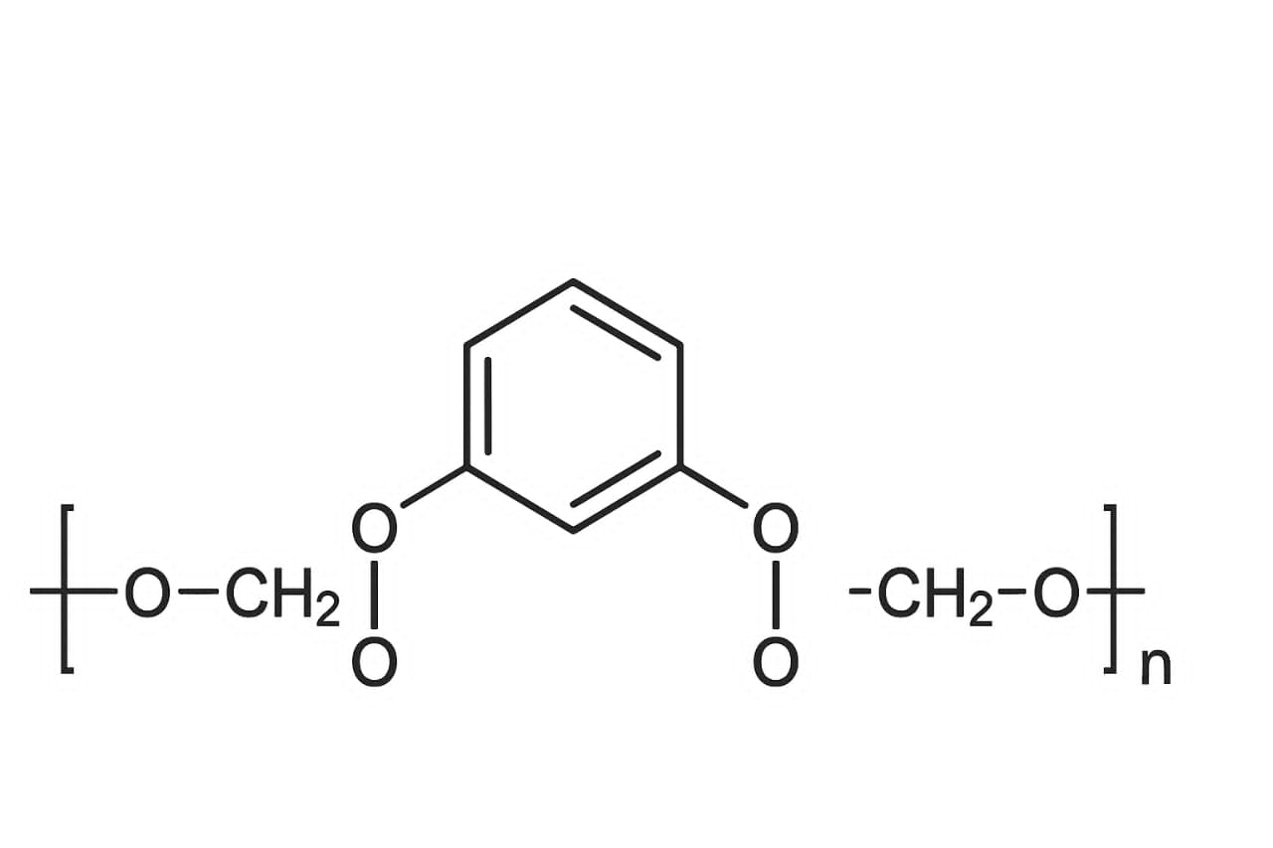
The polymer’s structure imparts excellent mechanical strength, transparency, and chemical resistance (Ghaemy and Mossaddegh, 2005). PET has a glass transition temperature around 70–80 °C and a melting point near 250 °C, which makes it suitable for beverage packaging and textile applications (Hopewell, Dvorak and Kosior, 2009).
PET’s high molecular weight and ester linkages make it resistant to hydrolysis and biodegradation. Consequently, discarded PET bottles can persist in the environment for hundreds of years. Understanding the structure and chemical nature of PET is therefore essential for determining appropriate recycling or depolymerization methods.
2.3. Classification of Plastics Based on Functional Groups
Plastics can be classified using several criteria — origin, thermal response, or molecular structure — but classification based on functional groups provides insight into their chemical reactivity and recycling potential.

2.3.1 Polyesters
Polyesters are condensation polymers containing ester (–COO–) linkages. Common examples include PET, polybutylene terephthalate (PBT), and polycaprolactone (PCL). Polyesters are susceptible to alcoholysis, hydrolysis, and aminolysis, making them ideal for chemical recycling.

2.3.2Polyamides
These contain amide (–CONH–) functional groups, such as in nylon-6 and nylon-6,6. Their strong hydrogen bonding gives excellent mechanical strength and resistance to abrasion.

2.3.3 Polyolefins
Polymers such as polyethylene (PE) and polypropylene (PP) are composed solely of carbon and hydrogen, featuring C–C single bonds. They are chemically inert and difficult to depolymerize chemically due to the lack of reactive functional groups.

2.3.4 Polycarbonates
Polycarbonates contain carbonate (–O–(C=O)–O–) linkages. They exhibit high impact strength, heat resistance, and optical clarity, used in lenses and safety equipment.

2.3.5 Polyurethanes
Formed by reaction between polyols and diisocyanates, they contain urethane linkages (–NH–COO–) and are widely used in foams, elastomers, and coatings.

2.3.6 Polyethers
Polyethers have ether (–O–) linkages, giving flexibility and low glass transition temperatures. Examples include polyethylene oxide (PEO) and polypropylene oxide (PPO).
This classification helps in selecting suitable chemical depolymerization methods, since the type of functional group dictates reactivity and cleavage mechanism.

Table 2.4Applications of Plastics
The versatility of plastics has led to their widespread use across industries.
Sector | Examples of plastics used | Applications
Packaging | PET,PE,PP | Bottles,films, containers
Construction | PVC, PU,PS | Pipes,cables, insulation
Automotive | ABS,PP,PU | Dashboards, bumpers
Textiles | PET,Nylon | Fabrics, carpets
Electronics | PC,PS | Casings, insulation
Medical | PVC,PP,PET | Syringes,IV bags

However, the same durability that makes plastics valuable in these applications also makes them environmentally persistent. PET bottles, in particular, accumulate in large quantities and resist natural decomposition.
Recycling these materials through chemical depolymerization offers a dual advantage: reducing waste volume and recovering valuable monomers like terephthalic acid (TPA) and ethylene glycol (EG).

2.5 Environmental Impact of PET Waste
The environmental impact of PET waste is profound. When disposed of improperly, PET bottles clog drainage systems, cause flooding, and contribute to urban pollution. The burning of PET produces toxic gases such as carbon monoxide, benzene, and formaldehyde, which harm human health and contribute to greenhouse gas emissions (Vilaplana and Karlsson, 2008).
In Nigeria, plastic waste constitutes a large proportion of municipal solid waste, yet the level of recycling is still very low (Ikechukwu, 2019). PET bottles are often discarded after a single use due to lack of collection systems, poor awareness, and inadequate recycling infrastructure. This has led to growing concerns about environmental degradation and resource wastage.
Recycling PET into its monomers or useful chemicals like terephthalic acid offers a practical solution that not only reduces environmental pollution but also supports sustainable industrial development (Kumar and Sinha, 2020).

2.6 Methods of PET Waste Management
Several methods are employed globally for managing PET waste. These include:

2.6.1 Landfilling and Incineration
Landfilling is the simplest form of waste disposal, but it leads to land pollution and leachate formation that can contaminate groundwater (Andrady, 2015). Incineration, on the other hand, reduces waste volume but releases toxic gases and contributes to air pollution and global warming (Al-Salem et al., 2009).

2.6.2 Mechanical Recycling
Mechanical recycling involves collection, sorting, cleaning, shredding, and remolding of PET into new products. While cost-effective, this process leads to a decrease in polymer properties due to chain scission during processing (Welle, 2011). It also requires clean, sorted PET, which limits its application in mixed or contaminated waste streams.

2.6.3 Chemical Recycling
Chemical recycling breaks down PET into its monomers or oligomers through chemical reactions such as hydrolysis, glycolysis, methanolysis, and aminolysis. This process yields products of high purity that can be reused in new polymer synthesis (Sinha et al., 2010). Chemical recycling is more sustainable and efficient for recovering valuable raw materials from PET waste.

2.7 Chemical Depolymerization of Polyethylene Terephthalate (PET)
Depolymerization refers to the chemical process of converting a polymer back into its monomers or smaller molecular fragments through the breaking of covalent bonds within its structure. For polyethylene terephthalate (PET), this process involves the cleavage of the ester linkages connecting terephthalic acid (TPA) and ethylene glycol (EG) units. The aim of depolymerization is to recover valuable raw materials for reuse, thereby reducing plastic waste accumulation and conserving petrochemical resources (Datta and Kopczyńska, 2002).
PET, represented by the repeating structural unit [–OOC–C₆H₄–COOCH₂CH₂O–]ₙ, is highly stable and resistant to environmental degradation. The ester bonds (–COO–) that link the aromatic terephthalate units with the aliphatic ethylene glycol units can, however, be broken under suitable chemical conditions. Various depolymerization routes have been developed to achieve this, including hydrolysis, glycolysis, methanolysis, and aminolysis. Each method differs in the reagents used, operating conditions, and the type of products obtained.

2.7.1 Hydrolysis
Hydrolysis involves breaking down PET in the presence of water, and depending on the reaction medium, it can be carried out under acidic, neutral, or alkaline conditions. The overall reaction produces terephthalic acid (TPA) and ethylene glycol (EG) as major products.
General reaction:
PET + H₂O → TPA + EG
Acidic Hydrolysis:
This process uses concentrated acids such as sulfuric acid at elevated temperatures (200–250 °C). The acid acts as both a solvent and a catalyst, promoting the cleavage of ester bonds. It is efficient in yielding high-purity TPA but generates large volumes of corrosive effluent that must be neutralized before disposal (Goto et al., 2004).
The general chemical change can be summarized as:
PET + H₂O (H₂SO₄, heat) → TPA + EG
Neutral Hydrolysis:
Neutral hydrolysis uses only water or steam at high temperature and pressure (usually 200–250 °C and 1–4 MPa). It avoids acid or base wastes and produces TPA and EG directly. However, because PET is hydrophobic, high pressure and temperature are required to ensure adequate contact between PET and water (Awaja and Pavel, 2005).
Reaction: PET + H₂O (steam, high T/P) → TPA + EG
Alkaline Hydrolysis:
Also known as saponification, this method uses a base such as sodium hydroxide (NaOH) or potassium hydroxide (KOH). The base attacks the ester bonds of PET, forming a salt of terephthalic acid (Na₂TPA or K₂TPA) and releasing ethylene glycol. Acidification of the salt produces pure TPA.
Reactions:
PET + KOH → K₂TPA + EG
K₂TPA + HCl → TPA + KCl
This approach is the most environmentally friendly and cost-effective since it operates at moderate temperatures (70–90 °C) and produces high yields with minimal corrosion (Yoshioka et al., 2004; Imran et al., 2013).
Hydrolysis is one of the most direct methods for PET depolymerization and provides terephthalic acid suitable for reuse in polymer production or as a raw material for other chemical syntheses.

2.7.2 Glycolysis
Glycolysis is a widely studied method for PET depolymerization in which the polymer reacts with glycols such as ethylene glycol (EG), diethylene glycol (DEG), or propylene glycol (PG). This reaction typically occurs in the presence of a catalyst like zinc acetate or manganese acetate at 180–220 °C. The main product is bis(hydroxyethyl) terephthalate (BHET), a monomer that can be repolymerized into PET or used in the synthesis of unsaturated polyester resins.
Reaction: PET + EG → BHET
Glycolysis offers several advantages: it proceeds under relatively mild conditions, avoids the formation of corrosive by-products, and yields products of high purity. The BHET obtained can be separated by recrystallization, ensuring easy purification. However, the main limitation is the need for precise control of temperature and catalyst concentration to prevent incomplete depolymerization or unwanted side reactions (Ghaemy and Mossaddegh, 2005).

2.7.3 Methanolysis
Methanolysis involves treating PET with methanol under high temperature (200–280 °C) and pressure (20–40 bar) to yield dimethyl terephthalate (DMT) and ethylene glycol.
Reaction: PET + CH₃OH → DMT + EG
DMT can be purified through distillation and used again as a raw material for new PET synthesis. The method is effective and yields high-purity products, but its industrial use is limited due to high energy requirements and the need for specialized high-pressure reactors (Sinha et al., 2010).

2.7.4 Aminolysis
In aminolysis, PET is reacted with amines such as methylamine, ethylenediamine, or ethanolamine to produce terephthalamides.
Reaction: PET + RNH₂ → Terephthalamide + EG
This process is less common for large-scale recycling but is useful in producing chemical intermediates for resins, coatings, and adhesives. The amide derivatives obtained have applications in specialty polymer industries. Aminolysis generally occurs at temperatures between 100–180 °C and can proceed without additional catalysts (Datta and Kopczyńska, 2002).

2.8 Mechanism of Alkaline Depolymerization
In alkaline hydrolysis, hydroxide ions (OH⁻) attack the carbonyl carbon of the ester linkage in PET, forming a tetrahedral intermediate that collapses to release ethylene glycol and produce the corresponding terephthalate salt (e.g., K₂TPA). When the reaction mixture is acidified, terephthalic acid (TPA) precipitates as a solid product.
Step 1: PET + KOH → K₂TPA + EG
Step 2: K₂TPA + HCl → TPA + KCl
This mechanism explains the efficiency of KOH in breaking the ester bonds. Solvents such as ethanol and tetrahydrofuran (THF) enhance depolymerization by swelling the polymer and improving hydroxide ion accessibility (Chen et al., 2011). The resulting terephthalic acid can be purified by washing and recrystallization, yielding white crystalline solids suitable for reuse.

2.9 Importance of Chemical Depolymerization
Chemical depolymerization plays a vital role in PET recycling by
Recovering high-value monomers such as terephthalic acid and ethylene glycol.
Reducing environmental pollution from non-biodegradable plastics.
Conserving resources by reusing recovered raw materials in polymer production.
Supporting sustainability goals through waste minimization and material circularity.
Among the available methods, alkaline hydrolysis stands out for its simplicity, effectiveness, and adaptability to laboratory and industrial conditions. It forms the basis for this research, which focuses on optimizing the reaction parameters temperature, time, and solvent composition to maximize terephthalic acid yield from waste PET bottles.
2.10 Hydrolysis of PET to Produce Terephthalic Acid
Hydrolysis involves breaking the ester linkages in PET in the presence of water, base, or acid. It can occur under three main conditions:

2.10.1 Acidic Hydrolysis
This process uses strong acids such as sulfuric acid at high temperatures to yield terephthalic acid and ethylene glycol. Although effective, it produces corrosive waste and requires costly neutralization (Goto et al., 2004).2.6.1 Acidic Hydrolysis

2.10.2 Neutral Hydrolysis
Neutral hydrolysis uses water or steam under high temperature (200–250 °C) and pressure. It avoids acid waste but demands expensive equipment to handle the high pressure (Awaja and Pavel, 2005).

2.10.3 Alkaline Hydrolysis
Alkaline hydrolysis, also known as saponification, uses an alkaline medium such as sodium hydroxide (NaOH) or potassium hydroxide (KOH) to depolymerize PET into disodium or dipotassium terephthalate, which is later acidified to recover terephthalic acid (Yoshioka, Motoki and Okuwaki, 2004). This method is favored for its high yield, lower corrosion problems, and ability to operate under moderate conditions.
In this research, PET waste was depolymerized using ethanol and tetrahydrofuran (THF) as solvents and KOH as a base. These solvents enhance PET solubility and reaction rate by swelling the polymer matrix and allowing effective penetration of hydroxide ions.

2.11 Role of Solvents and Catalysts
Solvents play a crucial role in PET depolymerization. Ethanol acts as a polar solvent that helps dissolve the base and facilitates heat transfer, while THF assists in polymer swelling and mixing, thus improving reaction kinetics (Chen et al., 2011).
Potassium hydroxide (KOH) serves as the catalyst and reactant, providing hydroxide ions that attack the ester linkages of PET. Studies have shown that the efficiency of KOH in PET depolymerization depends on its concentration, solvent composition, and reaction temperature (Siddiqui et al., 2010).
Temperature and time also influence yield: higher temperatures accelerate hydrolysis but may cause degradation if too high, while longer reaction times allow complete breakdown of the polymer chains.

2.12 Optimization in Chemical Processes
Optimization is the process of finding the best operational conditions to maximize product yield or minimize cost and time. In chemical reactions, it involves varying parameters such as temperature, catalyst concentration, solvent ratio, and reaction time to achieve the highest efficiency (Montgomery, 2017).
In PET depolymerization, optimization ensures high terephthalic acid yield and purity while minimizing energy use and side reactions. Techniques like Response Surface Methodology (RSM) and Design of Experiments (DOE) are often applied to study the interaction of multiple parameters and determine optimal conditions (Kumar and Jha, 2015).
For instance, Imran et al. (2013) reported an optimum yield of 92% terephthalic acid from PET using NaOH at 80 °C for 60 min, while Ochoa-Gómez et al. (2017) optimized glycolysis of PET with a 90% recovery of BHET. These findings guide experimental design for efficient PET recycling.
2.13 Analytical Techniques for Characterization of Terephthalic Acid
Characterization of terephthalic acid confirms the identity and purity of the recovered product. The most common techniques include:
Fourier Transform Infrared Spectroscopy (FTIR): Detects functional groups and confirms the presence of carboxylic acid groups characteristic of TPA (Kumaresan and Sinha, 2016).
Melting Point Analysis: Pure TPA melts around 300 °C; deviations indicate impurities.
X-ray Diffraction (XRD): Determines crystallinity and structural purity.
Titrimetric and Gravimetric Methods: Used for yield and purity calculations (Imran et al., 2013).
2.13.1 Fourier Transform Infrared (FTIR) Spectrophotometer
The Fourier Transform Infrared (FTIR) spectrophotometer is an analytical instrument used to identify and characterize chemical compounds based on how they absorb infrared (IR) radiation. Every molecule has specific vibrational frequencies associated with its bonds and functional groups; when IR light passes through a sample, certain wavelengths are absorbed, producing a unique infrared spectrum or “molecular fingerprint.”
The FTIR instrument consists mainly of:
- An infrared source that emits a broad range of IR radiation.
- An interferometer (usually a Michelson type) that modulates the IR beam into an interference pattern.
- A sample compartment, where the radiation interacts with the sample (solid, liquid, or gas).
- A detector, which measures the intensity of transmitted or reflected IR light.
- A computer system that performs a mathematical operation known as the Fourier Transform to convert the interferogram into an interpretable spectrum (absorbance vs. wavenumber).
In practical terms, the FTIR machine provides rapid, accurate identification of chemical bonds such as C=O, O–H, C–O, and C–H. In PET depolymerization studies, it is used to confirm the conversion of ester groups in PET into carboxylic acid groups in terephthalic acid. The appearance of a strong C=O stretch near 1700 cm⁻¹ and a broad O–H band around 3000 cm⁻¹ are characteristic indicators of TPA formation.

2.14 Review of the Related Literature
Awaja and Pavel (2005) conducted a comprehensive review on polyethylene terephthalate (PET) recycling processes. Their study highlighted the advantages of chemical recycling over mechanical methods, emphasizing that chemical depolymerization allows for higher product purity and the recovery of valuable monomers suitable for reuse in polymer production.
Yoshioka et al. (2004) investigated the alkaline hydrolysis of PET using sodium hydroxide at 80 °C for 60 minutes. Their results showed a high yield of 92% terephthalic acid (TPA) under mild conditions, demonstrating that alkaline hydrolysis is an efficient and environmentally friendly route for PET depolymerization.
Ghaemy and Mossaddegh (2005) explored the glycolysis of PET using ethylene glycol at 180 °C for one hour. The process achieved an 85% yield, indicating efficient recovery of bis(2-hydroxyethyl) terephthalate (BHET) monomers and confirming glycolysis as a viable method for PET recycling.
Imran et al. (2013) also employed alkaline hydrolysis using sodium hydroxide at 80 °C for one hour. Their experiment achieved a 90% yield, showing complete conversion of PET to terephthalic acid and further validating the efficiency of base-catalyzed depolymerization.
Chen et al. (2011) modified the conventional alkaline hydrolysis process by introducing ethanol as a solvent along with potassium hydroxide at 75 °C for one hour. The reaction achieved an 88% yield, and the presence of ethanol significantly improved the reaction rate and product recovery.
Al-Salem et al. (2009) presented a review that classified various recycling routes for plastics, including PET. Their work categorized recycling methods into mechanical, chemical, and energy recovery, emphasizing that chemical recycling provides greater environmental and economic benefits when properly managed.
Ochoa-Gómez et al. (2017) optimized the glycolysis process of PET using ethylene glycol at 190 °C. Their findings revealed a high conversion efficiency of 90%, demonstrating that controlled temperature and catalyst optimization are key factors in enhancing PET depolymerization performance.
Kumar and Sinha (2020) investigated solvent-assisted hydrolysis of PET using potassium hydroxide at 70 °C for 60 minutes. The study achieved an 85% yield and demonstrated that introducing solvents can enhance the solubility of PET, leading to improved depolymerization efficiency.
Ikechukwu (2019) conducted a study on plastic waste management in Nigeria, focusing on PET recycling challenges. The findings revealed poor recycling infrastructure, low awareness, and inadequate policy enforcement, highlighting the need for improved technological and institutional frameworks.
Siddiqui et al. (2010) examined base-catalyzed hydrolysis of PET using potassium hydroxide at 75 °C for 60 minutes and achieved an 89% yield. Their study found that optimizing the ethanol/tetrahydrofuran (THF) solvent ratio significantly enhanced the reaction efficiency and product quality.

CHAPTER THREE

MATERIALS AND METHODS

3.1 Materials
The experiment was carried out in the Department of Energy and Applied Chemistry laboratory, Usmanu Danfodiyo University, Sokoto. All reagents used were of analytical grade and used without further purification. The PET (Polyethylene Terephthalate) bottles were obtained as post-consumer waste, thoroughly cleaned, shredded, and used as raw material for the production of terephthalic acid.

Table 3.1.1 List of Apparatus and Equipment
Apparatus/Equipment | Specification | Manufacturer
Hot plate with magnetic stirrer | Model 85-2, 220V/50Hz | Searchtech Instruments, China
Thermometer | 0 – 100 °C range | Pyrex, USA
Beakers | 250 mL, 500 mL | Pyrex, USA
Measuring cylinder | 50 mL, 100 mL | Pyrex, USA
Conical flask | 250 mL | Pyrex, USA
Funnel Standard laboratory size | _____ | Pyrex, USA
Filter paper | Whatman No. 1 | Whatman, UK
Oven | Model DHG-9053A | Techmel & Techmel, China
Analytical balance | ±0.001 g accuracy | Mettler Toledo, Germany
FT-IR Machine | Model 8400S | Shimadzu, Japan

Table 3.1.2 List of Reagents
Reagent | Specification/Purity | Manufacturer
Potassium hydroxide (KOH) | Analytical grade, 98% | Sigma-Aldrich
Ethanol (C₂H₅OH) | 99.5% purity | BDH Chemicals
Tetrahydrofuran (THF) | 99.8% purity | Sigma-Aldrich
Distilled water Laboratory grade | 99.2%purity | UDUS Chemistry Lab
PET plastic waste | Post-consumer bottles | Local source

3.2 Methods

3.2.1 Preparation of PET Samples
Discarded PET bottles were collected, washed thoroughly with detergent and distilled water to remove labels, adhesives, and impurities. They were then dried in an oven at 60 °C for 1 hour and shredded into small flakes of approximately 2–3 mm size to increase surface area and enhance reactivity during hydrolysis.

3.2.2 Preparation of Ethanolic potassium hydroxide
One gram (1g) of potassium hydroxide (KOH) was dissolved in 25 cm³ of ethanol under continuous stirring to form an ethanolic alkaline solution then 10 cm³ of tetrahydrofuran (THF) was added to the ethanolic KOH solution, followed by 5 g of shredded PET flakes then the mixture was heated on a magnetic stirrer at controlled temperatures and durations for three different experiments as per design in the table shown below:

Table 3.3 Experimental Run
Run | Temperature (°C) | Time (min) | Remarks
1 | 75 °C | 65 min | Highest temperature condition
2 | 70 °C | 55 min | Moderate condition
3 | 65 °C | 60 min | Lowest temperature condition

During the reaction, the PET gradually dissolved, and a white solid precipitate (crude terephthalic acid) began to form as hydrolysis progressed.
The reaction mixture was cooled to room temperature and filtered using Whatman No. 1 filter paper. The solid residue (terephthalic acid) was washed with distilled water to remove excess alkali and impurities.
The washed residue was oven-dried at 80 °C for 2 hours until constant weight was achieved. The filtrate was also collected for further characterization.

3.2.3 Determination of Percentage Yield
The percentage yield of terephthalic acid produced was calculated using the equation
Mass of PET used
Mass of terephthalic acid obtained

× 100
Percentage yield (%)=

Where:
Mass of terephthalic acid obtained was determined after drying to constant weight.
1.5 g of PET sample was used for each experimental run.

3.2.4 FTIR Analysis of residue filtrate samples
The FTIR analysis was carried out using Shimadzu FTIR-8400S spectrophotometer within the wavelength range of 4000 cm⁻¹–400 cm⁻¹ to determine the functional groups in both filtrate and residue samples.
The obtained spectra are presented and discussed in Chapter Four.

3.3 Experimental Design and Optimization
The experiment was designed to investigate the effect of temperature and time on the hydrolysis of PET to optimize the production of terephthalic acid. The three sets of runs were compared in terms of yield and FTIR characteristics. The optimization was aimed at identifying the condition that gives the highest percentage yield and purity of terephthalic acid.

CHAPTER FOUR

RESULTS AND DISCUSSION

4.1 Results
The experiment was carried out under three temperature and time conditions to optimize the yield of terephthalic acid produced from the ethanolysis of waste PET bottles.
The result obtained from the experimental runs are presented in Table 4.1.
Table 4.1: Experimental Data and Calculated Yields
Run | Temperature (°C) | Time (min) | Mass of PET Used (g) | Mass of Terephthalic Acid Obtained (g) | Percentage Yield (%)
1 | 75 | 65 | 1.5 | 1.35 | 90.0%
2 | 70 | 55 | 1.5 | 1.20 | 80.0%
3 | 65 | 60 | 1.5 | 1.10 | 73.3%

4.2 Graphical Representation of Percentage Yield
The results of the percentage yield against reaction temperature are presented in Figure 4.1 below.

65⁰C
70⁰C
75⁰C
73%
80%
90%

Percentage Yield (%)

Reaction Temperature (°C)
Figure 4.1: Line graph showing the relationship between temperature and percentage yield of terephthalic acid
The yield of terephthalic acid increased steadily as the temperature increased from 65 °C to 75 °C, indicating that higher temperatures favor the hydrolysis reaction.

4.3 FTIR Spectral Analysis
FTIR analysis was performed on both the residue (terephthalic acid) and filtrate to identify functional groups and confirm the depolymerization of PET.
Table:4.3.1 FTIR Spectrum of Residue (Terephthalic Acid)
Wavenumber (cm⁻¹) | Functional Group Assignment | Interpretation
3200–3500 | O–H Stretch | Broad band from carboxylic acid
1700 | C=O Stretch | Carboxylic acid carbonyl group
1600–1500 | C=C Stretch | Aromatic ring vibrations
1300–1250 | C–O Stretch | Carboxylic acid C–O bond
900–700 | C–H Bend | Aromatic bending vibration
The presence of strong peaks at 1700 cm⁻¹ (C=O) and 3200–3500 cm⁻¹ (O–H) confirms the successful conversion of PET to terephthalic acid.

Table:4.3.2 FT-IR Spectrum of Filtrate
Wavenumber (cm⁻¹) | Functional Group Assignment | Interpretation
1735 | C=O Stretch | Residual ester carbonyl group (unreacted PET)
1240 | C–O–C Stretch | Ester linkage from incomplete hydrolysis
3400 | O–H Stretch | Hydrolysis by-products present

The filtrate spectrum indicates the presence of unreacted PET fragments and intermediate monoesters, confirming partial hydrolysis under lower temperature conditions.

4.4 Discussion
The results show that temperature and reaction time significantly affect the hydrolysis of PET and the yield of terephthalic acid. The highest yield (90%) was achieved at 75 °C for 65 minutes, indicating that higher temperature enhances the reaction kinetics by providing sufficient energy to break ester bonds in the PET polymer chain.
The use of KOH in ethanol–THF mixture improved the solubility of PET and facilitated nucleophilic attack on the ester linkages. THF acted as a co-solvent to swell the polymer matrix, allowing effective penetration of the alkali, while ethanol ensured uniform dissolution of KOH.
At lower temperatures (65 °C), the reaction rate was slower, leading to incomplete hydrolysis and lower yield (73.3%). Increasing the temperature beyond 75 °C may, however, cause solvent loss and possible product degradation.
The FTIR spectra further confirm the identity of the produced terephthalic acid. The residue showed characteristic O–H and C=O stretching vibrations typical of carboxylic acids, while the filtrate contained bands due to unreacted ester groups, suggesting that the depolymerization was nearly complete but not total.
These findings are consistent with reports by Birnin-Yauri and Musa Aliyu (2014), who synthesized terephthalic acid from waste PET under similar alkaline conditions and achieved yields above 85%. The observed optimization trend also aligns with Yahaya et al. (2021), who demonstrated that temperature strongly influences polymer hydrolysis efficiency in aqueous-organic media.

CHAPTER FIVE

SUMMARY, CONCLUSION AND RECOMMENDATION

5.1 Summary
This research focused on the optimization in the production of terephthalic acid from waste plastic bottles (PET) through alkaline hydrolysis. Waste PET bottles were collected, washed, shredded, and reacted with an ethanolic solution of potassium hydroxide (KOH) in the presence of tetrahydrofuran (THF) as co-solvent. The reactions were conducted under different temperature and time conditions to determine the optimum yield.
From the results obtained, the highest yield (90%) of terephthalic acid was achieved at 75 °C for 65 minutes, while lower yields of 80% and 73.3% were obtained at 70 °C for 55 minutes and 65 °C for 60 minutes, respectively. The FTIR spectra of the residue confirmed the formation of terephthalic acid by showing strong peaks at 1700 cm⁻¹ (C=O stretching) and 3200–3500 cm⁻¹ (O–H stretching), which are characteristic of the carboxylic acid group.
The filtrate spectra, on the other hand, displayed absorption peaks around 1735 cm⁻¹ (C=O) and 1240 cm⁻¹ (C–O–C), indicating the presence of unreacted ester intermediates. These analyses validated that PET had undergone significant depolymerization into its monomeric component, terephthalic acid.
Overall, the research demonstrated that the reaction temperature and time are critical factors influencing the hydrolysis efficiency and product yield. The optimized condition improved the recovery of terephthalic acid and provided an eco-friendly pathway for managing plastic waste.

5.2 Conclusion
The experiment successfully converted waste PET bottles into terephthalic acid through alkaline hydrolysis using an ethanolic–THF medium. The findings established that reaction parameters such as temperature and duration greatly affect the conversion rate and yield.
At the optimized condition of 75 °C for 65 minutes, the yield of terephthalic acid reached 90%, indicating high efficiency of the depolymerization process. The FTIR analysis confirmed the purity of the recovered product, showing the presence of characteristic carboxylic acid functional groups.
This study therefore concludes that chemical recycling of PET waste via alkaline hydrolysis is a viable method for the sustainable recovery of terephthalic acid, a valuable industrial raw material used in the production of polyesters, coatings, and resins. The process offers an environmentally friendly approach to reducing plastic pollution while promoting circular economy practices.

5.3 Recommendations
Based on the results and observations from this study, the following recommendations are made:
- Optimization Studies: Further experiments should investigate the effect of varying KOH concentration, solvent ratios, and reaction pressures to achieve complete depolymerization and improved yields.
- Catalyst Modification: The use of heterogeneous catalysts or microwave-assisted heating should be explored to reduce reaction time and enhance product recovery.
- Purification Enhancement: The recrystallization of recovered terephthalic acid should be optimized to improve purity and remove trace impurities from unreacted intermediates.

References
Al-Salem, S. M., Lettieri, P., & Baeyens, J. (2009). Recycling and recovery routes of plastic solid waste. Waste Management, 29(10), 2625–2643.
Andrady, A. L. (2015). Plastics and environmental sustainability. John Wiley & Sons.
Awaja, F., & Pavel, D. (2005). Recycling of PET. European Polymer Journal, 41(7), 1453–1477.
Chen, J., Li, X., & Zhang, Q. (2011). Alkaline hydrolysis of PET using ethanol and KOH. Journal of Applied Polymer Science, 120(4), 1922–1930.
Datta, J., & Kopczyńska, P. (2002). Recycling of PET: Methods and developments. Polymer Degradation and Stability, 76(2), 263–270.
Ghaemy, M., & Mossaddegh, K. (2005). Depolymerization of PET waste with ethylene glycol. Polymer Degradation and Stability, 90(3), 570–576.
Goto, K., Koyama, Y., & Watanabe, M. (2004). Hydrolysis of PET in acid medium. Journal of Chemical Technology and Biotechnology, 79(6), 679–684.
Hopewell, J., Dvorak, R., & Kosior, E. (2009). Plastics recycling: Challenges and opportunities. Philosophical Transactions of the Royal Society B, 364(1526), 2115–2126.
Imran, M., Kim, B. K., Han, M., Cho, B. G., Kim, D. H., & Kim, S. C. (2013). Hydrolysis of PET using NaOH solution. Polymer Degradation and Stability, 98(5), 904–915.
Ikechukwu, P. (2019). Plastic waste management in Nigeria: Challenges and prospects. African Journal of Environmental Studies, 5(2), 112–120.
Kumar, A., & Jha, S. (2015). Optimization techniques in chemical engineering. Chemical Engineering Research Bulletin, 18(1), 15–24.
Kumar, R., & Sinha, V. (2020). Hydrolysis of PET in mixed solvent systems. Journal of Environmental Chemical Engineering, 8(3), 104–117.
Kumaresan, S., & Sinha, V. (2016). Characterization of terephthalic acid recovered from PET. Analytical Chemistry Letters, 6(4), 293–301.
Montgomery, D. C. (2017). Design and Analysis of Experiments (9th ed.). John Wiley & Sons.
Ochoa-Gómez, J. R., Gómez-Jiménez-Aberasturi, O., & Bastida, S. (2017). Optimization of PET glycolysis. Waste Management, 60, 530–540.
Siddiqui, M. N., Redhwi, H. H., & Al-Arfaj, A. A. (2010). Depolymerization of PET waste using KOH in ethanol/THF medium. Journal of Polymer Research, 17(6), 101–110.
Sinha, V., Patel, M. R., & Patel, J. V. (2010). PET waste management by chemical recycling: A review. Journal of Polymers and the Environment, 18(1), 8–25.
Vilaplana, F., & Karlsson, S. (2008). Quality concepts for the improved use of recycled polymeric materials. Macromolecular Materials and Engineering, 293(4), 274–297.
Welle, F. (2011). Twenty years of PET bottle to bottle recycling—An overview. Resources, Conservation and Recycling, 55(11), 865–875.
Yoshioka, T., Motoki, T., & Okuwaki, A. (2004). Kinetics of hydrolysis of PET in alkaline medium. Polymer Degradation and Stability, 86(3), 501–509.
Yousif, E., & Haddad, R. (2013). Photodegradation and photostabilization of polymers. Springer Briefs in Materials.
Awaja, F., & Pavel, D. (2005). Recycling of PET. European Polymer Journal, 41(7), 1453–1477.
Ghaemy, M., & Mossaddegh, K. (2005). Depolymerization of poly(ethylene terephthalate) waste with ethylene glycol. Polymer Degradation and Stability, 90(3), 570–576.

APPENDIX I

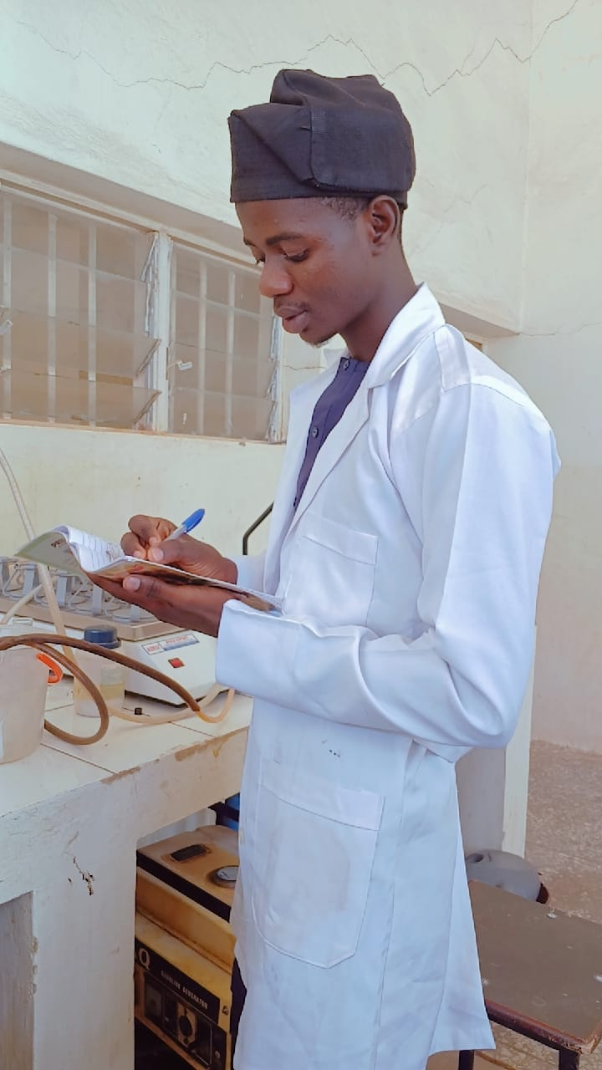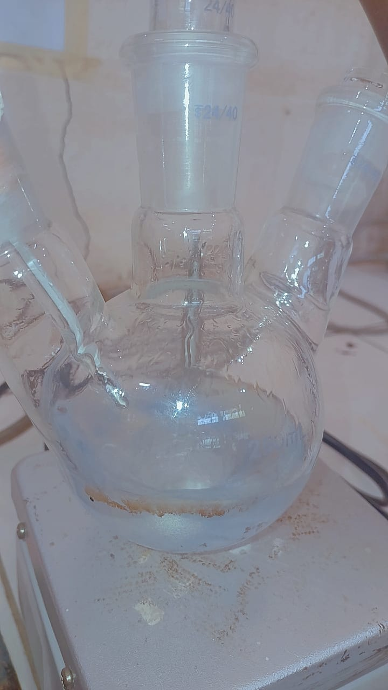
APPENDIX II

Percentage yield to calculate the experimental runs

$$percetage yield\%= \frac{mass of TPA obtained }{mass of Pet used } x 100$$

1st run
$$percetage yield\%= \frac{1.35 }{1.5 } x 100=90\%$$

2nd $percetage yield\%= \frac{1.20}{1.5 } x 100=80\%$

3rd $percetage yield\%= \frac{1.10}{1.5 } x 100=73.3\%$

