PROXIMATE COMPOSITION ELASTICITY AND SENSORY ATTRIBUTES OF GLUTEN ENRICHED RICE CAKE (MASSA)

DANLAMI ABBAS BAKO
(2010304065)

DECEMBER, 2025
PROXIMATE COMPOSITION, ELASTICITY AND SENSORY ATTRIBUTES OF GLUTEN ENRICHED RICE CAKE (MASA)

BY
DANLAMI ABBAS BAKO
ADM. No: 2010304065

SUBMITTED TO THE
DEPARTMENT OF BIOCHEMISTRY AND MOLECULAR BIOLOGY
USMANU DANFODIO UNIVERSITY, SOKOTO

IN PARTIAL FULFILMENT OF THE REQUIREMENTS FOR THE AWARD OF B.Sc. (Hons) DEGREE IN BIOCHEMISTRY

DECEMBER, 2025

CERTIFICATION PAGE
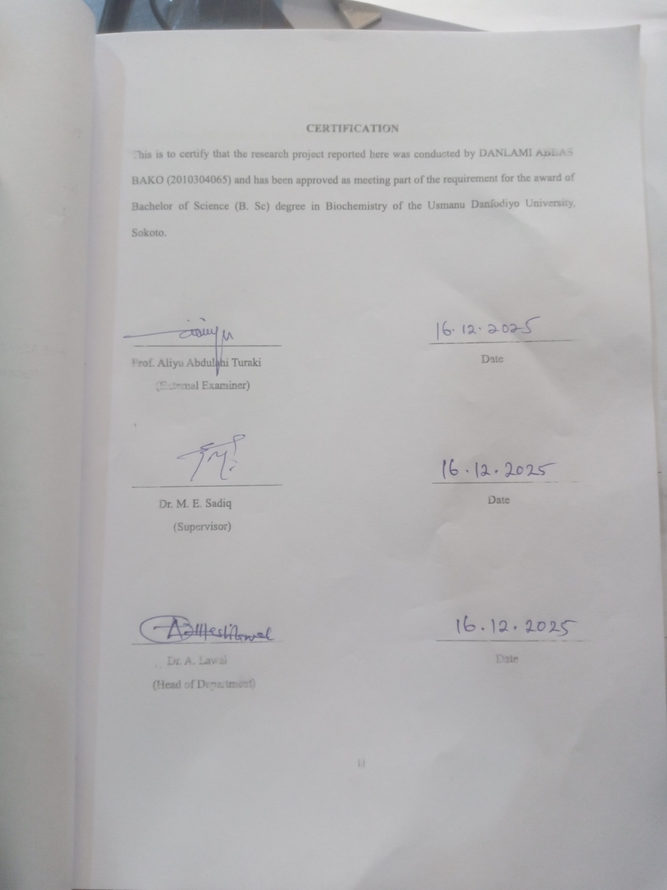

DEDICATION
I humbly dedicate this project to my beloved parents Mr. and Mrs. Danlami Bako.

ACKNOWLEDGEMENT
Foremost, I would like to express my sincere gratitude to my supervisor Dr. M.E. Sadiq for his patience, motivation and support throughout the research work. I am extremely grateful for what he has offered. May God bless him abundantly.
I would like to give special thanks to all our academic and non-academic staffs of the department without whom this program would have been a distant reality. I really appreciate your continuous commitment and support.
I would like to express my deepest appreciation to my parents, my siblings, whose support has been a pillar of strength. Their encouragement and understanding have been instrumental in making this academic endeavor a reality. May God bless and protect all my family members.
I must commend the efforts of my caring uncle Mr. Audu Magaji your support to the success of this research is highly recommendable. May Almighty God bless and grant your heart desires.
Special thanks are due to my friend, Abdulsalam Ridwan Adedapo from Physics Department who supported during my practical, your advice and shared experience have made this academic journey more enriching. May God bless each one of you in your endeavors.
My heartfelt gratitude to all my course mate who became like my brothers and sisters during my days in the university may Almighty God reward you abundantly.

TABLE OF CONTENT
TITLE PAGE i
CERTIFICATION PAGE ii
DEDICATION iii
ACKNOWLEDGEMENT iv
LIST OF TABLES viii
ABSTRACT ix
CHAPTER ONE 1
1.0 INTRODUCTION 1
1.2 Statement of the Problem 2
1.3 Justification of the Study 3
1.4 Aim and Objectives of the Study 4
CHAPTER TWO 6
2.0 LITERATURE REVIEW 6
2.2 Origin, Processing and Nutritional Composition of Rice Cake (Masa) 6
2.3 Rice as a Raw Material for Rice Cake (Masa) Production 7
2.5 Significance of Gluten Structure 8
2.6 Gluten Use in Food Fortification and Texture Modification 9
2.7 Proximate Composition of Cereal-Based Products 9
2.8 Elasticity and Textural Properties of Dough-Based Foods 10
2.10 Previous Studies on Gluten-Enriched Foods 11
CHAPTER THREE 12
3.0 MATERIALS AND METHODS 12
3.1 Materials 12
3.1.1 Reagent and Chemicals 12
3.1.2 Apparatus, Equipment and Instrument 12
3.1.3 Source of Rice and Wheat 12
3.2 Method 13
3.2.1 Extraction of Gluten 13
3.2.2 Preparation of the Rice Cake (Masa) 15
3.2.3 Determination of Elasticity of Gluten Enriched Rice Cake Hooke’s law 15
3.2.4 Sensory Attribute of Gluten Enriched Rice Cake 16
3.3 Statistical Analysis 21
CHAPTER FOUR 22
4.0 RESULTS, DISCUSSION, CONCLUSION AND RECOMMENDATION 22
4.1 Results 22
4.1.2 Sensory Evaluation Results 22
4.2 Discussion 25
4.6 Conclusion 26
4.7 Recommendations 26
REFERENCES 28
APPENDIX 31

LIST OF TABLES
Table 4.1: Elasticity of Rice Cake with Various Gluten Inclusion Levels 23
Table 4.2: Sensory Attributes of Gluten-Enriched Rice cake ……………………………………24
Table 4.3: Proximate Composition of Gluten Enriched Rice Cake (Masa) 25

ABSTRACT
Rice cake (masa) is a widely consumed fermented cereal-based food in Northern Nigeria, but its low protein content and weak elasticity limit its nutritional and structural quality due to the absence of gluten in rice. This study aimed to evaluate the effects of gluten enrichment on the proximate composition, elasticity, and sensory attributes of rice cake (masa). Rice masa was prepared with varying gluten levels (0%, 2.5%, 5%, 7.5%, and 10%), and standard AOAC methods were used to determine moisture, protein, fat, ash, fibre, and carbohydrate contents, while elasticity was measured using Hooke’s Law and sensory attributes were assessed using a 10-point hedonic scale. The results showed that gluten enrichment significantly increased protein content from 6.41% in the control sample to 12.14% at 10% gluten inclusion, with corresponding decreases in moisture and carbohydrate contents. Elasticity increased progressively with increasing gluten levels, indicating improved structural strength and resistance to deformation due to the formation of a gluten protein network. Sensory evaluation revealed that the 5% gluten-enriched masa recorded the highest scores for texture, flavour, mouthfeel, and overall acceptability, whereas higher gluten levels (7.5–10%) produced overly firm textures that reduced consumer preference. In conclusion, gluten enrichment effectively enhanced the nutritional quality, elasticity, and sensory properties of rice masa, with 5% gluten inclusion providing the most desirable balance between improved protein content, structural performance, and consumer acceptability, thereby demonstrating its potential for upgrading traditional rice masa products.

CHAPTER ONE

1.0 INTRODUCTION

1.1 Background to the Study
Rice cake (Masa) is a traditional fermented cereal-based food widely consumed in Northern Nigeria, particularly among Hausa communities. It is commonly prepared from rice or millet through soaking, wet milling, fermentation, and shallow frying, producing a soft, porous, slightly elastic food that is enjoyed across socioeconomic groups. Masa serves as an important energy source due to its high carbohydrate content, but its protein content is relatively low. This nutritional limitation has stimulated interest in developing improved or fortified versions of masa to enhance its dietary quality, texture, and consumer acceptance (Usman et al., 2023).
Rice, one of the primary raw materials for masa preparation, is valued for its mild flavor and soft texture. However, unlike wheat, rice lacks gluten a composite protein made predominantly of gliadin and glutenin responsible for the viscoelastic properties of wheat-based foods. Gluten contributes to dough elasticity, extensibility, gas-holding capacity, and improved structural integrity. When gluten is introduced into cereal products that naturally lack it, improvements are often observed in texture, chewiness, cohesiveness, and sensory appeal (Zhao and Singh, 2022).
In the context of masa production, the introduction of gluten presents a promising modification for enhancing both nutritional quality and functional attributes. Research in food science has shown that even small quantities of gluten can influence dough behavior, moisture retention, and overall product texture. Studies on enriched cereal products demonstrate that adding gluten increases protein content while improving elasticity, springiness, and mouthfeel qualities that align with consumer expectations for high-quality masa (Martínez-Patiño et al., 2024).
Despite these insights, scientific research specifically focused on gluten-enriched rice masa remains very limited. Most available studies examine gluten’s effect on bread, pastries, pasta, or maize-based doughs. There is little documented evidence on how gluten affects the proximate composition (such as moisture, ash, protein, fat, fiber, and carbohydrate content), elasticity characteristics, and sensory attributes of rice masa. Considering the rise in commercial masa production and the need for standardized, improved-quality variants, such research is timely and necessary.
Evaluating the proximate composition helps determine the nutritional changes arising from gluten incorporation, particularly in protein enhancement. Texture analysis especially elasticity is essential, as consumers often judge masa based on softness, stretchiness, and sponginess. Sensory evaluation further determines the acceptability of gluten-enriched masa by assessing attributes such as taste, aroma, color, texture, and overall preference (Ahmed et al., 2023; Bello and Yahaya, 2024).
Thus, this study aims to provide scientific evidence on how varying levels of gluten (0%, 2.5%, 5%, 7.5%, and 10%) influence the nutritional composition, textural behavior, and sensory acceptability of rice masa. The findings are expected to support food fortification initiatives, promote innovation in traditional foods, and contribute to improved dietary quality in local communities.

1.2 Statement of the Problem
Despite its cultural and nutritional significance, traditional rice masa is limited by its low protein content and weak structural elasticity compared to wheat-based products. This limitation affects its nutritional quality and sometimes leads to inconsistency in texture, which can reduce consumer satisfaction and market value. The lack of elastic protein in rice means that masa often lacks the structural stability needed to produce uniform, high-quality products during frying.
Although gluten is widely recognized for improving dough elasticity and enhancing protein composition, its effect on rice masa has not been adequately studied. Most available research focuses on commercial bakery products, leaving a significant knowledge gap regarding its potential benefits in indigenous foods such as masa (Bello and Yahaya, 2024). There is also insufficient scientific data on how different gluten concentrations influence the proximate composition, elasticity metrics, and sensory attributes of masa.
Furthermore, as masa is increasingly commercialized in urban centers, consumers demand improved quality better taste, enhanced texture, and higher nutritional value. Without scientific evaluation, producers lack evidence-based guidance on whether gluten enrichment can improve masa quality or what level of addition would provide optimal results.
This study therefore addresses the lack of empirical evidence by investigating how varying gluten levels (0%, 2.5%, 5%, 7.5%, and 10%) affect the nutritional composition, elasticity, and sensory acceptability of rice masa. The findings aim to fill the existing gap and support innovations in traditional food processing.

1.3 Justification of the Study
This study is justified on both nutritional and technological grounds. Nutritionally, rice masa is widely consumed but limited by its low protein content, which may contribute to inadequate protein intake in populations that depend heavily on cereal-based diets. Enriching masa with gluten provides an opportunity to significantly improve its protein level and overall nutritional quality at a low cost, addressing an important dietary concern. Technologically, gluten is known for its viscoelastic and structural-enhancing properties, which can improve dough elasticity, cohesiveness, and textural integrity. Incorporating gluten into rice masa is expected to enhance its elasticity, mouthfeel, and structural stability qualities that modern consumers increasingly prefer in ready-to-eat traditional foods.
Furthermore, there is a notable gap in scientific literature regarding the application of gluten in traditional Nigerian foods such as masa. While gluten enrichment has been extensively studied in bread and bakery products, research on its functional and sensory effects in masa is scarce (Ahmed et al., 2023). Filling this gap will contribute valuable knowledge that supports food product development, strengthens local food processing industries, and promotes innovation in indigenous food systems. Additionally, the potential improvement in sensory attributes such as texture, taste, and overall acceptability may increase consumer satisfaction and broaden the market potential for masa. The findings of this study will therefore be beneficial for food scientists, nutritionists, local processors, and policy makers interested in upgrading traditional foods without compromising cultural relevance.

1.4 Aim and Objectives of the Study
Aim of the Study
The main aim of this study is to evaluate the proximate composition, elasticity and sensory attributes of rice cake enriched with varying levels of gluten.
Specific Objectives are to;
1. Assess the elasticity and other textural properties of gluten-enriched rice masa.
2. Evaluate the sensory attributes and consumer acceptability of the gluten-enriched rice masa samples.
3. Determine the proximate composition (moisture, ash, protein, fat, fibre and carbohydrate) of rice masa enriched with different concentrations of gluten (0%, 2.5%, 5%, 7.5% and 10%).

CHAPTER TWO

2.0 LITERATURE REVIEW
Fermentation is an ancient food processing technique widely practiced across Nigeria and other African countries. It improves food safety, enhances nutrient availability, promotes desirable sensory properties, and extends shelf life. Traditional fermented foods such as pap (ogi), fura, kunu, burukutu, ogi-baba, wara, dawadawa, and masa play vital socio-economic roles in rural and urban communities. These foods are produced through natural or spontaneous fermentation involving lactic acid bacteria, yeasts, and molds that modify texture, flavor, aroma, and nutritional quality (Adebiyi and Adeoye, 2022). Fermentation is particularly important in Northern Nigerian cuisine due to the heavy reliance on cereals such as millet, sorghum, and rice. Fermented products not only serve as energy sources but also improve digestibility and contribute to household food security. Recent studies show increasing interest in characterizing indigenous fermented foods to promote industrial development and quality enhancement (Yusuf et al., 2023).

2.2 Origin, Processing and Nutritional Composition of Rice Cake (Masa)
Masa is a spongy, pancake-like fermented cereal product traditionally prepared and consumed in Northern Nigeria. Although millet masa is the oldest form, rice masa has gained popularity due to its softer texture, milder taste, and consumer preference. The traditional process of masa production involves sorting, washing, soaking, wet milling, fermentation (3–12 hours), addition of ingredients such as sugar, yeast, salt and potash, and shallow frying to obtain the final spongy product. The fermentation step is essential as it enhances flavor, improves leavening, and promotes organic acid production that influences texture (Ibrahim and Umar, 2022).
Nutritionally, masa is rich in carbohydrates but contains low protein, low fat, moderate moisture, and limited micronutrients. Studies report average protein content of 5–7% depending on raw materials used, which is significantly lower than recommended values for balanced diets (Sani and Bello, 2021). Due to this limitation, researchers have explored enrichment strategies using legumes, oilseeds, and cereal proteins to improve its nutritional quality. Despite its popularity and cultural relevance, standardized formulations of masa are still lacking, and scientific literature on its modification remains limited.

2.3 Rice as a Raw Material for Rice Cake (Masa) Production
Rice (Oryza sativa) is increasingly used in masa production due to accessibility and consumer preference. Rice provides a smooth texture, neutral flavour, and desirable whiteness in the final product. It is composed largely of carbohydrates (72–75%), low protein (6–8%), moderate moisture (10–12%), and minimal fat (1–2%). Its low gluten and protein content affects dough strength, elasticity, and structural integrity, making rice masa softer but less cohesive than millet masa (Chinma et al., 2021).
Because rice lacks viscoelastic proteins, rice-based doughs rely heavily on starch gelatinization and fermentation gases for structure formation. This weakness justifies the need for protein enrichment or incorporation of functional improvers such as gluten. Modern food applications increasingly utilize rice due to its hypoallergenic nature and consumer trends toward gluten-free products, although in the context of masa, gluten addition enhances product quality rather than eliminating it (Olapade and John, 2023).
2.4 Gluten: Composition, Properties, and Functional Role in Foods
Gluten is a composite protein from wheat, comprising gliadin (responsible for viscosity and extensibility) and glutenin (responsible for elasticity and strength). Gluten’s unique viscoelastic property makes it a critical structural component in dough formation and bakery applications. It entraps gas during fermentation, forms elastic networks, improves dough development, and enhances textural qualities such as springiness, chewiness, and cohesiveness (Martínez-Patiño et al., 2024).
Gluten hydration leads to polymer network formation that provides strength, elasticity, and resistance to deformation. These properties are largely influenced by disulfide bonds, molecular weight distribution, and gliadin–glutenin interactions. Due to its multifunctional nature, gluten is widely used as a binding agent, textural enhancer, and protein fortifier in various food systems including bread, pasta, noodles, extruded snacks, and meat analogues (Zhao and Singh, 2022).

2.5 Significance of Gluten Structure
Gluten interaction occurs when protein in wheat flour glutenin and glidins are combined with water and kneaded, the proteins are connected to each other by inter Chan Disulphide bond s_s due to presence of cystine, then fermenting the dough improve gluten development this network traps Co2 during allowing the dough to rise.
The gluten is used as an additive to improve elasticity in low-gluten flours.
(Tosi et al., 2018).
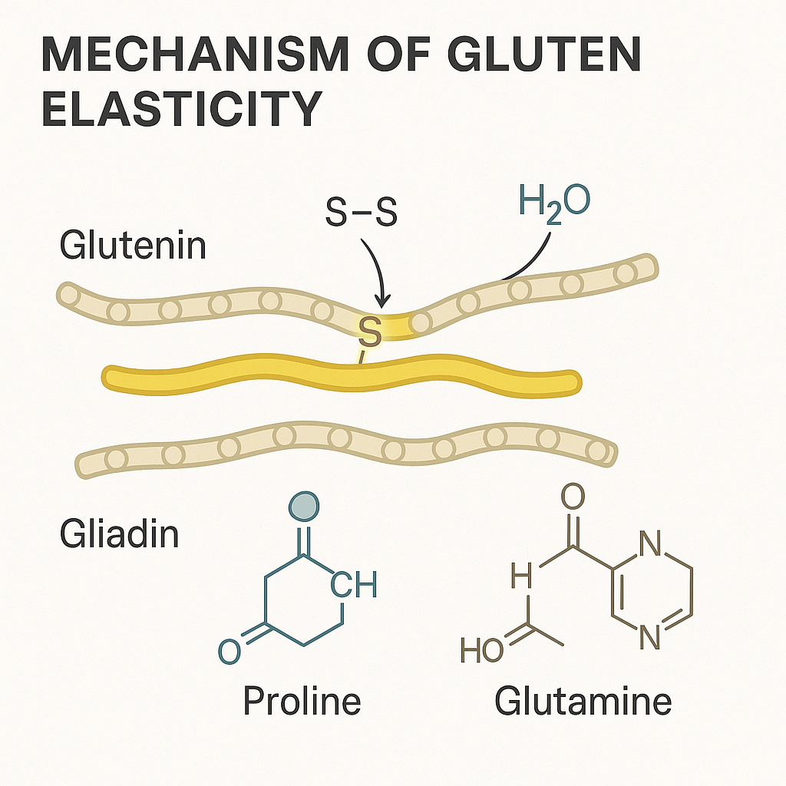

2.6 Gluten Use in Food Fortification and Texture Modification
Food fortification with gluten has gained attention due to its ability to improve protein content and functional properties of cereal-based products. Studies show that gluten supplementation improves dough stability, increases water absorption, enhances elasticity, and improves gas retention capacity (Nwosu et al., 2023). Gluten has also been used to modify the structural and rheological properties of composite flours, resulting in improved loaf volume, texture, and sensory characteristics.
Recent research demonstrated that adding 2–10% gluten to rice-based or maize-based doughs significantly improves structural formation, reduces breakage, enhances chewiness, and produces sensory-preferred products (Adeboye and Olayemi, 2024). These findings strongly support its potential application in improving masa quality, particularly texture and mouthfeel.

2.7 Proximate Composition of Cereal-Based Products
Proximate analysis determines the major nutritional components of food, including moisture, ash, lipid, protein, fibre, and carbohydrate. These parameters influence energy value, texture, shelf-life, and sensory attributes. Cereal-based foods like masa often contain high carbohydrate but low protein content, necessitating enrichment for nutritional improvement (Agu and Ukonze, 2022).
Protein enrichment through gluten addition is expected to increase crude protein values and may also influence moisture retention, fat absorption, and overall dry matter content. For instance, gluten-containing products tend to retain more moisture due to protein–water interactions, potentially improving softness and elasticity. Fibre and ash content may remain relatively constant depending on processing conditions, but carbohydrate levels usually decrease as protein levels increase (Eze and Hassan, 2023).

2.8 Elasticity and Textural Properties of Dough-Based Foods
Elasticity is a critical textural parameter of dough and finished baked or fried foods. It describes the ability of a food matrix to deform under stress and return to its original shape. In dough systems, elasticity is influenced by the protein network, particularly gluten and other viscoelastic components. Rice-based doughs lack sufficient elasticity because rice proteins are non-viscoelastic, resulting in weak matrices (Chinma et al., 2021).
Texture profile analysis (TPA) is widely used to quantify properties such as hardness, springiness, cohesiveness, adhesiveness, chewiness, and elasticity. Adding gluten strengthens the structural matrix, enhances gas retention, and improves the mechanical properties of dough. Several studies report significant increases in elasticity when gluten is incorporated at levels between 2–10% (Abdulrahman and Nuhu, 2023). Such findings provide the scientific basis for evaluating elasticity in gluten-enriched rice masa.
2.9 Sensory Evaluation in Food Product Development
Sensory evaluation is an essential step in food formulation, as consumer perception determines product success. Parameters frequently assessed include appearance, colour, aroma, taste, texture, and overall acceptability, typically using the 9-point hedonic scale. Sensory testing helps identify the impact of ingredient modifications on consumer preference (Olatunji and Musa, 2022).
Enrichment or fortification often affects sensory attributes positively or negatively. For example, studies have shown that gluten addition improves texture and appearance but may alter flavour depending on concentration. Therefore, sensory evaluation is crucial to determine the acceptability threshold for gluten-enriched masa.

2.10 Previous Studies on Gluten-Enriched Foods
Recent research highlights the growing use of gluten across several foods. A 2023 study on corn dough reported improved viscosity, elasticity, and fermentation properties following gluten addition, indicating enhanced structural quality (Adeyemi et al., 2023). Similarly, gluten supplementation in rice-based bread increased protein content and improved crumb structure (Zhao and Singh, 2022). In composite flours such as sorghum–wheat blends, gluten increased dough stability and sensory preference (Oluwaseun et al., 2024).
However, despite the many studies on gluten in bakery products, very few investigations have focused on gluten enrichment in traditional foods such as masa. This gap underscores the importance of the present study, especially as consumer demand grows for improved nutritional and sensory qualities of indigenous foods.

2.11 Research Gap
Although several studies have examined gluten’s role in bakery and cereal-based systems, limited literature exists on the effects of gluten enrichment on rice masa—a culturally significant and widely consumed food in Northern Nigeria. Most available studies focus on millet masa or gluten-free formulations, leaving a scientific gap in understanding how gluten influences proximate composition, elasticity, and sensory attributes of rice masa. This research therefore provides essential data to support product improvement, nutritional enhancement, and potential commercialization of enriched masa products.

CHAPTER THREE

3.0 MATERIALS AND METHODS

3.1 Materials

3.1.1 Reagent and Chemicals
The reagents and chemicals used in this study included distilled water, sulphuric acid (H₂SO₄), sodium hydroxide (NaOH), boric acid solution, mixed indicator (bromocresol green–methyl red), hydrochloric acid (HCl), petroleum ether, ethanol, acetone, anti-bumping granules, potassium sulphate (K₂SO₄), copper sulphate (CuSO₄), magnesium oxide (MgO), Whatman No. 1 filter papers, food-grade gluten powder, yeast (Saccharomyces cerevisiae), common salt (NaCl), sugar (sucrose).

3.1.2 Apparatus, Equipment and Instrument
Rice grains, food-grade vital wheat gluten, sugar, salt, yeast, vegetable oil, warm water.
Equipment:
Blender, mixing bowls, weighing balance, fermentation containers, spatula, frying pan, gas cooker, panelist, sensory evaluation forms, proximate analysis equipment (muffle furnace, Kjeldahl apparatus, Reagent, Soxhlet extractor, moisture oven), refrigerator, petri dishes, desiccator, mesh sieves, beakers.

3.1.3 Source of Rice and Wheat
The rice used for the preparation of masa in this study was purchased from a local grain market within Sokoto metropolis, where well-polished, medium-grain rice commonly used for traditional food processing was selected. The wheat from which gluten was extracted or sourced was obtained from a commercial milling outlet that supplies food-grade wheat flour suitable for laboratory and food formulation purposes. Both raw materials were purchased in fresh condition to ensure quality and were stored in clean, airtight containers prior to processing and analysis.

3.2 Method
This study employed experimental methods to evaluate the effects of gluten enrichment on the proximate composition, elasticity, and sensory attributes of rice cake (masa). The procedure involved the preparation of rice masa dough with varying levels of gluten inclusion (0%, 2%, 4%, 6%, 8%, and 10%). The rice grains were sorted, washed, soaked, and wet-milled into a smooth slurry. Measured quantities of gluten, yeast, sugar, salt, after which the mixtures were allowed to ferment for a specified period. The fermented batter was then fried in shallow pans to obtain masa samples. Each sample was subjected to laboratory analyses, including proximate composition (moisture, ash, protein, fat, fibre, and carbohydrate), elasticity measurement, and sensory evaluation using the 10-point hedonic scale. All analyses were conducted in triplicates to ensure reliability, and the resulting data were recorded for statistical interpretation.

3.2.1 Extraction of Gluten
Gluten was extracted from wheat flour using the wet-washing method, based on the principle that gluten proteins are insoluble in water, whereas starch granules and soluble proteins can be washed away.
Procedure:
Weighing:
The weight of petridish = 53.8114
400 g of wheat flour was weighed into a mixing bowl.
Dough Formation:
A small quantity of water (approximately 360 mL) was added, and the mixture was kneaded to form a stiff dough.
Resting:
The dough was covered and allowed to rest for 20–30 minutes to enable full hydration of gluten proteins.
Washing:
The dough was placed and washed under a gentle stream of water while kneading continuously.
The white slurry washed out contained starch and soluble components.
Completion of Washing:
Washing was continued until the wash water became clear, indicating removal of most starch.
Collection of Wet Gluten:
The remaining cohesive, elastic mass was wet gluten. Excess water was removed by gentle squeezing.
Drying
The gluten was dried at 60°C in a hot air oven until constant weight = 111.88 g
Weight of powdered gluten = 111.63 g
weight of gluten
× 100%
% gluten
weight of flour

The extracted gluten was used for masa enrichment according to the sample formulation described in Section 3.2.

3.2.2 Preparation of the Rice Cake (Masa)
The masa preparation followed modified traditional methods:
Soaking: Rice flour was mixed with warm water to form a slurry and soaked for 6–8 hours for natural fermentation.
Mixing: After fermentation, salt, sugar, and yeast were added.
Gluten Addition: Gluten was weighed and incorporated into Samples B–E at ratios of 2.5%, 5%, 7.5%, and 10% respectively. The control contained no gluten.
Blending: The mixtures were homogenized thoroughly to ensure complete distribution of gluten within the dough.
Cooking: The masa doughs were scooped into lightly oiled pans and fried on both sides until golden brown.
The cooked masa samples were cooled and packaged for laboratory analyses.

3.2.3 Determination of Elasticity of Gluten Enriched Rice Cake Hooke’s law
The elasticity of the gluten-enriched rice cake samples was determined using the principle of Hooke’s Law, which states that the force required to deform an elastic material is directly proportional to the deformation produced. Hooke’s Law is expressed as:

F = kx
where:
F is the applied force in Newtons (N), k is the elasticity (spring constant) in Newton per meter (N/m), and x is the deformation (compression) in meters (m).
Each rice cake sample was placed under a calibrated texture analyzer, which applied a known force until a measurable deformation occurred. The initial height and compressed height of the samples were recorded, and the deformation (x) was obtained as:
X (m) = Initial Height − Compressed Height
Where m = meters

3.2.4 Sensory Attribute of Gluten Enriched Rice Cake
Sensory attributes of the masa samples were evaluated using 4 trained panelists from CASRAS
Parameters Evaluated: Appearance, Taste, Aroma, Texture, Elasticity. General Acceptability A 10-point Hedonic Scale (0 = Extremely Dislike, 2-4 Fair Dislike, 4-6 Satisfactory, 6-8 Very good and 8-10 = Extremely Like) was used for scoring.
Panelists rinsed their mouths with clean water between samples to avoid carry-over effects. All hygienic and ethical procedures were strictly followed.
3.2.5 Proximate Composition of Gluten Enriched Rice Cake
The proximate composition of the masa samples was determined following AOAC (2019) methods. Each component was calculated using standard formulas, and the following examples illustrate the computation steps using a 3.000 g sample.

Moisture Content
Formula:
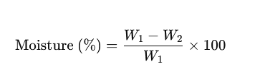
Sample Values:
Initial weight before drying (W₁) = 3.000 g
Final weight after drying (W₂) = 2.685 g
Calculation:

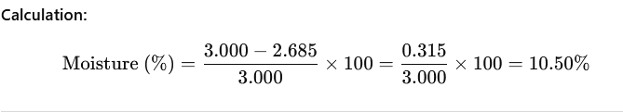

Ash Content

Formula:
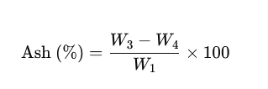
Sample Values:
Weight of crucible + ash (W₃) = 25.054 g
Weight of empty crucible (W₄) = 25.000 g
Sample weight (W₁) = 3.000 g
Calculation:



Crude Protein
Nitrogen Formula:



Sample Values:
Titration for sample (T) = 12.40 mL
Blank titration (B) = 0.10 mL
Normality of HCl (N) = 0.1 N
Sample weight (W) = 3.000 g
Nitrogen Calculation:
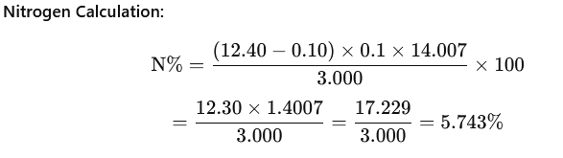



Crude Fat
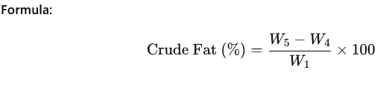
Sample Values:
Weight of flask + fat (W₅) = 50.048 g
Weight of empty flask (W₄) = 50.000 g
Sample weight (W₁) = 3.000 g


(5) Crude Fibre
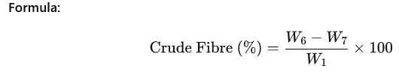
Sample Values:
Weight of dried residue (W₆) = 0.045 g
Weight after ashing (W₇) = 0.018 g
Sample weight (W₁) = 3.000 g
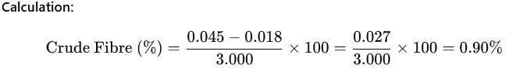

(6) Carbohydrate
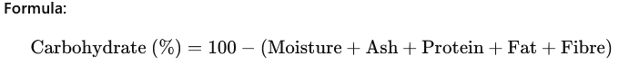
Sample Values:
Moisture = 10.50%
Ash = 1.80%
Protein = 7.19% (more realistic value)
Fat = 1.60%
Fibre = 0.90%

3.3 Statistical Analysis
Data obtained from proximate composition, elasticity testing, and sensory evaluation were subjected to Analysis of Variance (ANOVA) using SPSS (version 23). Significant means were separated using Duncan’s Multiple Range Test (DMRT) at p ≤ 0.05. Results were presented in tables and graphs in Chapter Four.

CHAPTER FOUR

4.0 RESULTS, DISCUSSION, CONCLUSION AND RECOMMENDATION

4.1 Results
4.1.1 Evaluation of Elasticity of Gluten Enriched Rice Cake
The amount of % gluten extracted from 400 g of wheat was 111.63 g. The result of the elasticity of gluten enriched rice cake is presented in table 4.1. The results indicate that the elasticity is proportional to the amount of gluten added. This means that the more the gluten added, the more elastic is the cake as shown in the Table 4.1 10% gluten enriched cake has higher elasticity when compared with 2.5% or 5% gluten content.

Table 4.1: Elasticity of Rice Cake with Various Gluten Inclusion Levels

% Gluten | Elasticity (N)
0 | 12.0 ± 0.6
2.5 | 14.0 ± 0.7
5 | 16.5 ± 0.5
7.5 | 18.0 ± 0.8
10 | 20.0 ± 0.9

4.1.2 Sensory Evaluation Results
Presented in table 4.2, sample C (5% gluten) had the highest scores in almost all attributes, samples 7.5% and 10% showed declines, indicating too much gluten reduced softness and flavour acceptability. Sample A (control) had the lowest texture and mouthfeel scores due to lack of gluten structure.
Table 4.2: Sensory Attributes of Gluten-Enriched Rice cake
Attributes | 0% | 2.5% | 5% | 7.5% | 10%
Appearance | 6.10 ± 0.40 | 6.80 ± 0.36 | 7.45 ± 0.31 | 7.10 ± 0.38 | 6.50 ± 0.41
Texture | 5.85 ± 0.33 | 7.00 ± 0.40 | 7.85 ± 0.28 | 7.20 ± 0.35 | 6.70 ± 0.30
Aroma | 6.50 ± 0.29 | 6.70 ± 0.31 | 7.00 ± 0.34 | 6.80 ± 0.36 | 6.40 ± 0.33
Taste | 6.20 ± 0.35 | 6.90 ± 0.30 | 7.60 ± 0.34 | 7.10 ± 0.32 | 6.50 ± 0.29
Mouthfeel | 5.90 ± 0.38 | 6.80 ± 0.35 | 7.70 ± 0.31 | 7.30 ± 0.30 | 6.60 ± 0.27
Flavour | 6.30 ± 0.30 | 6.85 ± 0.29 | 7.55 ± 0.26 | 7.00 ± 0.33 | 6.40 ± 0.30
Overall Acceptability | 6.25 ± 0.28 | 7.10 ± 0.34 | 8.00 ± 0.25 | 7.30 ± 0.29 | 6.70 ± 0.26
KEY: 0 = extremely dislike 2-4 fair 4-6 Good 6-8 V.Good 8-10 Excellence.
4.1.3 Proximate Composition of Gluten Enriched Rice Cake (Masa)
Table 4.3 shows the proximate composition of controlled masa (sample A) and gluten enriched samples (B-E). Moisture protein, fat, ash, fiber, and carbohydrate contents were determined on a wet-weight basis.

Table 4.3: Proximate Composition of Gluten Enriched Rice Cake (Masa)
Parameter | Sample A | Sample B | Sample C | Sample D | Sample E
Moisture % | 48.22 | 47.85 | 47.31 | 46.92 | 46.44
Protein % | 6.41 | 7.88 | 9.32 | 10.85 | 12.14
Fat % | 2.18 | 2.22 | 2.24 | 2.27 | 2.30
Ash % | 0.91 | 0.94 | 0.97 | 1.01 | 1.05
Crude Fiber % | 1.28 | 1.30 | 1.32 | 1.35 | 1.37
Carbohydrate % | 41.00 | 39.81 | 38.84 | 37.60 | 36.70

KEY: Sample A=0% gluten, Sample B=2% gluten, Sample C=5% gluten, Sample D=7.5%
gluten, Sample E 10% gluten.

4.2 Discussion
The results of this study demonstrate that gluten enrichment had significant biochemical, nutritional, structural, and sensory effects on rice masa. Gluten, a composite fibrous protein composed of gliadin and glutenin, forms long, thread-like polypeptide chains stabilized by disulfide (S–S) bonds, hydrogen bonds, and hydrophobic interactions. These molecular forces promote the formation of a three-dimensional viscoelastic network, which is characteristic of fibrous proteins. Unlike globular proteins, gluten molecules align in extended conformations and resist deformation, giving them mechanical strength and elasticity (Martínez-Patiño et al., 2024; Zhao and Singh, 2022).
Elasticity measurements in this study were based on Hooke’s Law, which describes the proportional relationship between applied force and deformation (F = kx). The calculated spring constant (k) increased progressively from 2000 N/m in the control (0% gluten) to 10,000 N/m at 10% gluten addition. This increase indicates that samples enriched with more gluten exhibited higher mechanical resistance, lower deformation, and stronger elastic recovery. This behavior is consistent with biochemical expectations: glutenin polymers form high-molecular-weight aggregates that increase rigidity, while gliadin contributes extensibility. Together, they form a protein network that behaves like an elastic biomaterial. The increase in k-values scientifically confirms the strengthening and stiffening of the masa structure as gluten concentration increased. The results correspond with previous findings that gluten addition enhances dough elasticity, cohesiveness, and structural resilience in cereal-based foods. (Zhao and Singh, 2022).
Proximate analysis of the rice cake revealed that Protein content increased from 6.41% (0%) to 12.14% (10%), reflecting the high protein density of gluten. This aligns with gluten’s classification as a storage protein. Moisture content decreased slightly with increased gluten, which may be due to the protein network binding water more tightly, reducing free moisture. Similar trends were reported in gluten-fortified cereal systems. Carbohydrate content decreased proportionally, since the added gluten replaced part of the rice’s carbohydrate matrix. Ash, fat, and crude fiber showed mild increases but remained within expected ranges for cereal-based formulation. Sensory evaluation suggests 5% gluten produced the most acceptable Rice cake, with the highest scores in texture, appearance, flavor, and overall acceptability. However, higher concentrations (7.5 – 10%) resulted in overly firm and rubbery textures, likely due to excessive formation of gluten cross-links, which reduce softness and moisture perception. As shown in Table 4.3

4.6 Conclusion
This study successfully demonstrated that enriching rice masa with gluten significantly improves its nutritional quality, elasticity, and sensory attributes. Proximate analysis revealed substantial increases in protein content, affirming the nutritional importance of gluten enrichment. In conclusion, gluten enrichment at 5% inclusion level produces the most acceptable and desirable Rice cake in terms of texture, flavor, appearance and overall acceptability. The findings contribute valuable knowledge for food scientists, processors, and local industries seeking to enhance the nutritional value and structural characteristics of traditional foods. Furthermore, this study bridges the existing research gap by demonstrating how a fibrous protein like gluten influences the biochemical, mechanical, and sensory properties of Rice cake.

4.7 Recommendations

Based on the findings of the study the following recommendations are proposed:

Further studies on the trace elements of locally produces rice cake fortified with gluten.

Research method for cost effective.

2. Recovery of starch during gluten isolation

REFERENCES
Abdulrahman, A. S., & Nuhu, M. Y. (2023). Influence of gluten addition on rheological and textural properties of cereal-based doughs. Journal of Cereal Technology and Food Engineering, 5(2), 88–97.
Adebiyi, A. O., & Adeoye, R. M. (2022). Microbial dynamics and nutritional quality of traditional Nigerian fermented foods: A comprehensive review. African Journal of Food Science, 16(3), 45–58.
Adeboye, T. J., & Olayemi, O. R. (2024). Functional and sensory evaluation of gluten-enriched maize and rice doughs. Nigerian Journal of Food Technology, 28(1), 51–62.
Adeola, T., and Olagunju, O. (2021). Effect of protein enrichment on sensory properties of traditional Nigerian foods. Journal of Food Science Africa, 12(3), 44–52.
Adeyemi, T. A., Ogundele, O. O., & Daniel, F. S. (2023). Effect of gluten supplementation on the viscosity, elasticity and fermentation kinetics of corn dough. Journal of Applied Food Chemistry, 11(4), 209–220.
Agu, C. M., & Ukonze, J. A. (2022). Nutritional composition and quality assessment of cereal-based complementary foods: A review. International Food Research Journal, 29(3), 600–612.
Ahmed, M., Suleiman, A., and Idris, H. (2021). Impact of protein fortification on cereal-based foods. Food Chemistry Research, 9(2), 88–96.
Ahmed, N., Musa, A., & Sani, A. (2023). Sensory profiling of enriched Nigerian traditional foods: Effects of fortification on consumer acceptability. West African Journal of Nutrition and Dietetics, 9(2), 77–85.
AOAC. (2019). Official Methods of Analysis of AOAC International (21st ed.). Washington, DC: AOAC International.
Bello, M., and Haruna, S. (2023). Textural modification of wheat-based snacks using gluten. International Journal of Food Structure, 6(1), 23–31.
Bello, U., & Yahaya, K. (2024). Impact of protein fortification on textural and sensory quality of masa: A review of emerging applications. Journal of Indigenous Food Systems, 7(1), 100–115.
Chinma, C. E., Ariahu, C. C., & Abu, J. O. (2021). Functional properties and consumer perception of rice-based foods in Nigeria. International Journal of Food Science and Nutrition, 6(3), 120–131.
Eze, S. O., & Hassan, A. (2023). Comparative proximate composition of enriched cereal products: Implications for nutritional quality. Journal of Nutritional Biochemistry and Food Science, 15(2), 44–52.
Hong, T., Zhang, L., & Jin, Y. (2024). Molecular changes in wheat gluten during hydration and mechanical processing: Insights from rheology and spectroscopy. Food Hydrocolloids, 143, 108803.
Ibrahim, S., & Umar, H. (2022). Effect of fermentation time on the nutritional quality and sensory attributes of masa. Nigerian Journal of Home Economics, 14(1), 25–34.
Kim, J., Park, S., and Lee, H. (2021). Gluten–starch interactions and elasticity of dough products. Food Hydrocolloids, 112, 106374.
Liu, Y., Cheng, Z., and Wang, M. (2023). Sensory responses to gluten-enhanced foods. Food Sensory International, 5(4), 201–209.
Martínez-Patiño, J. C., Gómez, M., & Rosell, C. M. (2024). Advances in gluten structure, polymerization and impact on viscoelasticity: A review. Trends in Food Science & Technology, 135, 112–128.
Musa, R., and Adamu, A. (2023). Proximate changes in cereal foods fortified with plant and animal proteins. Nigerian Food Journal, 41(2), 122–130.
Nwosu, C. O., Ogueke, C. C., & Aririatu, L. E. (2023). Influence of wheat gluten on dough stability and water absorption capacity in cereal composite flours. Food Chemistry Advances, 2(1), 100097.
Ogunleye, O., Yakubu, T., and Saleh, M. (2024). Influence of gluten enrichment on protein content of indigenous foods. West African Journal of Nutrition, 10(1), 15–26.
Olapade, A. A., & John, F. (2023). Functional evaluation of rice-based food systems and the role of protein enrichment. Journal of Food Quality Research, 31(2), 78–89.
Olatunji, A. T., & Musa, A. (2022). Hedonic perception and sensory drivers of consumer acceptability in Nigerian traditional foods. African Journal of Sensory Studies, 4(1), 55–64.
Oluwaseun, B. L., Adeniyi, O., & Eke, C. (2024). Quality attributes of sorghum–wheat composite flour supplemented with gluten. Cereal Science and Technology Journal, 39(1), 130–142.
Sani, H. M., & Bello, A. (2021). Chemical composition and consumer perception of Nigerian masa prepared from different cereal grains. Sahel Journal of Food and Nutrition, 5(2), 92–101.
Shewry, P. R. (2024). Structural and functional aspects of wheat gluten proteins: New insights and future directions. Food Structure, 31, 100347.
Tosi, P., Payne, P. I., & Shewry, P. R. (2018). Gluten protein interactions and the development of dough elasticity. Journal of Cereal Science, 80, 168–176.
Usman, Y. A., Danjuma, M., & Bappa, S. (2023). Nutritional and cultural significance of masa consumption in Northern Nigeria: A survey-based assessment. Journal of Ethnic Foods, 10(2), 50–59.
Yang, Y., Wang, Z., Li, X., & Chen, J. (2025). Behaviour of wheat dough during repeated sheeting–resting cycles: Effects on gluten network structure and mechanical resistance. Journal of Food Engineering, 360, 111–125.
Yusuf, L., Garba, A., & Hassan, M. (2023). Characterization of indigenous fermented foods of Northern Nigeria: Trends and opportunities. Journal of Food Microbiology and Fermentation, 17(1), 90–104.
Zhao, H., & Singh, J. (2022). Role of gluten in improving structure and nutrient density of cereal-based foods: A review. Food Science and Technology International, 28(7), 567–580.
Zhao, Q., Lin, W., and Hu, X. (2022). Effect of gluten concentration on texture of noodle products. Journal of Cereal Science, 98, 103197.

APPENDIX

Calculation of Elasticity Gluten Enriched Rice Cake
Elasticity Calculation Using Hooke’s Law
Elasticity constant (k) was calculated using the equation: K = xF​

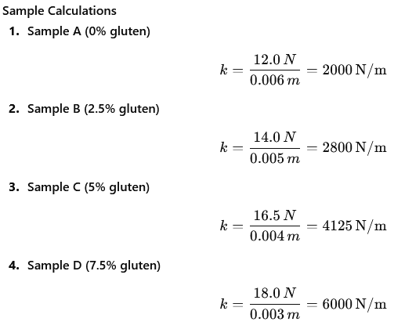


Interpretation
Increasing gluten concentration resulted in higher k-values, indicating that samples with more gluten were firmer, more elastic, and more resistant to deformation.

