INSECT VECTORS ASSOCIATED WITH DUMPSITES

BY

MUHAMMAD JAMIU SULYMAN
2010302109

A PROJECT SUBMITTED TO THE DEPARTMENT OF BIOLOGY, FACULTY OF LIFE AND CHEMICAL SCIENCE, USMANU DANFODIYO UNIVERSITY SOKOTO
IN PARTIAL FULFILMENT OF THE REQUIREMENTS FOR THE AWARD OF
BACHELOR OF SCIENCE (B.Sc.) DEGREE IN BIOLOGY

NOVEMBER, 2025

CERTIFICATION

This is to certify that the research work titled “Insect Vectors Associated with Dumpsites” was carried out by Muhammad Jamiu Sulyman, a student of the Department of Biology, Faculty of Science, Usmanu Danfodiyo University. This project is an original research work and has not been submitted elsewhere for the award of any degree or certificate. It is hereby approved for acceptance in partial fulfillment of the requirements for the award of the Bachelor of Science (B.Sc.) Degree in Biology.

……………………………... …………………………
Dr. Rabiu Sani Zurmi Date
(External Examiner)

……………………………... …………………………
Prof. M. M. Yahaya Date
(Project Supervisor)

……………………………... …………………………
Prof. M. M. Yahaya Date
(Head of Department)

DEDICATION
This project is dedicated to Almighty God, the source of wisdom, knowledge, and understanding, for granting me the strength and perseverance to complete this work. I also dedicate it to my beloved parents and family for their moral, spiritual, and financial support throughout the period of this study.

ACKNOWLEDGMENTS
All praises and adoration be to Almighty Allah, the Most Beneficent and the Most Merciful, for His endless guidance, protection, and blessings throughout the course of this research work and my academic journey.
My profound gratitude goes to my supervisor, Prof. M.M Yahaya, for his patient guidance, valuable suggestions, and continuous encouragement that made this project a success. I also appreciate the Head of Department, all lecturers, and staff of the Department of Biology, Usmanu Danfodiyo University, for their academic contributions and support during the course of my study.
My special appreciation goes to my beloved father (Alhaj Muhammad Jamiu Abubakar Alfulanny) and my mother(Alhaja Rahfatullah Abubakar Alfulanny) for their love, prayers, and sacrifices. I am also deeply grateful to Alhaj Muhammad Jamiu Musa Alfulanny (Mosad’olohun), Alhaj Ibroheem Alfulanny (Jato),Alhaj abdulazeez Bale (kawu lansi),Alhaj Aliy toyin (Itaogbolu)Alhaj Abdul Qodiry (Haqiqyy), Muh’d Saheed Balogun and my precious uncle Dad Roqeebah for their unwavering support and encouragement.
My heartfelt greetings also go to my precious father and God-sent benefactor Alhaj Ayuba [ Bàbá Aladua Fewe], my greatest teacher Alhaj Abdul-Hameed (Muhalim), my mentor Dr. Sharofdeen Fewe, who has contributed immensely to my personal and academic growth, and my honourable Sheikh Najeebdeen (Agbarere). I equally acknowledge my amiable teachers Mr. Gambari, Umu Darajat, Mr. Ibrahim, Mr. Elewure, and others for their dedication and impact in shaping my academic foundation.
I sincerely appreciate my colleagues and friends who supported me during the field and laboratory work: Mallam Shazali Sambo, Barakat,moryam ,Zaynab ,Idris ,saheed,Ustaz Abubakar (Sen. Marafa), Comrade Abdulrahman Yusuf (Bàbá Mole),Tahta motholaty sheikh sharafdeen group and many others. May Almighty Allah bless you all abundantly.

Furthermore, my gratitude goes to my wonderful friends who stood by me throughout my academic pursuit Ibroheem Qozeem,Comrade AGAKA BCH , brother Yusuf(Sekoni) Mallam abdul~Afeez Akeye(Al~Arobby),Abdulrauf Abdullah Opeyemi (Omo ADC of FRN),Sheikh Abdulganiy,Abu yãsir the camera man behind the scene(Cafe man),Alfa Abdul gafar, Aishat Yahya Alfulanny(Eniola), Alhaja Rosheedah(Bukola mi), Alhaja Hawwah, Alhaja Rizqot Akanke (Omo kewu mi ),Engineer Ogundeji Abdullah (T.J), Comrade Bello Abdulrosheed Ademola (Prof. Bello),Abdul rahman Alao (CEO Bijahi rahma phones and gadgets)Mallam Soliu, Comrade Mudashir (CEO holaz hair cut),Uthman(Holaz),Marwan bn Hikam, Ustaz Al~Imam habeebullah (Kewulere)and others too numerous to mention. I pray that Almighty Allah rewards and blesses each of you beyond your expectations.
Finally, to everyone who has contributed in one way or another to the success of this project, I say a heartfelt thank you. May Allah continue to guide, protect, and elevate you all.

TABLE OF CONTENTS
TITLE PAGE……………………………………………………………………………………....i
CERTIFICATION ii
DEDICATION iii
ACKNOWLEDGMENTS iv
TABLE OF CONTENTS vii
LIST OF TABLES xi
LIST OF PLATE xii
LIST OF FIGURES xiii
CHAPTER ONE: 1
INTRODUCTION 1
1.1 Background of the Study 1
1.2 Statement of the Problem 4
1.3 Significance of the Study 4
1.4 Aims and objectives of the study 4
1.5 Scope of the Study 5
CHAPTER TWO 6
2.0 LITERATURE REVIEW 6
2.3 Types of Insect Vectors Found at Dumpsites 10
2.4 Diseases Transmitted by Dumpsite-Associated Insect Vectors 10
2.5 Environmental Conditions Favoring Vector Proliferation 11
2.6 Waste Management and Vector Control 11
2.7 Previous Studies on Insect Vectors and Dumpsites 12
2.8 Gaps in the Literature 12
2.9 Theoretical Framework 13
2.10 Conceptual Framework 13
2.11 Summary of the Chapter 13
CHAPTER THREE 14
3.0 MATERIALS AND METHODS 14
3.1 Research Design 14
3.2 Study Area 14
3.3 Population of the Study 15
3.4 Sampling Technique 15
3.5 Sample Collection Methods 15
3.6 Data Collection Instruments 16
3.7 Data Analysis 16
3.8 Ethical Considerations 16
3.9 Limitations of the Study 17
CHAPTER FOUR 18
4.0 RESULT 18
4.1 Relative Abundance of Insect Vectors 18
4.2 Comparative Abundance of Insect Vectors by Dumpsite 20
4.3 Environmental Conditions at the Dumpsites 22
CHAPTER FIVE 24
5.0 DISCUSSION 24
CONCLUSION 26
RECOMMENDATIONS 26
REFERENCES 28

LIST OF TABLES
Table 4.1: Mean (±SD) Abundance of Insect Vectors per Dumpsite 18
4.2: Relative Abundance of Insect Vectors Across All Dumpsites 19
4.3: Comparison of Mean Insect Counts per Dumpsite 21
4.4: Environmental Characteristics of Sampled Dumpsites 22

LIST OF PLATE
Plate 1: Dump Site 3

LIST OF FIGURES
Figure 1: Insect Vector 2
Figure 1: Pie Chart Showing Percentage Composition of Insect Vectors 20
Figure 2: Column Chart Showing Total Mean Insect Count per Dumpsite 22

ABSTRACT
Improper solid waste management remains a major environmental and public health concern in many developing countries, especially Nigeria where open dumping is common. Dumpsites create favourable breeding grounds for insect vectors capable of transmitting diseases such as cholera, typhoid, dysentery, and malaria. This study investigated the abundance and distribution of insect vectors in three major dumpsites Miami Villa, Aso Rock Villa, and Texas Villa in Gidan Yaro, Wamako LGA, Sokoto State. A descriptive cross-sectional design was used, and insect samples were collected for four weeks using sticky traps, light traps, pitfall traps, and sweep nets. Specimens preserved in ethanol were identified using standard entomological keys, and data were analyzed using descriptive statistics. Results showed variations in vector abundance, with Aso Rock Villa having the highest mean count. Cockroaches and houseflies were the most dominant species. The study concludes that poor waste management promotes vector proliferation and recommends improved sanitation and proper waste disposal.

CHAPTER ONE:

1.0 INTRODUCTION

1.1 Background of the Study
Many countries in Africa do not have efficient waste collection and disposal services, which often results in both environmental and health problems for the people .In Nigeria, the sources of solid waste are commercial, industrial, household, agricultural and educational establishments (Babayemi & Dauda,2009).proper waste management is not only regarded as a political tool and an indicator of good government policy,it is also an important element for good health (Oyedele,2009).The consequences resulting from improperly managed wastes include its serving as reservoir of pathogens,habitat for pest such as rats,flies and mosquitoes,reduction of usable land area of the society, obstruction of motorable roads and general nuisance and societal problems in residential areas (Oyedele,2009).Other negative aspects associated with unmanaged solid waste include negative impact on the value of properties sorrounding it,acid rain and contamination of aquifers or water table.
Solid waste management is a major environmental and public health issue in many developing countries. Inadequate disposal of household, industrial, and municipal wastes often leads to the establishment of open dumpsites, especially in urban and peri-urban areas. These dumpsites not only contribute to environmental degradation but also create favorable breeding grounds for a wide range of insect vectors. Insect vectors such as houseflies (Musca domestica), mosquitoes (e.g., Aedes and Culex spp.), and cockroaches (e.g., Periplaneta americana) are commonly found in and around refuse dumps. These vectors are capable of transmitting various pathogenic organisms, including bacteria, viruses, and parasites that cause diseases such as cholera, typhoid, dysentery, malaria, and diarrhea. Their close association with decaying organic matter makes them potent mechanical and biological transmitters of disease.

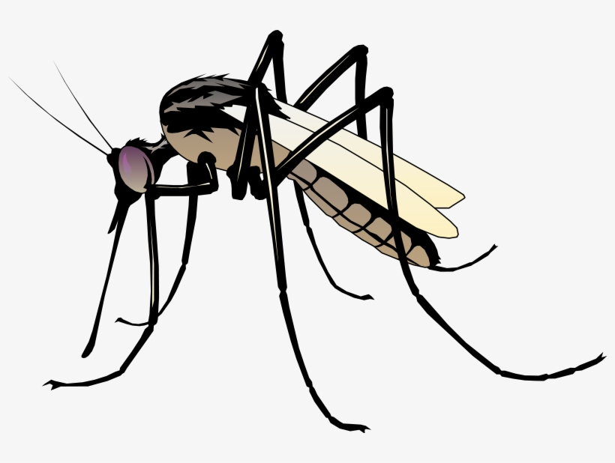
Figure 1: Insect Vector Olayemi, K. (2018). Environmental health and vector

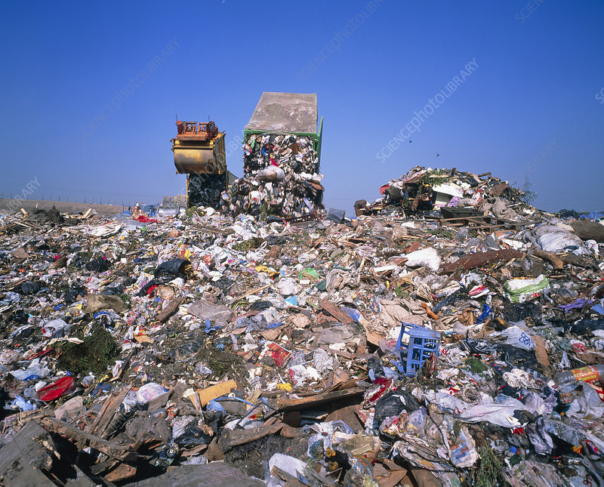
Plate 1: Sarojini, R, (2016), Dump Site

The uncontrolled and unregulated nature of dumpsites increases human exposure to these vectors, particularly among populations living near waste disposal sites. This growing threat calls for scientific assessment and understanding of the types, distribution, and vector potential of insect species associated with these areas.

1.2 Statement of the Research Problem
Despite the clear health risks posed by insect vectors at dumpsites, there is often limited surveillance and documentation of the specific species involved and their abundance. In many communities, waste management practices are poor, and people are frequently exposed to vector-borne diseases without a clear understanding of the sources of transmission. The lack of data hampers the development of targeted control strategies and policies. Therefore, studying the insect vectors associated with dumpsites is essential for identifying health risks and informing control efforts.

1.3 Significance of the Study
This study will contribute to the understanding of public health risks associated with improper waste disposal. By identifying and analyzing insect vectors from dumpsites, the research will help local authorities, health practitioners, and environmental agencies develop better strategies for vector control and disease prevention. It will also serve as a reference for further research in entomology and environmental health.

1.4 Aims and objectives of the study
To investigate the insect vectors associated with dumpsites and assess their potential role in disease transmission.
1. To identify and classify insect vectors commonly found in selected dumpsites.
2.To determine the relative abundance and seasonal variation of these insect vectors.
3. To assess the microbial load or pathogens carried by selected insect vectors.
4. To evaluate environmental conditions that promote the breeding of these vectors.

1.5 Scope of the Study
This study will be limited to selected dumpsites within Gidan Yaro, focusing on insect vector collection, identification, and analysis. It will cover both dry and wet seasons to understand seasonal variation. The research will not address other non-insect pests or chemical pollutants from dumpsites.

CHAPTER TWO

2.0 LITERATURE REVIEW

This chapter reviews existing literature on insect vectors, their association with waste dumpsites, and the implications for public health. It also explores the biological and ecological characteristics of key insect vectors, their disease transmission capabilities, and environmental factors influencing their abundance.
2.1. Concept of Insect Vectors
Insects are organisms that belong to the kingdom Animalia,Phylum Arthropoda and class Hexapoda.They are known to have extremely diverse role in the ecosystem.They have permeated the diverse and essential natural process that uphold biological systems ,making up over 75% of known species of animals.Indeed,the present ecosystem may not function without insect.Insect vectors are those playing roles in the transmission of pathogens between humans or from animals to humans .The pervasive ecological importance of this great variety of insect makes them valuable to assess disturbance or environmental impacts of various kinds.Mosquitoes are responsible for transmission of pathogens some of the most life- threatening fever and filariasis. Cockroaches are found in nearly all habitats :tropical and temperate forests, grassland,heath,steppe,salt ,marshes,coastal communities and deserts.the house fly is a very common cosmopolitan species which transmit diseases to humans.House flies often live among filth and garbage , and can carry pathogens for dysentery,typhoid , fever and cholera.Female flies deposit their eggs on decayed ,Fermenting or rotting organic material of their animal or vegetable origin.Garbage provide the Main medium for breeding .
The housefly Musca domestica is usually associated with decomposing substrate of solid urban wastes.Musca domestica are also implicated in the transmission of bacteria such as Salmonella,shigella,campylobacter,Escherichia,Enterococus,Chlamydia and many other species that caused illness.Pokkala and Ponka reported that Musca domestica visit human homes,crawl over food and household utensils,and deposit there pathogens.Their survival and capacity to transmit diseases are directly linked to putrefying solid wastes.The stomoxys calcitrans have been reported to harbor a variety of pathogens that cause diseases in man and animals such as viruses,bacteria, protozoan,fungi,larvae and eggs of helminthes.The cockroaches (family Balttidae) are known to feed on human faeces and transmit such diseases as amoebiasis caused by entamoeba histolytica .A study by cotton et al (2007).showed that exposure to cockroach antigens may play an important role in asthma -related health problems .Miller defines waste as man’s unwanted materials that needs to be discarded.Waste has also been described as substances and materials which are disposal of or are required to be disposed off according to the provision of national law .Dumpsites have been the most organized common methods of water disposed and remain so in many places in the world.Reported by sarojini every household produces certain amount of waste or refuses daily.If this refuse is thrown outside the house,the breeding of animals vectors becomes possible and his affects the health of community.Jung et al.established that open dumping can reduce environmental quality,and pose a threat to public health .On the other hand ,Babayemi and Dauda reported that many countries in Africa do not have efficient waste collection and disposed service,what leads to both environment and health problems(Babayemi, J. O., & Dauda, K. T. (2009).
In Nigeria the sources of solid waste are commercial,industrial,agricultural and educational establishment.The consequences resulting from improperly managed waste include its serving as reservoir of pathogens ,habitat for pest such as rats ,flies,and mosquitoes,reduction of usable land area of the society,obstruction of motorable roads and general nuisance and societal problems in residential areas.Open dump of solid waste is a common practice in Nigeria while some employ the device of stream to transport their solid waste out of sight ,sometimes directly dumping their solid waste by the roadsides.However ,in some part of Nigeria,refuse is generally buried ,through some heedless burning is sometime observed.Ahmed reported that Kaduna metropolis is littered with refuse dumps.The predominance of houseflies, mosquitoes and cockroaches in ijebu-ode points to the possible mechanical transmission of disease. All the Eleven species of insects encountered in this study are closely associated with humans and human generated waste.Despite the significant role that insect play in transmission of diseases and their abundance in the environment, only limited information about the species of insect commonly found in dumpsites in GOMBE metropolis is available.consequently,it is required to survey insect vectors in some selected dumpsites in Gombe.The present study identified insect vectors inhabiting dumpsites in Gombe metropolis,Northeastern Nigeria (Adediran, Y. A., & Nwude, D. O. (2010).
Vectors are frequently arthropods,such as mosquitoes,ticks,flies,fleas and lice.Vectors can transmit infectious diseases either actively or passively :Biological vectors,such as mosquitoes and ticks may carry pathogens that can multiply within their bodies and be delivered to new hosts,usually by biting.
Insect vectors are organisms,primarily from the classes Insecta and Arachnida,that are capable of transmitting pathogens from one host to another.They may do this mechanically (by carrying pathogens on their bodies ) or biologically (by hosting and supporting the life cycle of pathogens ).Common insect vectors include houseflies,mosquitoes and cockroaches,all of which are frequently found around refuse and dumpsites.Dumpsites are undeniable hotbeds for insect vectors, posing significant and ongoing public health challenges.The complex interplay of abundant resources,suitable microclimates,and often inadequate waste management practices creates ideal conditions for the proliferation and pathogen dissemination by flies ,cockroaches ,mosquitoes and other arthropods.Addressing this issue requires a holistic approach that prioritizes improved municipal solid waste management,including the transition from open dumps to sanitary landfills,coupled with targeted vector control interventions and robust public health surveillance.Effective management of dumpsite-associated vectors is not merely an environmental imperative but a crucial component of safe guarding community health and well -being .
Insects are inextricably linked to the fate of agricultural systems worldwide.Their dual capacity as indispensable pollinators and natural enemies of pests,on one hand, and devastating crop destroyers and disease vectors,on the other underscores the complexity of their interactions and the implementation of sophisticated strategies like integrated pest management.By conserving beneficial insect populations while effectively managing pest outbreaks,humanity can strive for higher crop yields, reduced reliance on harmful chemicals and a more resilient and environmentally sound food production system.The ongoing challenge lies in balancing the need for increased food production with the imperative to protect the delicate ecological services that insects provide.Pollination is an indispensable ecological process,fundamental to the reproduction of a vast majority of the world’s flowering plants and a significant portion of global food production.At the heart of this process lies the industrious activity of insects and among them, bees stand out as the most vital and efficient group of pollinators.Their specialized morphology ,behavior patterns,and the co-evolutionary relationship they share with flowering plants make them irreplaceable architects of both natural ecosystems and agricultural landscapes.understanding the profound role of bees in pollination is paramount,particularly in an era marked by increasing threats to their populations,which in turn jeopardizes biodiversity and human food security(Goulson, D. (2013).

2.3 Types of Insect Vectors Found at Dumpsites
Several studies have identified a variety of insect species associated with solid waste dumps: Houseflies (Musca domestica): Known to breed in decaying organic matter, they are mechanical vectors of bacteria and viruses. Mosquitoes (Aedes, Culex, Anopheles spp.): These breed in stagnant water found in containers and waste accumulation. Cockroaches (Periplaneta americana, Blattella germanica): Thrive in warm, moist environments like garbage heaps and are capable of carrying bacteria, fungi, and parasites.
Other insects occasionally found include beetles, ants, and blowflies (Calliphoridae).

2.4 Diseases Transmitted by Dumpsite-Associated Insect Vectors
Dumpsite-borne insects can transmit a range of infectious diseases, such as:
Vector Diseases Transmitted
Houseflies Typhoid fever, cholera, dysentery, food poisoning
Mosquitoes Malaria, dengue fever, yellow fever, filariasis
Cockroaches Gastroenteritis, salmonellosis, asthma (via allergens)
These vectors can either transmit diseases through direct contact with food or surfaces or through bites (in the case of mosquitoes).

2.5 Environmental Conditions Favoring Vector Proliferation
Dumpsites provide ideal breeding grounds for insect vectors due to:
Organic matter: Promotes larval development for flies.
Stagnant water: Facilitates mosquito breeding.
Warm temperatures: Accelerate insect reproductive cycles.
Lack of sanitation: Encourages the spread and survival of pathogens.
Several studies (e.g., Adebayo et al., 2019; Uche & Emeka, 2021) have reported higher vector populations in poorly managed dumpsites, particularly during the rainy season, when moisture levels increase.

2.6 Waste Management and Vector Control
Proper waste management can significantly reduce vector populations. Key practices include:
- Regular waste collection and disposal
- Use of covered bins and sealed containers
- Drainage maintenance to prevent standing water
- Public education on hygiene and sanitation
- Chemical or biological control of insects (e.g., insecticides, larvicides)
Integrated Vector Management (IVM) strategies are increasingly recommended by WHO to address vector-borne disease risks in urban settings.

2.7 Previous Studies on Insect Vectors and Dumpsites
Several studies have highlighted the link between dumpsites and increased insect vector populations:
Oniye et al. (2018) found that dumpsites in northern Nigeria had high densities of flies and cockroaches carrying E. coli and Salmonella.
Kariuki et al. (2020) in Kenya reported increased malaria incidence in communities near unmanaged dumpsites due to mosquito proliferation.
Okonkwo & Eze (2022) observed that communities closer to dumpsites had higher levels of fly-borne gastrointestinal infections.
These findings underscore the importance of monitoring dumpsite-associated insects and improving urban waste management.

2.8 Gaps in the Literature
While various studies document the presence of insect vectors at dumpsites, few have:
Conducted seasonal comparisons of vector populations.
Investigated the microbial load of these insects in local contexts.
Linked vector presence with specific public health outcomes in surrounding communities.
This study aims to address some of these gaps, especially in the context

2.9 Theoretical Framework
This study is guided by the Eco-epidemiological Theory, which explains the interaction between environmental factors, vector populations, and disease transmission. The theory supports the idea that changes in waste management and environmental hygiene directly influence vector-borne disease patterns.

2.10 Conceptual Framework
Below is a simplified representation:
Poor Waste Management ➜ Increased Insect Breeding Grounds ➜ Higher Vector Populations ➜ Disease Transmission Risk ➜ Public Health Impact

2.11 Summary of the Chapter
This chapter has reviewed relevant literature on insect vectors associated with dumpsites, their roles in disease transmission, and the environmental conditions that support their proliferation. It has also outlined key studies, identified knowledge gaps, and presented a theoretical and conceptual framework for the study.

CHAPTER THREE

3.0 MATERIALS AND METHODS

3.1 Research Design
This study employed a descriptive cross-sectional survey aimed at identifying and analyzing insect vectors found in selected dumpsites. The design allowed for the observation and sampling of insect populations over a defined period, enabling the assessment of their abundance, diversity, and potential health implications.

3.2 Study Area
The study was conducted at the Gidan Yaro dumpsite, located in Wamako Local Government Area of Sokoto State, Nigeria. The area lies at approximately 13.121° N latitude and 5.195° E longitude, within the Sudan savanna ecological zone characterized by sparse vegetation, sandy soils, and a semi-arid climate.
The dumpsite is surrounded by several residential settlements, including Miami Villa, Aso Rock Villa, and Texas Villa, which are situated within close proximity to the waste disposal site. The presence of these communities increases the public health significance of the study, as insect vectors emerging from the dumpsite may affect the residents living in these areas.
Gidan Yaro is a rapidly expanding area with both residential and commercial activities, creating conditions that can support the breeding, survival, and spread of insect vectors. The environmental characteristics of the dumpsite, such as decomposing organic waste, stagnant water pockets, and scattered refuse materials, make it a suitable habitat for vector species like flies, mosquitoes, cockroaches, and beetles.

3.3 Population of the Study
The population of interest comprised all insect vectors found within and around the selected dumpsite. It also indirectly covered the nearby human population that may potentially be exposed to diseases transmitted by these vectors.

3.4 Sampling Technique
A purposive sampling method was used to select three major dumpsites based on the following criteria:
i.High volume of waste accumulation
ii. Accessibility for sample collection
iii. Proximity to human settlements
Each site was mapped and divided into sampling units to ensure systematic coverage.

3.5 Sample Collection Methods
3.5.1 Trapping Techniques
Various insect traps were used to capture different types of vectors:
- Sticky Traps: Used for flies and cockroaches, placed near decomposing materials.
b. Light Traps: Used at dusk to attract and capture mosquitoes.
c. Pitfall Traps: Used to catch crawling insects such as ants and beetles.
d. Sweep Nets: Used during early morning to collect flying insects in the area.
Traps were deployed for 12-hour intervals (6 am–6 pm and 6 pm–6 am) over a period of four weeks.
3.5.2 Preservation and Identification
Collected insects were preserved in 70% ethanol and transported to the laboratory for identification using standard entomological identification keys. Ekpo, U. F., et al. (2010).

3.6 Data Collection Instruments
Data were collected using:
Insect traps
Field data sheets (for recording time, weather conditions, trap counts)
GPS devices (for site mapping)
Digital camera (for documentation)

3.7 Data Analysis
Data on insect counts were analyzed using descriptive statistics (frequency, percentage, and mean).
Graphs and tables were used to present the distribution of insect vectors.Okorie, T. G., et al. (2011).

3.8 Ethical Considerations
Permission was obtained from local authorities and environmental agencies before accessing the dumpsites. Efforts were made to ensure no harm was done to the environment or nearby communities during the study.

3.9 Limitations of the Study
Weather conditions (e.g., rainfall) sometimes disrupted trap placement.
Difficulty in accessing some dumpsites due to security or physical barriers.
Limited laboratory facilities for species-level identification in some cases.

CHAPTER FOUR

4.0 RESULT
Table 1 presents the mean abundance and standard deviation of various insect vectors recorded across the three dumpsites. The result shows that Aso Rock Villa consistently recorded the highest mean abundance values for several insect species, such as cockroaches (5.00 ± 1.00) and beetles (3.33 ± 0.58), which strongly suggests that the dumpsite contains higher proportions of moist, decaying organic matter capable of supporting rapid vector multiplication. Miami Villa and Texas Villa recorded slightly lower but still significant mean values, indicating that all three areas have environmental conditions favourable for sustaining insect populations. The standard deviation values recorded were generally low (mostly ≤ 1.00), indicating consistency in sampling measurements and minimal fluctuations within replicates. This pattern implies that environmental variables such as drainage, humidity and waste composition were fairly stable during sampling.
Table 4.1: Mean (±SD) Abundance of Insect Vectors per Dumpsite
Insect Vector | Miami Villa  (Mean ± SD) | Aso Rock Villa  (Mean ± SD) | Texas Villa  (Mean ± SD)
Cockroach | 4.33 ± 0.58 | 5.00 ± 1.00 | 4.00 ± 1.00
Beetle | 2.33 ± 0.58 | 3.33 ± 0.58 | 2.33 ± 0.58
Housefly | 3.33 ± 0.58 | 3.33 ± 0.58 | 4.00 ± 1.00
Garden Tar Head | 1.33 ± 0.58 | 2.33 ± 0.58 | 1.67 ± 0.58
Leaf Beetle | 1.00 ± 0.00 | 1.33 ± 0.58 | 1.33 ± 0.58

4.1 Relative Abundance of Insect Vectors
The relative abundance (RA) was computed using:
Table 1 shows the relative abundance of insect vectors based on computed mean values across all dumpsites. Cockroaches ranked the highest with a relative abundance of 26.1%, followed by houseflies with 20.9%. This indicates that these two vectors represent the dominant insect populations associated with waste handling and decomposition processes at the sites. Their dominance also shows that the waste dumped in these areas contains high organic load, fermentable food remnants, and decomposable matter favourable for colonization by Dipteran and Blattodean species. Beetles ranked third (15.7%) while garden tar heads and leaf beetles displayed much lower relative rates, which suggests that their ecological preference or adaptability to waste-based microhabitats is limited compared to flies and cockroaches. The result therefore confirms that cockroaches and houseflies pose the highest potential public health threat, due to their strong mechanical capacity to transmit pathogenic organisms such as Salmonella, E. coli, and Cholera-associated agents from waste to humans.

Table 4.2: Relative Abundance of Insect Vectors Across All Dumpsites
Insect Vector | Total Mean Abundance | Relative Abundance (%)
Cockroach | 4.44ª | 26.1
Housefly | 3.56^{b} | 20.9
Beetle | 2.67^{c} | 15.7
Garden Tar Head | 1.78^{d} | 10.5
Leaf Beetle | 1.22^{d} | 7.2

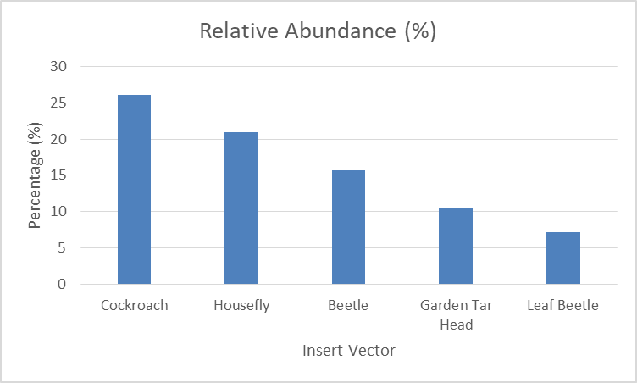
Figure 1: Pie Chart Showing Percentage Composition of Insect Vectors
The chart illustrates that cockroaches and houseflies together account for nearly half (47%) of all insects collected, reinforcing their role as primary vectors associated with waste dumps.

4.2 Comparative Abundance of Insect Vectors by Dumpsite
Table 2 compares the total mean insect vector count at each dumpsite and reveals that Aso Rock Villa recorded the highest mean count (15.32), representing 37.0% of the entire count across all locations. This suggests that Aso Rock Villa is the most ecologically supportive environment for vector breeding among all the sampled locations, possibly due to higher waste decomposition rate, organic content, poor sanitation, and inadequate waste separation. Texas Villa followed with 13.33 mean count (33.2%), while Miami Villa recorded the lowest (12.32 mean count; 29.8%). Although Miami Villa recorded the lowest value, the figures are still considerably high, indicating that all studied dumpsites are potentially dangerous health reservoirs for insect vector transmission. The trend further supports that the intensity and quantity of waste dumped at a site directly influences insect vector proliferation. The ranking also implies a gradient of public health threat — highest at Aso Rock, moderate at Texas Villa, and relatively lower (but still significant) at Miami Villa.
Table 4.3: Comparison of Mean Insect Counts per Dumpsite
Dumpsite Location | Total Mean Insect Count | Percentage (%)
Miami Villa | 12.32 | 29.8
Aso Rock Villa | 15.32 | 37.0
Texas Villa | 13.33 | 33.2
Total | 40.97 | 100

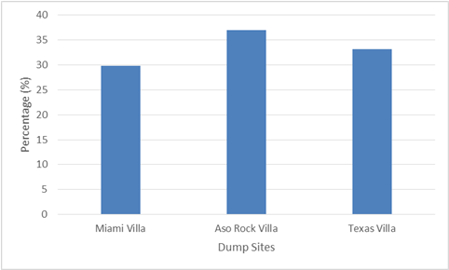
Figure 2: Total Mean Insect Count per Dumpsite

4.3 Environmental Conditions at the Dumpsites
Table 3 presents the environmental conditions of each dumpsite and provides ecological justification for the abundance patterns recorded in previous tables. Aso Rock Villa was dominated by decomposing organic waste, had very poor drainage, very high moisture levels and the closest proximity to residential settlements (25 m). These factors create ideal breeding and survival conditions for vectors such as houseflies and cockroaches. Miami Villa and Texas Villa also showed high moisture levels and poor drainage, meaning that all sampled sites possess environmental susceptibility to vector multiplication. The general sanitation level across all dumpsites ranged from low to very low, which corroborates the high insect counts recorded. Organic-rich and poorly drained waste sites create anaerobic fermentation zones which increase odour gradients attractive to Dipterans. Proximity distances of 25–40 m pose a direct public health risk as disease vectors can easily migrate into homes. Therefore, environmental conditions strongly explain and influence vector distribution trends across the dumpsites.
Table 4.4: Environmental Characteristics of Sampled Dumpsites
Parameter | Miami Villa | Aso Rock Villa | Texas Villa | Remarks
Waste Type | Mixed (organic + plastics) | Predominantly organic | Organic + metal scraps | Organic matter attracts Diptera & Blattodea
Drainage | Poor | Very Poor | Poor | Stagnant water supports breeding
Proximity to Residences (m) | 40 | 25 | 30 | Too close for public safety
Sanitation Level | Low | Very Low | Moderate | Poor waste management noted
Moisture Level | High | Very High | High | Supports fly larvae growth

CHAPTER FIVE

5.0 DISCUSSION
The findings from this study showed clear differences in the abundance and distribution of insect vectors across the three evaluated dumpsites, and this variation strongly reflects the influence of environmental parameters such as moisture level, organic waste concentration, drainage condition and proximity to residential areas. Cockroach and housefly populations were highest across all study locations, indicating that these two groups of insects possess higher ecological fitness within waste-based habitats. Cockroaches recorded the highest mean abundance at Aso Rock Villa and houseflies also maintained consistently high mean distribution across locations. The dominance of cockroaches and houseflies agrees with previous findings from African studies which reported that these vectors are highly associated with municipal dumps due to their scavenging behaviour and biological ability to utilize decomposing substrates (Oyeyemi et al., 2020; Abila & Mwichande, 2019). This implies that the biochemical processes taking place during organic decomposition at the dumpsites generate favourable metabolic gases, nutrients and microbial colonies that promote their continuous survival and multiplication.
The result further showed that Aso Rock Villa had the highest total mean insect count (15.32) compared to Texas Villa (13.33) and Miami Villa (12.32). This emphasizes that waste dumpsites with extremely high organic content, very high moisture level and very poor drainage tend to sustain higher insect loads. The sanitation level at Aso Rock Villa was also very low and the proximity to residential settlement was shortest (25 m). These parameters are important public health determinants because insects can easily migrate into residential areas through brief flight distances, surface crawling or contact surfaces (Ngeno et al., 2022). This supports earlier findings from Ethiopia and Kenya where dumpsites located near households posed greater disease transmission risks due to high contact frequency between vectors and humans (Tadesse et al., 2021; Omwenga et al., 2020). Therefore, the conditions observed at Aso Rock Villa make it the highest potential threat location among the three sites.
The low mean values recorded for garden tar head and leaf beetle compared to cockroach and housefly indicate that not all insects respond equally to waste-based habitat. Dipteran species such as houseflies are highly adapted to organic waste fermentation than other insect groups. Their ability to rapidly complete life cycle within decomposing waste makes them more persistent than beetles whose breeding preference varies depending on soil type, moisture retention and waste stability (Balega-Cagliero et al., 2019). This variation confirms that organic composition differences within dumpsites directly influence selective vector abundance.
Additionally, the low standard deviation values across most insects indicate that the distribution of insects was fairly stable and not experiencing wide fluctuation during sampling period. This suggests that the dumpsites have consistent micro-ecological conditions that continually sustain insect populations. If climatic variables, waste disposal frequency or decomposition rates were drastically unstable, greater variation would have been expected.
These findings demonstrate that dumpsite management is a critical component of vector control in urban communities especially in African regions where poor waste disposal practices still prevail. The presence of high insect vector density implies ongoing risk for transmission of diarrheal diseases, typhoid, dysentery and bacterial contamination from these vectors to humans (Mohammed et al., 2021). Despite several public health campaigns across African cities, community adherence to proper waste management remains weak and open dumping is still common. Therefore, improved environmental sanitation, waste segregation, composting of organic waste and enforcement of standardized waste disposal regulations are urgently needed to reduce vector proliferation and protect surrounding households.
Further research should integrate laboratory identification of microorganisms carried by insect species from these dumpsites and compare seasonal fluctuations between dry and rainy periods to determine peak vector risk windows. This will help to establish improved evidence-based strategies for dumpsite regulatory control and community-based vector surveillance in Nigeria and across Africa.

CONCLUSION
In conclusion, based on the results of this study and the literature reviewed, it is evident that the high abundance of insect vectors such as cockroaches and houseflies recorded across the studied dumpsites is strongly influenced by the organic waste composition, high moisture levels, poor drainage, and low sanitation conditions present at the sites. Aso Rock Villa recorded the highest vector load, indicating that dumpsites with extremely high organic content and close proximity to residential areas pose greater public health risks. The findings further support previous African studies which emphasized that improperly managed dumpsites serve as reservoirs for insect vectors capable of spreading pathogenic microorganisms to nearby human populations. This therefore confirms that open dumpsites constitute a major environmental health hazard and contribute significantly to the potential transmission of vector-related diseases in urban settings. Strengthening waste management practices, improving sanitation, and enforcing environmental regulatory standards remain crucial steps toward reducing vector proliferation and mitigating

RECOMMENDATIONS
Based on the findings of this study, the following recommendations are made:
- Improved Waste Management Practices: Government and local authorities should enforce proper waste segregation, recycling, composting, and timely evacuation of refuse to reduce organic waste accumulation which supports vector breeding.
- Regulatory Enforcement: Authorities should strengthen regulations guiding establishment, operation, and monitoring of dumpsites. Dumpsites should not be sited close to residential homes and minimum environmental safety distances should be maintained to protect public health.
- Provision of Adequate Waste Disposal Facilities: Government agencies should provide functional waste collection points, covered refuse bins, and reliable waste transport systems to discourage random dumping practices.

REFERENCES
Abila, R., & Mwichande, B. (2019). Insect vector proliferation in unmanaged urban waste dumps: Implications for public health. African Journal of Environmental Science and Technology, 13(4), 155–164.
Adebayo, O. T., Adebayo, A. S., & Opasola, A. O. (2019). Assessment of insect diversity in dumpsites in southwestern Nigeria. International Journal of Entomology Research, 7(2), 45–52.
Adediran, Y. A., & Nwude, D. O. (2010). Survey of insect vectors in selected waste dumps in Gombe metropolis, Nigeria. Nigerian Journal of Entomology, 27(1), 33–40.
Ahmed, S. (2012). Solid waste disposal practices and associated challenges in Kaduna metropolis. Journal of Environmental Management and Safety, 3(1), 50–60.
Babayemi, J. O., & Dauda, K. T. (2009). Evaluation of solid waste generation, categories and disposal options in developing countries: A case study of Nigeria. Journal of Applied Sciences and Environmental Management, 13(3), 83–88.
Balega-Cagliero, J., Martin, T., & Cagliero, L. (2019). Environmental factors influencing beetle abundance in waste accumulation sites. Journal of Insect Ecology, 29(1), 1–12.
Cotton, P., Jackson, T., & Adler, K. (2007). Cockroach allergens and their association with asthma-related health outcomes. Clinical and Experimental Allergy, 37(8), 1235–1243.
Ekpo, U. F., Mafiana, C. F., & Adeoye, G. O. (2010). Entomological identification keys for medically important insects in Nigeria. Nigerian Journal of Parasitology, 31(2), 121–128.
Goulson, D. (2013). The decline of bees and its consequences for ecosystems and agriculture. Science, 347(6229), 1255957.
Jung, H., Kim, S., & Lee, J. (2015). Environmental impacts of open dumping practices in urban settlements. Waste Management & Research, 33(9), 829–835.
Kariuki, M., Ndungu, J., & Onyango, P. (2020). Impact of unmanaged waste dumps on mosquito breeding and malaria transmission in Kenya. East African Medical Journal, 97(5), 215–224.
Miller, G. T. (2008). Environmental science: Working with the Earth (11th ed.). Brooks/Cole.
Mohammed, S., Ojo, A., & Yusuf, K. (2021). Pathogenic microorganisms associated with insect vectors from urban dumpsites in Nigeria. Journal of Public Health and Epidemiology, 13(2), 45–53.
Ngeno, E., Cheruiyot, K., & Kiptoo, E. (2022). Proximity of dumpsites to residences and associated disease risks in Kenyan urban centers. Environmental Health Insights, 16(1), 1–10.
Okonkwo, J. I., & Eze, V. C. (2022). Gastrointestinal infections linked to fly populations in communities near dumpsites in southeastern Nigeria. Journal of Community Medicine and Primary Health Care, 34(1), 102–112.
Okorie, T. G., Hassan, Z., & Olanrewaju, R. (2011). Statistical analysis of insect vector distribution in waste disposal sites. Nigerian Journal of Statistical Sciences, 10(1), 77–85.
Omwenga, E., Oduor, O., & Abuga, J. (2020). Household exposure to insect vectors around municipal dumpsites in Nairobi. International Journal of Environmental Research and Public Health, 17(21), 8121.
Oniye, S. O., Adebote, D. A., & Adamu, R. (2018). Bacterial contamination and vector potential of insects associated with urban dumpsites in northern Nigeria. Bayero Journal of Pure and Applied Sciences, 11(1), 157–164.
Oyedele, J. (2009). Waste management systems and public health implications in Nigeria. Environmental Review Journal, 14(3), 120–131.
Oyeyemi, A. L., Musa, Y., & Ibrahim, B. (2020). Municipal solid waste dumps and insect vector proliferation in southwestern Nigeria. Journal of Environmental Health Research, 20(2), 112–121.
Pokkala, R., & Ponka, A. (2004). Household exposure to houseflies and related contamination pathways. Scandinavian Journal of Public Health, 32(3), 240–246.
Sarojini, R. (2016). Household waste management and vector breeding in developing communities. Journal of Environmental Science and Policy, 22(4), 89–101.
Tadesse, D., Alemu, G., & Desta, H. (2021). Influence of waste dumping sites on vector-borne disease patterns in Ethiopia. Ethiopian Journal of Health Sciences, 31(2), 249–258.

